
Manola Inn

Relax. You’re at Manola Inn.

BUSINESS PLAN

[YEAR]

John Doe | 10200 Bolsa Ave, Westminster, CA, 92683 | (650) 359-3153 | info@example.com
http://www.example.com

Information provided in this business plan is unique to this business and confidential; therefore, anyone reading this plan agrees not to disclose any of the information in this business plan without prior written permission of the Company
Table of Contents

Executive Summary | 6
Business Overview | 7
Services | 7
Customer Focus | 7
Management Team | 8
Keys to Success | 8
Objectives | 8
Financial Overview | 8

Company Summary | 10
Who is The Manola Inn? | 11
Manola Inn’s History | 11
Manola Inn’s Services | 12
Bed and Breakfast Design | 12

Industry Analysis | 13
Industry Statistics & Trends | 14
Market Segmentation | 14
Geo-graphics | 14
Demographics | 15
Target Market Segment Strategy | 15
Vacationers | 15
Honeymooners | 16
Drop-ins | 16
Service Business Analysis | 16

Customer Analysis | 18
Profile of Target Market | 19
Customer Segmentation | 19
The U.S. Leisure Travel Market | 19
The U.S. Business Travel Market | 20

Manola Inn | Business Plan [YEAR] 2/40

International Tourists | 20

Competitive Analysis | 21
Direct & Indirect Competitors | 22
The Madison Concourse Bed and Breakfast | 22
The Edgewater Bed and Breakfast | 22
Doubletree Bed and Breakfast Madison | 22
Competitive Pricing | 23
Competitive Advantage | 23

Marketing Plan | 24
The Malona Inn Brand | 25
Promotions Strategy | 25
Phone Prospecting | 25
Public Relations | 26
Advertising | 26
Ongoing Customer Communications | 26
Pre-Opening Events | 26
Pricing Strategy | 27

Operations Plan | 28
Functional Roles | 29
Administrative Functions | 29
Bed and Breakfast Services | 29
Milestones | 29

Management Team | 30
John Doe | 31
Hiring Plan | 31
Financial Plan
Financial Plan | 32
Revenue and Cost Drivers | 33
Capital Requirements and Use of Funds | 33

Manola Inn | Business Plan [YEAR] 3/40

Key Assumptions & Forecasts | 33
Income Statement (5 Year projections) | 33
Balance Sheet (5 Year projections) | 36
Cash Flow Statement (5 Year projections) | 37

Manola Inn | Business Plan [YEAR] 4/40

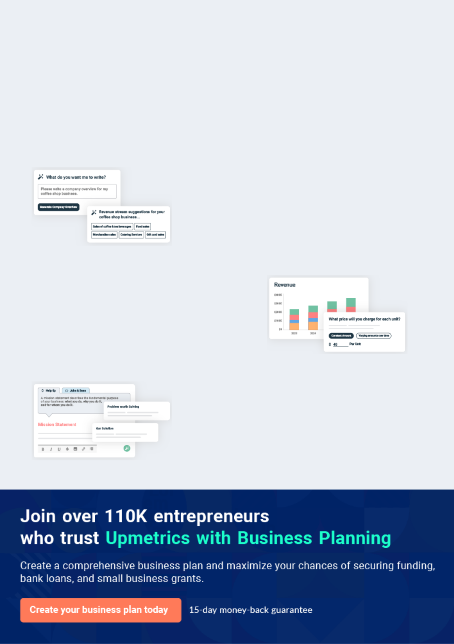
Business planning that’s simpler and faster than you think

Creating a business plan using Upmetrics to start and grow a business is literally the easiest thing in the World. Simply read the instructions and fill in the blanks. It’s as simple as that.

❛ | Upmetrics has everything you need to create a | ❜
❛ | comprehensive business plan. | ❜

AI-powered Upmetrics Assistant

AI-powered insights to streamline your plan

Not sure where to start? Upmetrics’ AI Assistant will automatically generate ideas for each section of your plan and offer improved versions of your writing, adjusting for tone, voice, and grammar or spelling errors.

Financial Forecasting Tool

All the financials are calculated for you

Forget the complex formulas and clumsy spreadsheets — with automatic financials and drag-and-drop forecasting, you can finish your plan faster and be confident that your numbers are accurate.

Business Plan Builder

Guides you like a business mentor

Upmetrics’ step-by-step instructions, prompts, and the library of 400+ sample business plans will guide you through each section of your plan as a business mentor.

1.


Executive Summary

Business Overview

Keys to Success

Objectives

Financial Overview

Manola Inn | Business Plan [YEAR] 6/40

Business Overview
To unlock help try Upmetrics!
To unlock help try Upmetrics!

 Manola Inn


The Manola Inn is a beautiful facility that sits atop a bluff overlooking the Pacific Ocean in scenic Half Moon Bay California. The Inn offers seven individually furnished rooms, each with its own antique theme.



Start writing here..

 Manola Inn

The Manola Inn will offer all of the standard Bed and Breakfast services including daily room cleaning, free local calls, cable TV, a free wireless network, and various other amenities. Additionally, the Bed and Breakfast will include a restaurant lounge serving breakfast, lunch,
To unlock help try Upmetrics! 

Services

Start writing here..

 Manola Inn

The Manola Inn will primarily serve leisure travelers who seek comfort, necessary amenities, and simplicity of services. In general, the market for the bed and breakfast segment tends to be relatively affluent and well educated.



Customer Focus

Start writing here..

Manola Inn | Business Plan [YEAR] 7/40

 Manola Inn

The Manola Inn is led by John Doe who has been in the Bed and Breakfast industry for 20 years. While Doe has never developed a Bed and Breakfast from the ground up, he has worked in the Bed and Breakfast industry most recently as a general manager and has held various
To unlock help try Upmetrics! 

Management Team

Start writing here..

Keys to Success

 Manola Inn

The Manola Inn is uniquely qualified to succeed due to the following reasons:

• There is currently no Bed and Breakfast in the community we are entering. In addition, we
To unlock help try Upmetrics! 

Start writing here..

Objectives

 Manola Inn


- Generate a customer satisfaction rate above 90%.

- Generate an average of $26,000 in sales each month.
• Stay above 90% occupancy each month. To unlock help try Upmetrics! 

Start writing here..

Financial Overview

The Manola Inn is currently seeking $3,000,000 to launch. Specifically, these funds will be used as follows:

- Bed and Breakfast design/build: $2,500,000

- Working capital: $500,000 to pay for marketing, salaries, and land costs until [Company Name] reaches break-even.

Manola Inn | Business Plan [YEAR] 8/40

Topline projections over the next five years are as follows:

 | Year1 | Year2 | Year3 | Year4 | Year5
Revenue | $1,980,125 | $2,832,031 | $3,409,160 | $3,783,447 | $4,100,713
Total Expenses | $1,375,530 | $1,561,763 | $1,866,977 | $2,027,436 | $2,107,349
EBITDA | $604,595 | $1,270,268 | $152,183 | $1,756,011 | $1,993,364
Depreciation | $372,760 | $372,760 | $372,760 | $372,760 | $372,760
EBIT | $231,835 | $897,508 | $1,169,423 | $1,383,251 | $1,620,604
Interest | $164,782 | $144,184 | $123,586 | $102,988 | $82,391
PreTax Income | $67,054 | $753,324 | $1,045,837 | $1,280,263 | $1,538,213
Income Tax Expense | $23,469 | $263,663 | $366,043 | $448,092 | $538,375
Net Income | $43,585 | $489,661 | $679,794 | $832,171 | $999,839

Manola Inn | Business Plan [YEAR] 9/40

2.

Company Summary

Who is The Manola Inn?

Manola Inn’s History

Manola Inn’s Services

Bed and Breakfast Design

Manola Inn | Business Plan [YEAR] 10/40

 Manola Inn
To unlock help try Upmetrics!

The Manola Inn is a beautiful facility that sits atop a bluff overlooking the Pacific Ocean in scenic Half Moon Bay California. We are a new start-up enterprise that will offer seven wonderfully furnished rooms to guests who want to get away from the ordinary.
To unlock help try Upmetrics! 

Start writing here..

Who is The Manola Inn?

 Manola Inn

The Manola Inn, located in California, is a new, small Bed and Breakfast focused on providing rooms with a clean and modern character that is attractive to visitors to the area. The Company’s rooms will feature modern furniture, high-end technology, and modern accessories.
To unlock help try Upmetrics! 

Start writing here..

Manola Inn’s History

 Manola Inn

Upon returning from Madison, surveying the local customer base and online market, estimating travel growth, and finding a potential Bed and Breakfast location, John Doe incorporated The Manola Inn as an S-Corporation on Jan 2011.



Start writing here..

Manola Inn | Business Plan [YEAR] 11/40

Manola Inn’s Services

 Manola Inn

Below is Manola Inn's initial service offerings and amenities provided.

1. Single Rooms

Start writing here..

Bed and Breakfast Design

 Help Tip  Manola Inn


The Manola Inn will develop a 20,000 square foot Bed and Breakfast with key elements that will include the following:

Start writing here..

To unlock help try Upmetrics! 

To unlock help try Upmetrics! 

Manola Inn | Business Plan [YEAR] 12/40

3.

Industry Analysis

Industry Statistics & Trends

Market Segmentation

Target Market Segment Strategy

Manola Inn | Business Plan [YEAR] 13/40

 Manola Inn

Manola Inn directly or indirectly competes with all Bed and Breakfasts nearby our Bed and Breakfast locations. The competition will come from inns, motels, and hotels.
To unlock help try Upmetrics! 

Start writing here..

Industry Statistics & Trends

 Manola Inn

The Bed and Breakfast and Hostel Accommodations industry is expected to perform at a slightly slower rate over the five years to 2021 than the past five-year period. The resurgence of travel rates since the recession is expected to continue, while travel spending is projected to
To unlock help try Upmetrics! 

Start writing here..

Market Segmentation

The profile of our customer consists of the following geographic and demographic information.

 Manola Inn

Our immediate geographic market is the San Francisco Bay area with a population of over one million people.
To unlock help try Upmetrics! 

Geo-graphics

Start writing here..

Manola Inn | Business Plan [YEAR] 14/40

 Manola Inn
To unlock help try Upmetrics!

- Male and female.

- Married and single.
• Combined annual income in excess of $75,000. To unlock help try Upmetrics! 

Demographics

Start writing here..

Target Market Segment Strategy

 Manola Inn

Our target market strategy is based on becoming a destination for people who are looking to get away for a few days, on the beautiful California coast. Our marketing strategy is based on superior performance in the following areas:



Start writing here..

 Manola Inn

The most dominant segment of the three is comprised of the San Francisco Bay and the surrounding area. Half Moon Bay is approximately a 45-minute drive for Bay area residents.
To unlock help try Upmetrics! 

Vacationers

Start writing here..

Manola Inn | Business Plan [YEAR] 15/40

 Manola Inn
To unlock help try Upmetrics!

Because of the beauty and location of our Inn, we will be a very attractive choice for people looking for a honeymoon location.
To unlock help try Upmetrics! 

Honeymooners

Start writing here..

 Manola Inn

When rooms are available we will welcome the drop-in customer who is looking for a place to stay for the night. Our sign can be seen from Highway 101 and we expect to get quite a few drop-ins.



Drop-ins

Start writing here..

 Manola Inn

The Manola Inn is a seven-room facility that provides overnight lodging and breakfast in a luxurious setting on the beautiful California Coast. There are several other Inns in the area as well as motels. Most people who need lodging in the area make reservations in advance to
To unlock help try Upmetrics! 

Service Business Analysis

Start writing here..

Manola Inn | Business Plan [YEAR] 16/40

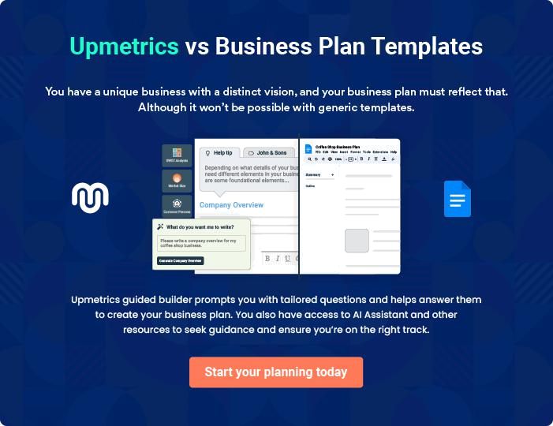

Manola Inn | Business Plan [YEAR] | 17/40

4.

Customer Analysis

Profile of Target Market

Customer Segmentation

Manola Inn | Business Plan [YEAR] 18/40

Profile of Target Market

 Manola Inn

The Manola Inn will serve the leisure travel market of California and its immediate surrounding area.
To unlock help try Upmetrics! 

Start writing here..

Customer Segmentation

We will primarily target the following three market segments:
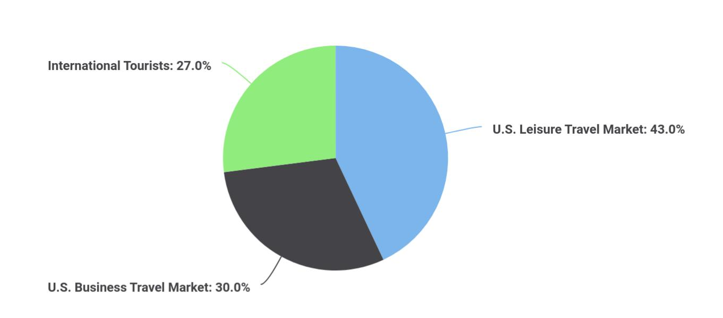

 Manola Inn

Travelers to California tourist attractions such as the Museum of Fine Art and the Annual Film Festival, as well as visitors to social events such as weddings.
To unlock help try Upmetrics! 

The U.S. Leisure Travel Market

Start writing here..

Manola Inn | Business Plan [YEAR] 19/40

 Manola Inn

Travelers to California for corporations and events

To unlock help try Upmetrics! 

The U.S. Business Travel Market

Start writing here..

 Manola Inn

Last year, there were over 903 million international tourist arrivals worldwide, with a growth of 6.6%. International tourist receipts were $856 billion, according to tourismrout.com.
To unlock help try Upmetrics! 

International Tourists

Start writing here..

Manola Inn | Business Plan [YEAR] 20/40

5.

Competitive Analysis

Direct & Indirect Competitors

Competitive Pricing

Competitive Advantage

Manola Inn | Business Plan [YEAR] 21/40

Direct & Indirect Competitors
To unlock help try Upmetrics!
To unlock help try Upmetrics!

The following Bed and Breakfasts are located within a 10-mile radius of The Malone Inn, thus providing either direct or indirect competition for customer acquisition:

 Malona Inn

The Madison Concourse Bed and Breakfast is Madison’s leading Bed and Breakfast and has been in business for 20 years. The Bed and Breakfast offers a wide array of services and amenities that you typically find at a Bed and Breakfast.



The Madison Concourse Bed and Breakfast

Start writing here..

 Malona Inn

The Edgewater Bed and Breakfast has been in business for 15 years. The Edgewater Bed and Breakfast offers a variety of services and amenities all typical of the Bed and Breakfast and hospitality industry.



The Edgewater Bed and Breakfast

Start writing here..

 Malona Inn

Doubletree Bed and Breakfast Madison is located four miles to the East of our intended location. Doubletree Bed and Breakfast Madison has been in business for the past 10 years and is part of the Hilton family of Bed and Breakfasts, allowing it to use centralized booking with
To unlock help try Upmetrics! 

Doubletree Bed and Breakfast Madison

Start writing here..

Manola Inn | Business Plan [YEAR] 22/40

Competitive Pricing

 Malona Inn


Madison

Concourse

Edgewater Bed and |  | Doubletree
Breakfast | To unlock help try Upmetrics! 

Start writing here..

Competitive Advantage

The Malona Inn enjoys several advantages over its competitors. These advantages include:


Location

The Malona Inn’s location in the downtown area, gives the best access to the airport, tourist attractions, corporate center, downtown, shopping and restaurants. The Company also offers adequate parking making it easy for customers to relax upon arrival.

Business Amenities

Wi-fi throughout the Bed and Breakfast will make working remotely simple for business visitors.

Management

Our management team has years of business and marketing experience that allows us to market and serve customers in the same manner as our most sophisticated competitors.

Relationships

Having visited the community for a number of years, John Doe knows all of the local leaders, newspapers and other influences. As such, it will be relatively easy for us to build the brand and awareness of the Bed and Breakfast.

Manola Inn | Business Plan [YEAR] 23/40

6.

Marketing Plan

The Malona Inn Brand

Promotions Strategy

Pricing Strategy

Manola Inn | Business Plan [YEAR] 24/40

 Malona Inn

The Marketing Plan describes the type of brand The Malona Inn seeks to create and the Company’s planned promotions and pricing strategies.
To unlock help try Upmetrics! 

Start writing here..

The Malona Inn Brand

 Malona Inn

The Malona Inn brand will focus on the Company’s unique value proposition:

• Offering rooms suited for families and business travelers and services
To unlock help try Upmetrics! 

Start writing here..

Promotions Strategy

The Malona Inn expects its target market to leisure travelers mainly from the U.S and surrounding locations in the Midwest. The Company’s promotions strategy to reach these individuals includes:

 Malona Inn

The Malona Inn will assign salespeople to contact area corporations to arrange for bulk corporate rates for their visitors depending on the volume of visitors they will have.
To unlock help try Upmetrics! 

Phone Prospecting

Start writing here..

Manola Inn | Business Plan [YEAR] 25/40

 Malona Inn
To unlock help try Upmetrics!

We will contact all local and regional area newspapers and television stations to tell them about the Bed and Breakfast opening and unique value proposition of The Malona Inn.
To unlock help try Upmetrics! 

Public Relations

Start writing here..

 Malona Inn

The Malona Inn will initially advertise on travel websites, which are frequently being used these days to book travel due to their ease of use and reviews.
To unlock help try Upmetrics! 

Advertising

Start writing here..

 Malona Inn

The Malona Inn will maintain a website and publish a monthly email newsletter to tell local corporations and past customers about promotions and events.
To unlock help try Upmetrics! 

Ongoing Customer Communications

Start writing here..

 Malona Inn

Before opening the Bed and Breakfast, The Malona Inn will organize pre-opening events designed for prospective national customers, local customers, and press contacts. These events will create buzz and awareness for The Malona Inn in the area.

Pre-Opening Events

Start writing here..



Manola Inn | Business Plan [YEAR] 26/40

Pricing Strategy

 Malona Inn

The Malona Inn’s pricing will fluctuate based on the season and occupancy percentages using a computerized yield management system, but pricing will always place the Bed and Breakfast in the mid-range, below luxury offerings and above Bed and Breakfasts and motels in the area.
To unlock help try Upmetrics! 

Start writing here..

Manola Inn | Business Plan [YEAR] 27/40

7.

Operations Plan

Functional Roles

Milestones

Manola Inn | Business Plan [YEAR] 28/40

Functional Roles

In order to execute on The Malona Inn's business model, the Company needs to perform many functions including the following:

 Malona Inn

- General & Administrative functions including legal, marketing, bookkeeping, etc.

- Sourcing and storing supplies for the Bed and Breakfast and conference space
• ^{Hiring and training staff} To unlock help try Upmetrics! 

Administrative Functions

Start writing here..

 Malona Inn

- Housekeeping

- Check-in focused on customer service
- Janitor/maintenance personnel to keep the Bed and Breakfast clean_{To unlock}andin_{help}working_{tryUpmetrics!}order 

Bed and Breakfast Services

Start writing here..

Milestones

The Malona Inn expects to achieve the following milestones in the following 5 months:

Date | Milestone
[Date 1] | Finalize Land Rights
[Date 2] | Design and build out [Company Name]Bed and Breakfast
[Date 3] | Hire and train initial staff
[Date 4] | Launch [Company Name]Bed and Breakfast
[Date 5] | Reach break-even

Manola Inn | Business Plan [YEAR] 29/40

8.

Management Team

Hiring Plan

Manola Inn | Business Plan [YEAR] 30/40


John Doe

CEO & Founder - john.doe@example.com

The Malona Inn is led by John Doe who has been in the Bed and Breakfast Industry for 20 years.

While Mr. Doe has never developed a Bed and Breakfast from the ground up, he has worked in the Bed and Breakfast industry most recently as a general manager and has held various different positions in the management chain over the last 20 years. As such John Doe has in-depth knowledge of the Bed and Breakfast business including the operations side (e.g., running day-to-day operations) and the business management side (e.g., staffing, marketing, etc.).

John Doe has also worked real estate consultant on a part-time basis over the past 10 years. Specifically, he has worked in contracting positions to help real estate developers with their Bed and Breakfast launch plans, as well as their operations, plans once the Bed and Breakfast have been launched.

John Doe graduated from the University of ABC where he majored in Bed and Breakfast and Restaurant Management.

Hiring Plan

 Malona Inn

The Malona Inn will serve as the Bed and Breakfast president. In order to launch our Bed and

Breakfast, we need to hire the following personnel:
To unlock help try Upmetrics! 

Start writing here..

Manola Inn | Business Plan [YEAR] 31/40

9.

Financial Plan

Revenue and Cost Drivers

Capital Requirements and Use of Funds

Key Assumptions & Forecasts

Income Statement (5 Year projections)

Balance Sheet (5 Year projections)

Cash Flow Statement (5 Year projections)

Manola Inn | Business Plan [YEAR] 32/40

Revenue and Cost Drivers
To unlock help try Upmetrics!

 Malona Inn

The Malona Inn’s will come from Bed and Breakfast room occupancy and food and beverage.

The major costs for the company will be the salaries of the staff and cost to maintain the
To unlock help try Upmetrics! 

Start writing here..

Capital Requirements and Use of Funds

 Malona Inn

The Malona Inn is seeking total funding of $3,000,000 to launch the Bed and Breakfast. The capital will be used for funding capital expenditures, manpower costs, marketing expenses, and working capital.



Start writing here..

Key Assumptions & Forecasts

Below please find the key assumptions that went into the financial forecast and a summary of the financial projections over the next five years.

Date | Milestone
[Date 1] | Finalize Land Rights
[Date 2] | Design and build out [Company Name]Bed and Breakfast
[Date 3] | Hire and train initial staff
[Date 4] | Launch [Company Name]Bed and Breakfast
[Date 5] | Reach break-even

Income Statement (5 Year projections)

Manola Inn | Business Plan [YEAR] 33/40

 | 2024 | 2025 | 2026
Revenue | $1,118,634.37 | $2,653,987.92 | $4,601,699.94
Room Rentals | $700,134.37 | $2,229,142.92 | $4,168,353.54
Users | 5,365 | 12,169 | 20,798
Recurring Charges | $20.83 | $20.83 | $20.83
Event Hosting | $202,500 | $204,525 | $208,620
Unit Sales | 45 | 45 | 46
Unit Price | $4,500 | $4,500 | $4,500
Food and Beverage Sales | $216,000 | $220,320 | $224,726.40
Unit Sales | 10,800 | 11,016 | 11,236
Unit Price | $20 | $20 | $20

Cost Of Sales | $242,611.03 | $546,501.79 | $931,086.10
General Costs | $242,611.03 | $546,501.79 | $931,086.10
Room-Related Costs | $30,070.51 | $42,244.08 | $56,763.11
Room Cleaning | $15,878.43 | $22,009.48 | $27,913.46
Laundry Services | $14,192.08 | $20,234.60 | $28,849.65
Food-Related Costs | $212,540.52 | $504,257.71 | $874,322.99
Food Supplies | $134,236.12 | $318,478.56 | $552,204
Beverages and Snacks | $78,304.40 | $185,779.15 | $322,118.99
Revenue Specific Costs | $0 | $0 | $0
Personnel Costs (Direct | $0 | $0 | $0
Labor) | $0 | $0 | $0

Gross Margin | $876,023.34 | $2,107,486.13 | $3,670,613.84
Gross Margin (%) | 78.31% | 79.41% | 79.77%

Manola Inn | Business Plan [YEAR] 34/40

Operating Expense

Payroll Expense (Indirect Labor)

Management

General Manager

Assistant Manager

Housekeeping

Housekeeping Staff

Food and Beverage

Chef

Wait Staff

General Expense

Utility and Maintenance Costs

Electricity and Heating

Water and Sewage

Marketing and Advertising

Online Advertising

Print and Media Advertising

Operational Supplies and Services

Cleaning Supplies

Laundry Services

Bad Debt

Amortization of Current Assets

2024 | 2025 | 2026
$383,851.31 | $504,250.49 | $656,256.43
$264,876 | $271,167.12 | $277,613.88
$99,360 | $102,340.80 | $105,411.12
$60,480 | $62,294.40 | $64,163.28
$38,880 | $40,046.40 | $41,247.84
$62,100 | $63,342 | $64,608.84
$62,100 | $63,342 | $64,608.84
$103,416 | $105,484.32 | $107,593.92
$50,976 | $51,995.52 | $53,035.44
$52,440 | $53,488.80 | $54,558.48
$118,975.31 | $233,083.37 | $378,642.55
$18,769.16 | $25,704 | $35,308.18
$12,063.19 | $17,199.26 | $24,522.05
$6,705.97 | $8,504.74 | $10,786.13
$82,099.77 | $184,416.21 | $314,211.46
$72,711.25 | $172,509.22 | $299,110.49
$9,388.52 | $11,906.99 | $15,100.97
$18,106.38 | $22,963.16 | $29,122.91
$7,376.62 | $9,355.35 | $11,864.90
$10,729.76 | $13,607.81 | $17,258.01
$0 | $0 | $0
$0 | $0 | $0

Manola Inn | Business Plan [YEAR] 35/40

EBITDA

Additional Expense

Long Term Depreciation

Gain or loss from Sale of Assets

EBIT

Interest Expense

EBT

Income Tax Expense / Benefit

2024 | 2025 | 2026
$492,172 | $1,603,235.64 | $3,014,357.42

$21,179.98 | $20,256.21 | $19,285.20
$16,590 | $16,590 | $16,590
$0 | $0 | $0
$475,582 | $1,586,645.64 | $2,997,767.42
$4,589.96 | $3,666.20 | $2,695.19
$470,992.02 | $1,582,979.43 | $2,995,072.22
$0 | $0 | $0

Total Expense | $647,642.33 | $1,071,008.49 | $1,606,627.73
Net Income | $470,992.02 | $1,582,979.43 | $2,995,072.22
Net Income (%) | 42.10% | 59.65% | 65.09%

Retained Earning Opening | $0 | $452,992.02 | $2,027,971.45
Owner's Distribution | $18,000 | $8,000 | $8,000
Retained Earning Closing | $452,992.02 | $2,027,971.45 | $5,015,043.67

Balance Sheet (5 Year projections)

 | 2024 | 2025 | 2026
Assets | $584,936.56 | $2,140,936.76 | $5,108,058.74
Current Assets | $26,526.56 | $1,599,116.76 | $4,582,828.74
Cash | $26,526.56 | $1,599,116.76 | $4,582,828.74

Manola Inn | Business Plan [YEAR] 36/40

 | 2024 | 2025 | 2026
Accounts Receivable | $0 | $0 | $0
Inventory | $0 | $0 | $0
Other Current Assets | $0 | $0 | $0
Long Term Assets | $558,410 | $541,820 | $525,230
Gross Long Term Assets | $575,000 | $575,000 | $575,000
Accumulated Depreciation | ($16,590) | ($33,180) | ($49,770)

Liabilities & Equity | $584,936.54 | $2,140,936.73 | $5,108,058.70
Liabilities | $81,944.52 | $62,965.28 | $43,015.03
Current Liabilities | $18,979.24 | $19,950.25 | $0
Accounts Payable | $0 | $0 | $0
Income Tax Payable | $0 | $0 | $0
Sales Tax Payable | $0 | $0 | $0
Short Term Debt | $18,979.24 | $19,950.25 | $0
Long Term Liabilities | $62,965.28 | $43,015.03 | $43,015.03
Long Term Debt | $62,965.28 | $43,015.03 | $43,015.03
Equity | $502,992.02 | $2,077,971.45 | $5,065,043.67
Paid-in Capital | $0 | $0 | $0
Common Stock | $0 | $0 | $0
Preferred Stock | $0 | $0 | $0
Owner's Contribution | $50,000 | $50,000 | $50,000
Retained Earnings | $452,992.02 | $2,027,971.45 | $5,015,043.67

Check | $0 | $0 | $0

Cash Flow Statement (5 Year projections)

Manola Inn | Business Plan [YEAR] 37/40

 | 2024 | 2025 | 2026
Cash Received | $1,118,634.35 | $2,653,987.92 | $4,601,699.95
Cash Paid | $631,052.33 | $1,054,418.49 | $1,590,037.73
COS & General Expenses | $361,586.35 | $779,585.16 | $1,309,728.65
Salary & Wages | $264,876 | $271,167.12 | $277,613.88
Interest | $4,589.96 | $3,666.20 | $2,695.19
Sales Tax | $0 | $0 | $0
Income Tax | $0 | $0 | $0
Net Cash From | $487,582.02 | $1,599,569.43 | $3,011,662.22
Operations | $487,582.02 | $1,599,569.43 | $3,011,662.22

Assets Sell | $0 | $0 | $0
Assets Purchase | $575,000 | $0 | $0
Net Cash From | ($575,000) | $0 | $0
Investments | ($575,000) | $0 | $0

Amount Received | $150,000 | $0 | $0
Loan Received | $100,000 | $0 | $0
Common Stock | $0 | $0 | $0
Preferred Stock | $0 | $0 | $0
Owner's Contribution | $50,000 | $0 | $0
Amount Paid | $36,055.46 | $26,979.23 | $27,950.24
Loan Capital | $18,055.48 | $18,979.24 | $19,950.25
Dividends & Distributions | $18,000 | $8,000 | $8,000
Net Cash From | $113,944.54 | ($26,979.23) | ($27,950.24)
Financing | $113,944.54 | ($26,979.23) | ($27,950.24)

Summary

Manola Inn | Business Plan [YEAR] 38/40

 | 2024 | 2025 | 2026
Starting Cash | $0 | $26,526.56 | $1,599,116.76
Cash In | $1,268,634.35 | $2,653,987.92 | $4,601,699.95
Cash Out | $1,242,107.79 | $1,081,397.72 | $1,617,987.97
Change in Cash | $26,526.56 | $1,572,590.20 | $2,983,711.98
Ending Cash | $26,526.56 | $1,599,116.76 | $4,582,828.74
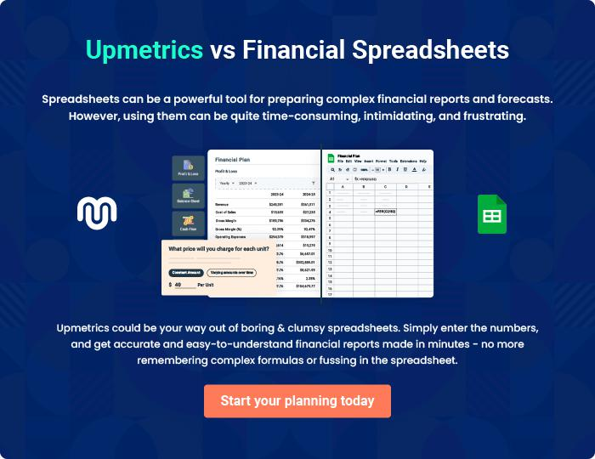

Manola Inn | Business Plan [YEAR] 39/40


Create a winning business plan that gets you funded

Creating a stunning and investment-ready plan requires no writing, graphic designing, or financial planning expertise.

Upmetrics has all the features required to help you create a comprehensive business plan—from start to finish. Make no mistakes, it’s the modern way of planning to structure ideas, make plans, and create stunning pitch decks to awe investors.

Pitch decks that impress investors

Create pitch decks that provide a visual representation of your business, engage investors, and make them want to invest in your business idea.

Interactive plans in no time

Import business plan sections like—SWOT analysis, comparison tables, and others to create an interactive business plan. No designing skills are required.

Stunning cover page designs

With Upmetrics, you have the liberty to choose from multiple stunning cover page designs. Choose a creative design and make your plan stand out.

Online sharing made simple

Upmetrics makes online sharing quick and easier for users. Easily share your business plans with a link while tracking reader activity.

500+ sample business plans

Simply import a template from our library of sample plans into the editor and start customizing it to make it yours. It takes only a few clicks to get started.

Collaborate with team in real-time

Invite team members, initiate conversations, discuss ideas & strategies, share feedback, and work on a business plan in real-time.

