
Beauty Supply Store

Let’s be Beautiful. Be Colorful. and Be You.

BUSINESS PLAN

[YEAR]

John Doe | 10200 Bolsa Ave, Westminster, CA, 92683 | (650) 359-3153 | info@example.com
http://www.example.com

Information provided in this business plan is unique to this business and confidential; therefore, anyone reading this plan agrees not to disclose any of the information in this business plan without prior written permission of the company.
Table of Contents

Executive summary | 5
Problem Definition & Validation | 6
Solution | 6
Objectives | 7
Short Term (1 -3 Years) | 7
Long Term (3-5 years) | 7
Mission statement | 7
Keys to success | 8
Financial Highlights | 8
Units Sold v/s Revenue Chart | 9

Business overview | 10
Company Ownership/Legal Entity | 11
Location | 11
Interior Operating Facilities | 12
Hours of Operation | 12
Startup summary | 12

Products & Services | 13
Range of Products | 14
Suppliers | 15
Market Analysis
Market Analysis | 16
Market segmentation | 17
Market Trends | 17
Target market | 18
Target Market Persona | 18
Competitive Advantage | 19
SWOT analysis
SWOT analysis | 20

Beauty Supply Store | Business Plan [YEAR] 2/44

Strategy & implementation | 22
Distribution Strategy | 23
Marketing and Promotion Programs | 23
Direct Sales | 23
Trade Publications | 24
Trade shows and Lifestyle Exhibitions | 24
Website | 24
Targeted Online Advertising | 24
Positioning Statement | 25
Sales strategy | 25
Online Marketing Channels | 26
Offline Marketing Channels | 26
Pricing strategy | 27

Operational Plan | 28
Organization chart | 29
Management Team | 29
Personnel Plan | 30
Hiring plan | 30
Jane Doe | 30
Amanda Doe | 30
John Doe | 31
Milestones | 32
CLEARA | 32

Financial plan | 33
Important Assumptions | 34
Brake-even Analysis | 34
Projected Profit and Loss | 35
Projected Cash Flow | 37
Projected Balance Sheet | 40
Business Ratios | 41

Beauty Supply Store | Business Plan [YEAR] 3/44

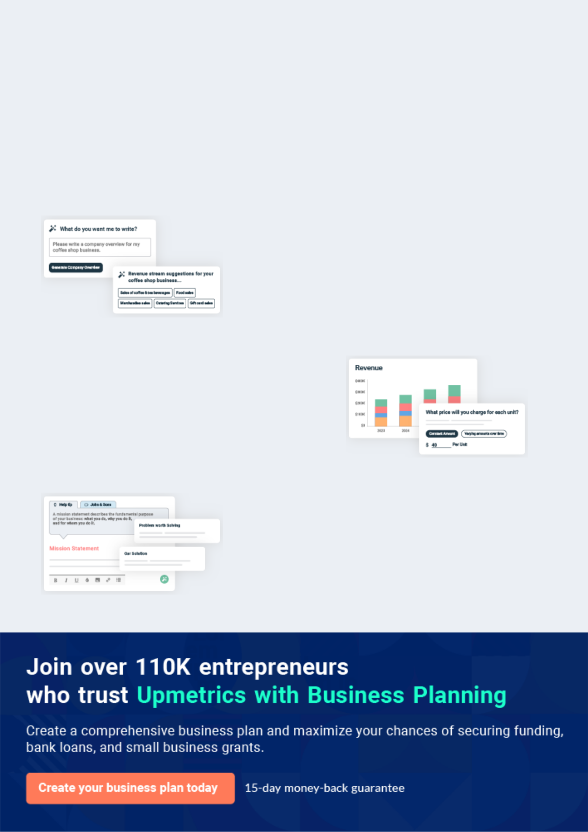
Business planning that’s simpler and faster than you think

Creating a business plan using Upmetrics to start and grow a business is literally the easiest thing in the World. Simply read the instructions and fill in the blanks. It’s as simple as that.

❛ | Upmetrics has everything you need to create a | ❜
❛ | comprehensive business plan. | ❜

AI-powered Upmetrics Assistant

AI-powered insights to streamline your plan

Not sure where to start? Upmetrics’ AI Assistant will automatically generate ideas for each section of your plan and offer improved versions of your writing, adjusting for tone, voice, and grammar or spelling errors.

Financial Forecasting Tool

All the financials are calculated for you

Forget the complex formulas and clumsy spreadsheets — with automatic financials and drag-and-drop forecasting, you can finish your plan faster and be confident that your numbers are accurate.

Business Plan Builder

Guides you like a business mentor

Upmetrics’ step-by-step instructions, prompts, and the library of 400+ sample business plans will guide you through each section of your plan as a business mentor.

1.


Executive summary

Problem Definition & Validation

Solution

Objectives

Mission statement

Keys to success

Financial Highlights

Beauty Supply Store | Business Plan [YEAR] 5/44

 Cleara


Cleara brings to the US allure of healthy, smooth, and youthful skin that radiates vitality through its professional range of skincare products. Leveraging Japan’s uncompromising commitment towards research and development of advanced skincare formulations, the company seeks to
To unlock help try Upmetrics! 

Start writing here..

Problem Definition & Validation

 Cleara

The cosmetic and personal care industry thrives on exploiting modern women’s insecurities and the cultural perception of beauty to flood the market with products that contain toxins and cheap fillers which are known to have harmful side effects. These products become even more
To unlock help try Upmetrics! 

Start writing here..

Solution

 Cleara

Cleara will source its products from the world’s second-largest cosmetic market, Japan. In a country known for its concepts of balance; all the products will be made from naturally
occurring ingredients that are perfectly balanced with the latest in skincare technology resulting
To unlock help try Upmetrics! 

Start writing here..

Beauty Supply Store | Business Plan [YEAR] 6/44

Objectives

 Cleara

• To begin commercial operations in LA by Q1 2021

• To build a market reputation for quality hygienic products and services during the
To unlock help try Upmetrics! 

Short Term (1 -3 Years)

Start writing here..

 Cleara

- To expand by opening additional store locations across the country during the forecast period
To unlock help try Upmetrics! 

Long Term (3-5 years)

Start writing here..

Mission statement

 Cleara

To build a global brand that is committed to enhancing the natural beauty of women and men by always providing the best products and services worldwide.
To unlock help try Upmetrics! 

Start writing here..

Beauty Supply Store | Business Plan [YEAR] 7/44

Keys to success



Natural Production

Cleara will source its products from the world’s second largest cosmetic market, Japan. A country known for its concepts of balance; all the products will be made from naturally occurring ingredients which are perfectly balanced with the latest in skin care technology resulting in products that are of the highest quality.


Supply Network


Cleara enjoys retains control over the quality of products by thoroughly vetting the suppliers and closely monitoring the manufacturing process.



Distribution Channels

Cleara will distribute its products through both B2B as well as B2C channels. This will allow it to hold a niche in a market where professional skin care products are not freely available in the retail market.

Value Added Services

Cleara will dedicate itself to the wellbeing of its customers. To this end, a professional beauty advisor will ensure all of the customer’s queries regarding the composition, application and suitability of the products are met professionally and promptly.

Price

The company enjoys sole distributorship of the products in Hong Kong which allows it to control prices. Cleara will thus be able to secure and distribute products at market beating price points.

Effective Marketing

Cleara will dedicate time and effort towards networking and gaining valuable insight into the prevailing market trends in the US which will allow the company to optimise its marketing strategies and effectively penetrate the market on launch.

Financial Highlights

 Cleara

The company envisions raising an equity investment of $50,000 through long-term borrowings, which will be used for the setup and launch of the salon in the US. The company expects to steadily grow its revenues through active efforts in marketing, networking, excellent customer
To unlock help try Upmetrics! 

Start writing here..

Beauty Supply Store | Business Plan [YEAR] 8/44

Units Sold v/s Revenue Chart
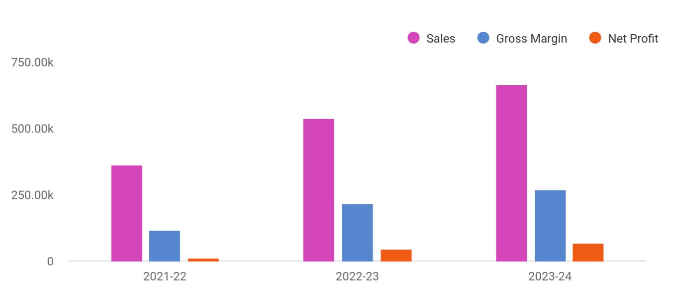

Financial Year | Sales | Gross Margin | Net Profit
2021-22 | 360,723 | 114,289 | 13,038
2022-23 | 538,041 | 216,784 | 44,360
2023-24 | 665,012 | 269,869 | 65,638

Beauty Supply Store | Business Plan [YEAR] 9/44

2.

Business overview

Company Ownership/Legal Entity

Location

Interior Operating Facilities

Hours of Operation

Startup summary

Beauty Supply Store | Business Plan [YEAR] 10/44

 Cleara

Established in 2011 by a team of professional engineers, Cleara provides high-quality aesthetics equipment, as well as professional consultation and after-sales service to
beauticians and aesthetics professionals. Through a network of top-tier, vetted and closely
To unlock help try Upmetrics! 

Start writing here..

Company Ownership/Legal Entity

 Cleara

The company will be registered as a limited liability entity with the Department of State. Further, since the company envisions setting up operations in LA, it will also register with the local county. The business will be wholly owned and Managed by Founder Mr. Thomas Green, who
To unlock help try Upmetrics! 

Start writing here..

Location

 Cleara

Los Angeles can be a tough city for entrepreneurs to establish and make a mark. Predominantly due to the thriving business landscape which has given rise to a competitive environment. However, there is so much room to have a rewarding career in the beauty industry in Los
To unlock help try Upmetrics! 

Start writing here..

Beauty Supply Store | Business Plan [YEAR] 11/44

Interior Operating Facilities
To unlock help try Upmetrics!

 Cleara

The company will begin operations from a rented retail space at the heart of LA’s commercial hub. Initial investments in setting up the interior facilities, consumables, inventory, and client entertainment space will be set up. Additions to space will be made as the company expands
To unlock help try Upmetrics! 

Start writing here..

Hours of Operation

 Cleara

Cleara will cater to walk-in as well as online customers, as such it will be required to stay open during business hours. The company envisions opening a showroom at 10 am and remain open till 7 pm to entertain walk-in prospects as well as fulfill online orders.



Start writing here..

Startup summary

 Cleara

The founding team will infuse a capital sum of £50,000 through long-term borrowings to meet the company’s start-up requirements. The start-up expenses are estimated at £18,500, primarily consisting of interior renovation, rent, and advertisement expenses. A further sum of £15,000
To unlock help try Upmetrics! 

Start writing here..

Beauty Supply Store | Business Plan [YEAR] 12/44

3.

Products & Services

Range of Products

Suppliers

Beauty Supply Store | Business Plan [YEAR] 13/44

 Cleara

Skincare is essential to graceful aging. Over time harsh elements in the environment wear on the skin, making it dry and tough. As such, a good skincare routine is imperative to eliminate the effects of the environment on the skin and revert the damaging impact. Good products
To unlock help try Upmetrics! 

Start writing here..

Range of Products



Hair Colour

Made from natural ingredients, the hair colour from Cleara is long lasting and vibrant


Foundation


Ideal for covering up uneven skin tone, the foundation is water based and made for all skin types


Hair curler/Iron


Reinforced plastic handle with rust free ironing gives your hair the desired curls in no time


Repair Lotions


Made for problem skin, these repair lotions work towards clearing skin and giving it a healthy glow

Lipstick

Cruelty free and free from parabens, the lipstick is of natural dye and skin friendly

Blush

Cruelty free and free from parabens, the blush is of natural dye and skin friendly

Gels

Clears offers a range of hair and face gels to keep oil at bay

Scrubs

Cleara offers a range of scrubs for all skin types from tea tree to papaya

Beauty Supply Store | Business Plan [YEAR] 14/44

Suppliers

 Cleara

Japan is well known for its “balanced state of mind”. The culture is deep-rooted in balancing tradition with the advancements in technology. Japan is home to the second-largest cosmetic industry in the world owing to the quality of products manufactured within its boundaries.
To unlock help try Upmetrics! 

Start writing here..
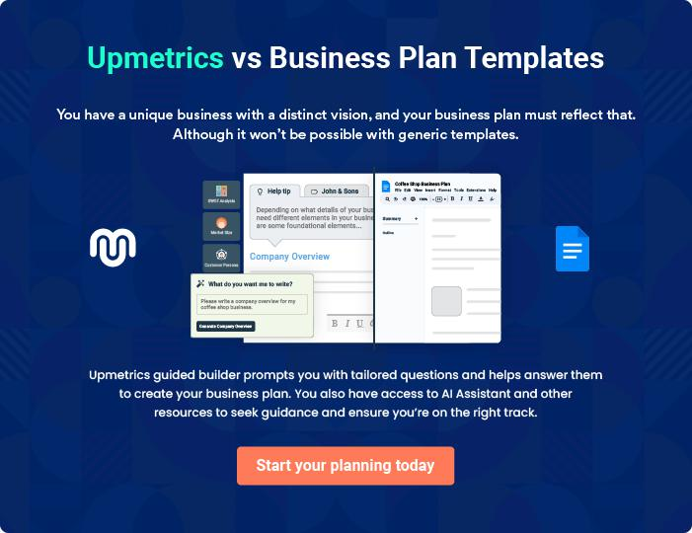

Beauty Supply Store | Business Plan [YEAR] 15/44

4.

Market Analysis

Market segmentation

Market Trends

Target market

Beauty Supply Store | Business Plan [YEAR] 16/44

 Cleara

Skincare, haircare, make-up, perfumes, toiletries and deodorants, and oral cosmetics are the main product categories of the cosmetic market. Since the early twentieth century, the production of cosmetics and beauty products has been controlled by a handful of multi-
To unlock help try Upmetrics! 

Start writing here..

Market segmentation

 Cleara

United States cosmetics market is segmented based on type, gender, distribution channel, and region. Based on type, the market is categorized into skincare, haircare, bath & shower products, makeup & color cosmetics, and fragrances & deodorants. The makeup and color
To unlock help try Upmetrics! 

Start writing here..

Market Trends

 Cleara

Within the cosmetics category in the U.S., eye cosmetics was the most profitable segment. In 2020, about 1.96 billion U.S. dollars were generated from sales of eye cosmetics in the U.S.
Facial cosmetics was the second most profitable segment, with sales revenue of 1.9 billion U.S.
To unlock help try Upmetrics! 

Start writing here..

Beauty Supply Store | Business Plan [YEAR] 17/44

Target market

 Cleara

The company will target B2B and B2C segments. Cleara expects to incorporate its company in the US by Q3 2021 and begin commercial operation by Q4 2021. The three-month period in between is sought to understand its potential market to serve its customers best fully. During
To unlock help try Upmetrics! 

Start writing here..

Target Market Persona
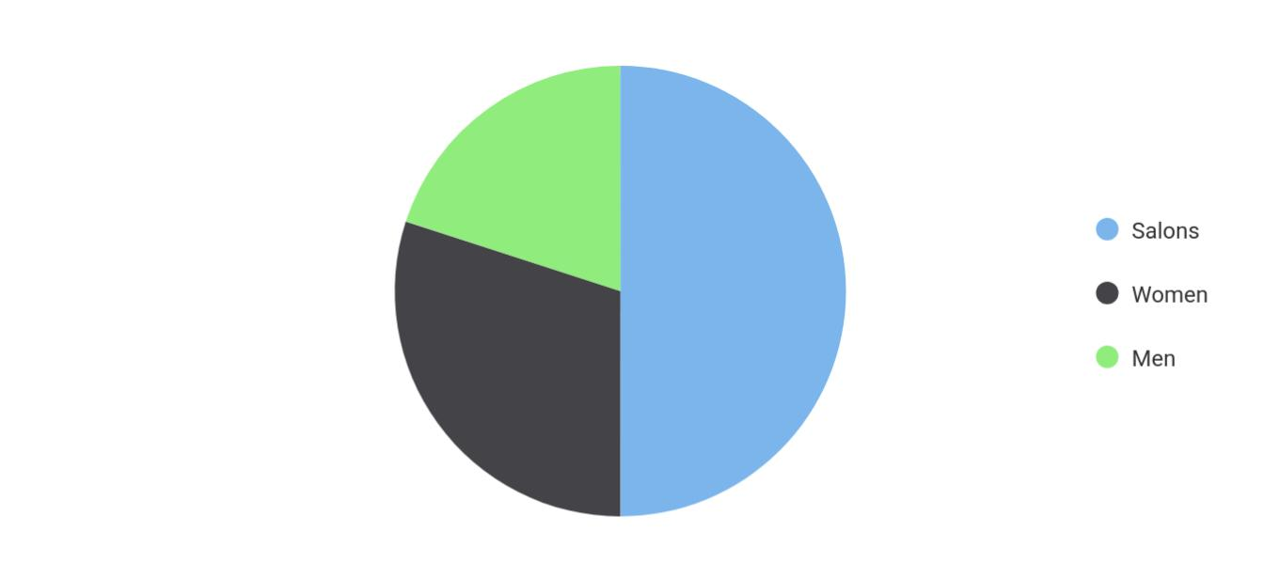

Market | Segment
Salons | 0.50
Women | 0.30
Men | 0.20

Beauty Supply Store | Business Plan [YEAR] 18/44

Competitive Advantage


Natural Production

Cleara will source its products from the world’s second largest cosmetic market, Japan. A country known for its concepts of balance; all the products will be made from naturally occurring ingredients which are perfectly balanced with the latest in skin care technology resulting in products that are of the highest quality.

Supply Network

Cleara enjoys superior supply connections and has complete control over the quality of products by thoroughly vetting the suppliers and closely monitoring the manufacturing process.

Distribution Channels

Cleara will distribute its products through both B2B as well as B2C channels. This will allow it to hold a niche in a market where professional skin care products are not freely available in the retail market.

Value Added

Services

Cleara will dedicate itself to the wellbeing of its customers. To this end, a professional beauty advisor will ensure all of the customer’s queries regarding the composition, application and suitability of the products are met professionally and promptly.

Price

The company enjoys sole distributorship of the products in the US which allows it to control prices. Cleara will thus be able to secure and distribute products at market beating price points.

Effective Marketing

Cleara will dedicate time and effort towards networking and gaining valuable insight into the prevailing market trends in the US which will allow the company to optimise its marketing strategies and effectively penetrate the market on launch.

Beauty Supply Store | Business Plan [YEAR] 19/44

5.

SWOT analysis

Beauty Supply Store | Business Plan [YEAR] 20/44

 Cleara

A SWOT (Strength, Weakness, Opportunity, and Threat) analysis is a useful tool for businesses to evaluate their position in the market against the potential internal and external factors that could assist or jeopardize their operations and existence. A SWOT has been conducted for
To unlock help try Upmetrics! 

Start writing here..


Strength Weakness

• Natural Products of Japan origin • Highly competitive market

• Thriving industry • Limited market understanding

- Lucrative business location

- Scalable pricing strategy and business model

Opportunity | Threat
• Collaboration with leading salons | • Competitors eroding the market
• Increased beauty consciousness | • Low barriers to entry
• High growth potential market in the US | • Competitors poaching B2B clients
• Export capabilities

Beauty Supply Store | Business Plan [YEAR] 21/44

6.

Strategy & implementation

Distribution Strategy

Marketing and Promotion Programs

Positioning Statement

Sales strategy

Pricing strategy

Beauty Supply Store | Business Plan [YEAR] 22/44

 Cleara
To unlock help try Upmetrics!

The objectives for the company’s early sales and marketing initiatives will be to generate awareness of Cleara as a new player in the market and to educate potential customers about
its portfolio of products. Over time, as Cleara becomes more established and develops a strong
To unlock help try Upmetrics! 

Start writing here..

Distribution Strategy

 Cleara

The company will reach its customer through both online and offline channels. Cleara’s comprehensive website will accept orders online and deliver them to the customer’s doorstep. Customers will also have an option to physically visit the company’s showroom to browse and
To unlock help try Upmetrics! 

Start writing here..

Marketing and Promotion Programs

 Cleara

Cleara will approach potential commercial clients directly, either through cold-calling or email, to arrange pitch meetings. The company’s sales representatives will use these opportunities to display the product catalog directly.



Direct Sales

Start writing here..

 Cleara

The Company will advertise in specific trade publications that are targeted towards the appropriate target markets. In the US there are a number of highly specialized publications (e.g. Skin Health Magazine, Glamour) that will be ideal for reaching these target markets.
To unlock help try Upmetrics! 

Beauty Supply Store | Business Plan [YEAR] 23/44

Trade Publications
To unlock help try Upmetrics!

Start writing here..

 Cleara

Cleara will establish a presence at various trade shows that are relevant to the target market. For example, LA Fashion week (US’s leading fashion trade show), HJ Live LA (Provides a platform to source the latest products and equipment from the brands exhibiting at the show).
To unlock help try Upmetrics! 

Trade shows and Lifestyle Exhibitions

Start writing here..

 Cleara

The Company will operate a professional and compelling website, with a dedicated section for commercial clients, to promote its commercial product lines and provide easy ability to contact sales staff.



Website

Start writing here..

 Cleara

The focus will be on Google Ads, which are more likely to drive commercial leads than other online advertising platforms (such as Facebook). The advertising will target specific keywords relevant to Cleara’s offering (e.g., “professional makeup,” “aesthetic products,” “cosmetics,”
To unlock help try Upmetrics! 

Targeted Online Advertising

Start writing here..

Beauty Supply Store | Business Plan [YEAR] 24/44

Positioning Statement

 Cleara

Cleara brings high-quality and effective essential cosmetic products to the US through a wide range of cleansers, toners, moisturizers, scrubs, and more. Creating a balance between luxurious and cosmetically elegant tactile comfort range with targeted fast-acting natural
To unlock help try Upmetrics! 

Start writing here..

Sales strategy

 Cleara

Professional service providers form the company’s primary target market. However, the company’s marketing efforts will also include end-users, clients of the professional service providers. While push marketing efforts will be deployed to reach service providers, pull
To unlock help try Upmetrics! 

Start writing here..

Beauty Supply Store | Business Plan [YEAR] 25/44

Online Marketing Channels


Electronic Direct Mail

Marketing

Salons looking for organic and natural skin care products to use for providing their services stand out prominently as viable marketing targets for this channel. Cleara will mail professionally designed materials with its value proposition to these companies and provide quotes for promotion merchandise printing services.

Social Media

Millennials and consumers in general spend a considerable time browsing social media platforms. Reaching to them through this channel will be and effective way to capture

attention and position its services.

Google Ad Campaigns

- The advertising will target specific keywords relevant to Cleara's offering (e.g. “professional makeup”, “aesthetic products”, “cosmetics” etc.).

Offline Marketing Channels


Networking | Pop-Up Store | Walk-in
Participate in leading | The company will also hold | The showroom will be
consumers exhibitions and | pop-up stalls at consumer | designed with attractive
beauty events. Display a range | exhibitions. | display of sample of products.
of samples and distribute |  | Visually attractive hoardings
flyers at these events. The |  | and a high street presence will
company will also keep a |  | further attract prospects to
record of visitors to their stalls |  | walk-in and buy high quality
as leads for its email |  | cosmetic products.
marketing campaigns.

Beauty Supply Store | Business Plan [YEAR] 26/44

Pricing strategy
To unlock help try Upmetrics!

 Cleara

Cleara's beauty product range is expected to carry an average price tag of $35.85 per item. The direct costs, which are primarily associated with stock procurement and carriage, are estimated to account for 60% of the average price, resulting in a 40% margin.



Start writing here..

Beauty Supply Store | Business Plan [YEAR] 27/44

7.

Operational Plan

Management Team

Personnel Plan

Milestones

Beauty Supply Store | Business Plan [YEAR] 28/44

 Cleara

The team will be headed by Managing Director Mr. Thomas Green who will also oversee production operations. Joining Mr. Thomas in the Management Team, the company will
onboard an office manager and a beauty advisor to help clients choose the best product for
To unlock help try Upmetrics! 

Start writing here..

Organization chart


Thomas Green

Managing Director
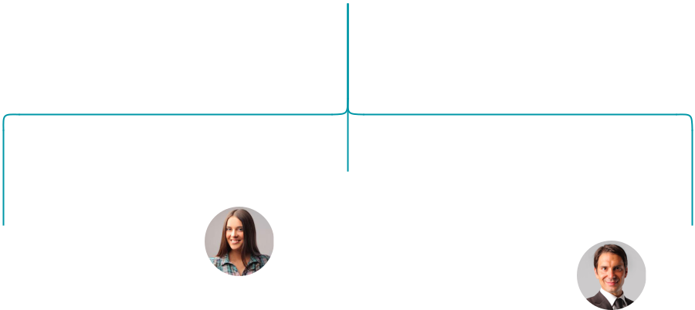

Amanda Doe

Jane Doe | Sales & Marketing | John Doe
Office Manager | Assistant | Beauty Assistant


Management Team

 Cleara

Mr. Thomas will serve as the Managing Director of Cleara. A highly motivated and dynamic individual, Thomas boasts vast experience in the field of aesthetics having spent a career
spanning 14 years essaying various white-collar roles for aesthetic companies across America.
To unlock help try Upmetrics! 

Start writing here..

Beauty Supply Store | Business Plan [YEAR] 29/44

Personnel Plan
To unlock help try Upmetrics!

 Cleara

The company plans to create six full-time equivalent jobs in addition to the management team within the first three years of operations. Salaries for each employee are in line with the industry’s benchmark.



Start writing here..

Hiring plan

20 |  |  |  | 5 |  |  |  |  | 25
Filled |  |  |  | Hired |  |  |  |  | Open
Group By Department |  |  |  | Position Filled |  | Time of Hire |  |  |  | Time of Start |  | Filled On Time
Office Manager |  |  |  | 1 of 20 |  |  | 10 days |  |  | 121 days |  | 100%
Sales & Marketing Assistant |  |  |  | 3 of 23 |  |  | 30 days |  |  | 21 days |  | 80%
Beauty Assistant |  |  |  | 4 of 15 |  |  | 158 days |  |  | 127 days |  | 0%


Jane Doe

Office Manager - Jane@cleara.com

Ability to cope with fast-paced and pressured work, accuracy, strong attention to detail and a strong analytical mind, ability to notice patterns within statistics, an interest in psychology and behavior, good organizational skills, excellent (spoken and written) communication skills.


Amanda Doe

Sales Representatives - Amanda@cleara.com

Preferably bilingual with ability to speak English and French fluently, problem-solving, ability to convert leads into sales, active listener, patience, and understanding of the company’s products and services. Additionally, skills in social media marketing, search engine optimization, newsletter marketing, other forms of digital marketing will also be required

Beauty Supply Store | Business Plan [YEAR] 30/44


John Doe

Beauty Specialist - John@cleara.com

Excellent verbal skills and a knack for cosmetic products, strong written and verbal communication skills, skilled in customer interaction, and a qualified skincare specialist.

Beauty Supply Store | Business Plan [YEAR] 31/44

Milestones

CLEARA


Establish

Cleara will rent a showroom space at the

heart of Los Angeles California commercial

hub alongside developing a fully optimized

and informative website. During this period,

the company will also acquire initial stocks

of inventory to give as samples and fill up

the showroom shelves. Marketing activities

will also begin during this stage to build

awareness and launch the brand into the

market.



 | Gain Market Traction
Year 2 | The company will begin expanding its
Year 2 | services beyond LA to cover other regions
 | around California.


Diversify

Having externally established the business,

the company will begin internally expanding

its range of products


Grow

- Year 3• Begin expanding across the US

  - Consider market expansion beyond US


Year 1

Year 3

Beauty Supply Store | Business Plan [YEAR] 32/44

8.

Financial plan

Important Assumptions

Brake-even Analysis

Projected Profit and Loss

Projected Cash Flow

Projected Balance Sheet

Business Ratios

Beauty Supply Store | Business Plan [YEAR] 33/44


If you are going to start your own beauty supply store business, then make sure you will pay special attention to your financial plan. Your financial plan should include the details about how well you manage your incomes and
To unlock help try Upmetrics! 

Important Assumptions

The company’s financial projections are forecasted on the basis of the following assumptions. These assumptions are quite conservative and are also expected to show deviation but to a limited level such that the company’s major financial strategy will not be affected.

 | Year 1 | Year 2 | Year 3
Plan Month | 1 | 2 | 3
Current Interest Rate | 10,00% | 11,00% | 12,00%
Long-term Interest Rate | 10,00% | 10,00% | 10,00%
Tax Rate | 26,42% | 27,76% | 28,12%
Other | 0 | 0 | 0

Brake-even Analysis

Monthly Units Break-even | 5530
Monthly Revenue Break-even | $159 740
Assumptions:
Average Per-Unit Revenue | $260,87
Average Per-Unit Variable Cost | $0,89
Estimated Monthly Fixed Cost | $196 410

Beauty Supply Store | Business Plan [YEAR] 34/44

Projected Profit and Loss

 | 2024 | 2025 | 2026
Revenue | $544,329.90 | $1,226,182.90 | $2,118,505.80
Product Sales | $159,171.40 | $285,849.20 | $513,343.20
Unit Sales | 7,959 | 14,292 | 25,667
Unit Price | $20 | $20 | $20
Salon Services | $141,923 | $202,352 | $288,508.50
Unit Sales | 2,838 | 4,047 | 5,770
Unit Price | $50 | $50 | $50
Online Sales | $243,235.50 | $737,981.70 | $1,316,654.10
Users | 1,273 | 2,743 | 4,478
Recurring Charges | $30 | $30 | $30

Cost Of Sales | $125,029.26 | $153,142.44 | $187,300.95
General Costs | $125,029.26 | $153,142.44 | $187,300.95
Product-related Costs | $74,299.21 | $95,978.51 | $122,887.37
Purchase of Beauty | $63,412.61 | $71,454.86 | $80,517.26
Products | $63,412.61 | $71,454.86 | $80,517.26
Packaging Materials | $10,886.60 | $24,523.65 | $42,370.11
Salon-related Costs | $50,730.05 | $57,163.93 | $64,413.58
Salon Supplies | $38,047.52 | $42,872.83 | $48,310.14
Equipment Maintenance | $12,682.53 | $14,291.10 | $16,103.44
Revenue Specific Costs | $0 | $0 | $0
Personnel Costs (Direct | $0 | $0 | $0
Labor) | $0 | $0 | $0

Gross Margin | $419,300.64 | $1,073,040.46 | $1,931,204.85

Beauty Supply Store | Business Plan [YEAR] 35/44

 | 2024 | 2025 | 2026
Gross Margin (%) | 77.03% | 87.51% | 91.16%

Operating Expense | $503,111.55 | $619,112.52 | $767,680.58
Payroll Expense (Indirect | $369,732 | $377,011.32 | $384,471.12
Labor) | $369,732 | $377,011.32 | $384,471.12
Management | $95,700 | $97,707 | $99,765.60
Store Manager | $52,500 | $54,075 | $55,697.28
Assistant Manager | $43,200 | $43,632 | $44,068.32
Sales Staff | $164,400 | $167,136 | $169,932.36
Senior Sales Associate | $54,600 | $56,238 | $57,925.20
Sales Associate | $109,800 | $110,898 | $112,007.16
Support Staff | $109,632 | $112,168.32 | $114,773.16
Inventory Specialist | $37,632 | $38,008.32 | $38,388.36
Customer Service | $72,000 | $74,160 | $76,384.80
Representative | $72,000 | $74,160 | $76,384.80
General Expense | $133,379.57 | $242,101.21 | $383,209.45
Store Operations | $69,809.41 | $121,560.20 | $188,553.80
Rent | $31,706.31 | $35,727.40 | $40,258.40
Utilities | $38,103.10 | $85,832.80 | $148,295.40
Marketing and Advertising | $46,240.25 | $82,745.51 | $130,080.36
Online Marketing | $19,023.72 | $21,436.34 | $24,155.06
Local Advertising | $27,216.53 | $61,309.17 | $105,925.30
Administrative Costs | $17,329.91 | $37,795.50 | $64,575.29
Insurance | $1,000 | $1,010 | $1,020.10
Office Supplies | $16,329.91 | $36,785.50 | $63,555.19
Bad Debt | $0 | $0 | $0

Beauty Supply Store | Business Plan [YEAR] 36/44

Amortization of Current Assets

EBITDA

Additional Expense

Long Term Depreciation

Gain or loss from Sale of Assets

EBIT

Interest Expense

EBT

Income Tax Expense / Benefit

Total Expense

Net Income

Net Income (%)

Retained Earning Opening

Owner's Distribution

Retained Earning Closing

2024 | 2025 | 2026
$0 | $0 | $0

($83,810.91) $453,927.94 $1,163,524.27

$8,207.48 | $7,240.38 | $6,213.63
$5,634 | $5,634 | $5,634
$0 | $0 | $0
($89,444.91) | $448,293.94 | $1,157,890.27
$2,573.47 | $1,606.38 | $579.64
($92,018.39) | $446,687.56 | $1,157,310.64
$0 | $0 | $0

$636,348.29 | $779,495.34 | $961,195.16
($92,018.39) | $446,687.56 | $1,157,310.64
(16.90%) | 36.43% | 54.63%

$0 | ($112,018.39) | $314,669.17
$20,000 | $20,000 | $20,000
($112,018.39) | $314,669.17 | $1,451,979.81

Projected Cash Flow

 | 2024 | 2025 | 2026
Cash Received | $544,329.90 | $1,226,182.90 | $2,118,505.80

Beauty Supply Store | Business Plan [YEAR] 37/44

 | 2024 | 2025 | 2026
Cash Paid | $630,714.29 | $773,861.35 | $955,561.15
COS & General Expenses | $258,408.81 | $395,243.65 | $570,510.40
Salary & Wages | $369,732 | $377,011.32 | $384,471.12
Interest | $2,573.47 | $1,606.38 | $579.64
Sales Tax | $0 | $0 | $0
Income Tax | $0 | $0 | $0
Net Cash From | ($86,384.39) | $452,321.55 | $1,162,944.65
Operations | ($86,384.39) | $452,321.55 | $1,162,944.65

Assets Sell | $0 | $0 | $0
Assets Purchase | $35,000 | $0 | $0
Net Cash From | ($35,000) | $0 | $0
Investments | ($35,000) | $0 | $0

Amount Received | $80,000 | $0 | $0
Loan Received | $50,000 | $0 | $0
Common Stock | $0 | $0 | $0
Preferred Stock | $0 | $0 | $0
Owner's Contribution | $30,000 | $0 | $0
Amount Paid | $35,679.72 | $36,646.82 | $37,673.45
Loan Capital | $15,679.73 | $16,646.82 | $17,673.44
Dividends & Distributions | $20,000 | $20,000 | $20,000
Net Cash From | $44,320.28 | ($36,646.82) | ($37,673.45)
Financing | $44,320.28 | ($36,646.82) | ($37,673.45)

Summary

Starting Cash | $0 | ($77,064.11) | $338,610.62

Beauty Supply Store | Business Plan [YEAR] 38/44

 | 2024 | 2025 | 2026
Cash In | $624,329.90 | $1,226,182.90 | $2,118,505.80
Cash Out | $701,394.01 | $810,508.17 | $993,234.60
Change in Cash | ($77,064.11) | $415,674.73 | $1,125,271.20
Ending Cash | ($77,064.11) | $338,610.62 | $1,463,881.82

Beauty Supply Store | Business Plan [YEAR] 39/44

Projected Balance Sheet

 | 2024 | 2025 | 2026
Assets | ($47,698.11) | $362,342.62 | $1,481,979.82
Current Assets | ($77,064.11) | $338,610.62 | $1,463,881.82
Cash | ($77,064.11) | $338,610.62 | $1,463,881.82
Accounts Receivable | $0 | $0 | $0
Inventory | $0 | $0 | $0
Other Current Assets | $0 | $0 | $0
Long Term Assets | $29,366 | $23,732 | $18,098
Gross Long Term Assets | $35,000 | $35,000 | $35,000
Accumulated Depreciation | ($5,634) | ($11,268) | ($16,902)
Liabilities & Equity | ($47,698.13) | $362,342.61 | $1,481,979.81
Liabilities | $34,320.26 | $17,673.44 | $0
Current Liabilities | $16,646.82 | $17,673.44 | $0
Accounts Payable | $0 | $0 | $0
Income Tax Payable | $0 | $0 | $0
Sales Tax Payable | $0 | $0 | $0
Short Term Debt | $16,646.82 | $17,673.44 | $0
Long Term Liabilities | $17,673.44 | $0 | $0
Long Term Debt | $17,673.44 | $0 | $0
Equity | ($82,018.39) | $344,669.17 | $1,481,979.81
Paid-in Capital | $0 | $0 | $0
Common Stock | $0 | $0 | $0
Preferred Stock | $0 | $0 | $0
Owner's Contribution | $30,000 | $30,000 | $30,000

Beauty Supply Store | Business Plan [YEAR] 40/44

 | 2024 |  |  | 2025 |  | 2026
Retained Earnings | ($112,018.39) |  | $314,669.17 |  |  | $1,451,979.81
Check | $0 |  |  | $0 |  | $0
Business Ratios
 |  | Year 1 | Year 2 |  | Year 3 | Industry profile
Sales Growth |  | 4,35% | 30,82% |  | 63,29% | 4,00%
Percent of Total Assets
Accounts Receivable |  | 5,61% | 4,71% |  | 3,81% | 9,70%
Inventory |  | 1,85% | 1,82% |  | 1,79% | 9,80%
Other Current Assets |  | 1,75% | 2,02% |  | 2,29% | 27,40%
Total Current Assets |  | 138,53% | 150,99% |  | 163,45% | 54,60%
Long-term Assets |  | -9,47% | -21,01% |  | -32,55% | 58,40%
TOTAL ASSETS |  | 100,00% | 100,00% |  | 100,00% | 100,00%
Current Liabilities |  | 4,68% | 3,04% |  | 2,76% | 27,30%
Long-term Liabilities |  | 0,00% | 0,00% |  | 0,00% | 25,80%
Total Liabilities |  | 4,68% | 3,04% |  | 2,76% | 54,10%
NET WORTH |  | 99,32% | 101,04% |  | 102,76% | 44,90%
Percent of Sales
Sales |  | 100,00% | 100,00% |  | 100,00% | 100,00%
Gross Margin |  | 94,18% | 93,85% |  | 93,52% | 0,00%
Selling, General & Administrative Expenses |  | 74,29% | 71,83% |  | 69,37% | 65,20%
Advertising Expenses |  | 2,06% | 1,11% |  | 0,28% | 1,40%
Profit Before Interest and Taxes |  | 26,47% | 29,30% |  | 32,13% | 2,86%
Main Ratios
Current |  | 25,86 | 29,39 |  | 32,92 | 1,63
Quick |  | 25,4 | 28,88 |  | 32,36 | 0,84

Beauty Supply Store | Business Plan [YEAR] 41/44

 | Year 1 | Year 2 | Year 3 | Industry profile
Total Debt to Total Assets | 2,68% | 1,04% | 0,76% | 67,10%
Pre-tax Return on Net Worth | 66,83% | 71,26% | 75,69% | 4,40%
Pre-tax Return on Assets | 64,88% | 69,75% | 74,62% | 9,00%
Additional Ratios
Net Profit Margin | 19,20% | 21,16% | 23,12% | N.A.
Return on Equity | 47,79% | 50,53% | 53,27% | N.A.
Activity Ratios
Accounts Receivable Turnover | 4,56 | 4,56 | 4,56 | N.A.
Collection Days | 92 | 99 | 106 | N.A.
Inventory Turnover | 19,7 | 22,55 | 25,4 | N.A.
Accounts Payable Turnover | 14,17 | 14,67 | 15,17 | N.A.
Payment Days | 27 | 27 | 27 | N.A.
Total Asset Turnover | 1,84 | 1,55 | 1,26 | N.A.
Debt Ratios
Debt to Net Worth | 0 | -0,02 | -0,04 | N.A.
Current Liab. to Liab. | 1 | 1 | 1 | N.A.
Liquidity Ratios
Net Working Capital | $120 943 | $140 664 | $160 385 | N.A.
Interest Coverage | 0 | 0 | 0 | N.A.
Additional Ratios
Assets to Sales | 0,45 | 0,48 | 0,51 | N.A.
Current Debt/Total Assets | 4% | 3% | 2% | N.A.
Acid Test | 23,66 | 27,01 | 30,36 | N.A.
Sales/Net Worth | 1,68 | 1,29 | 0,9 | N.A.
Dividend Payout | 0 | 0 | 0 | N.A.

Beauty Supply Store | Business Plan [YEAR] 42/44

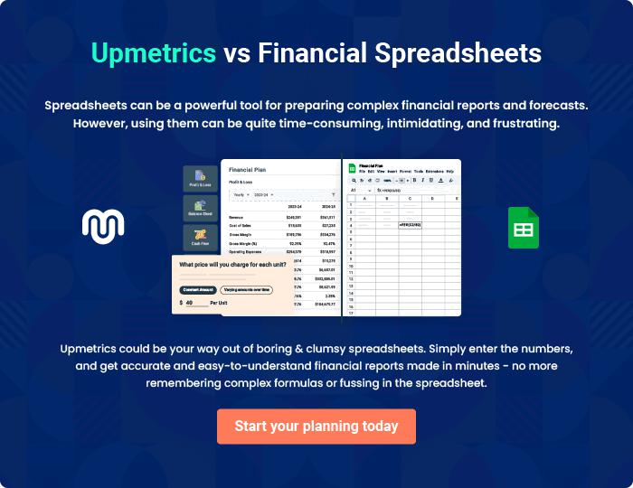

Beauty Supply Store | Business Plan [YEAR] | 43/44


Create a winning business plan that gets you funded

Creating a stunning and investment-ready plan requires no writing, graphic designing, or financial planning expertise.

Upmetrics has all the features required to help you create a comprehensive business plan—from start to finish. Make no mistakes, it’s the modern way of planning to structure ideas, make plans, and create stunning pitch decks to awe investors.

Pitch decks that impress investors

Create pitch decks that provide a visual representation of your business, engage investors, and make them want to invest in your business idea.

Interactive plans in no time

Import business plan sections like—SWOT analysis, comparison tables, and others to create an interactive business plan. No designing skills are required.

Stunning cover page designs

With Upmetrics, you have the liberty to choose from multiple stunning cover page designs. Choose a creative design and make your plan stand out.

Online sharing made simple

Upmetrics makes online sharing quick and easier for users. Easily share your business plans with a link while tracking reader activity.

500+ sample business plans

Simply import a template from our library of sample plans into the editor and start customizing it to make it yours. It takes only a few clicks to get started.

Collaborate with team in real-time

Invite team members, initiate conversations, discuss ideas & strategies, share feedback, and work on a business plan in real-time.

