
 B4Bakers

ADDRESS CONTACT

10200 Bolsa Ave, Westminster, CA, 92683 (650) 359-3153

http://www.example.com info@example.com
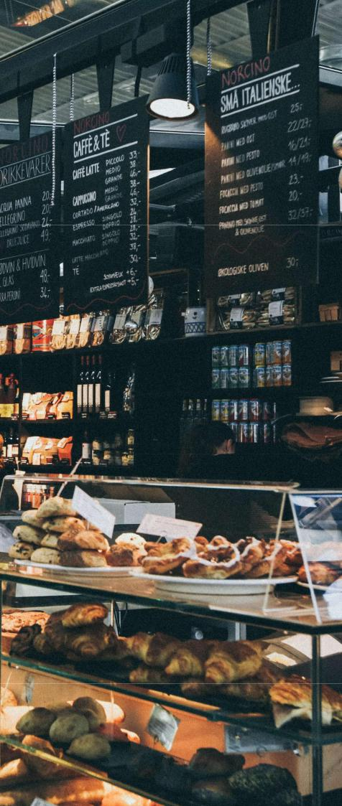

Business Plan

[YEAR]

Prepared By

John Doe


Enhancing Life around great food

Information provided in this business plan is unique to this business and confidential; therefore, anyone reading this plan agrees not to disclose any of the information in this business plan without prior written permission of the Company

Table of Contents

Executive Summary | 5
Business Overview | 6
Products & Services | 6
Customer Focus | 6
Operations Plan | 7
Management Team | 7
John Doe | 7
Keys To Success | 7
Financial Highlights | 8
EBITDA, Net Income | 8

Company Overview | 9
About B4Bakers | 10
B4Bakers’s History | 10
Products & Services | 10
Store Design | 12

Industry Analysis | 13
Industry Statistics & Trends | 14
Customer Analysis
Customer Analysis | 16
Customers | 17
Customer Segments | 18
Competitive Analysis
Competitive Analysis | 19
Direct & Indirect Competitors | 20
Joe’s Supermarket | 20
Old Time Bakery | 20
Freddy’s Deli | 20
Competitive Pricing | 21
Competitive Advantage | 21

B4Bakers | Business Plan [YEAR] 2/40

Marketing Plan | 22
The B4Bakers Brand | 23
Promotions Strategy | 23
Direct Mail | 23
Public Relations | 23
Advertising | 24
Sampling | 24
Ongoing Customer Communications | 24
Pre-Opening Events | 24
Pricing Strategy | 25

Operations Plan | 26
Functional Roles | 27
Administrative Functions | 27
Kitchen Functions | 27
Store/Retail Functions | 27
Milestones | 28

Management Team | 29
Management Team Members | 30
John Doe | 30
Hiring Plan | 30

Financial Plan | 31
Revenue and Cost Drivers | 32
Capital Requirements and Use of Funds | 32
Key Assumptions | 32
Financial Projections | 33
Projected Balance Sheet | 36
Cash Flow | 37

B4Bakers | Business Plan [YEAR] 3/40

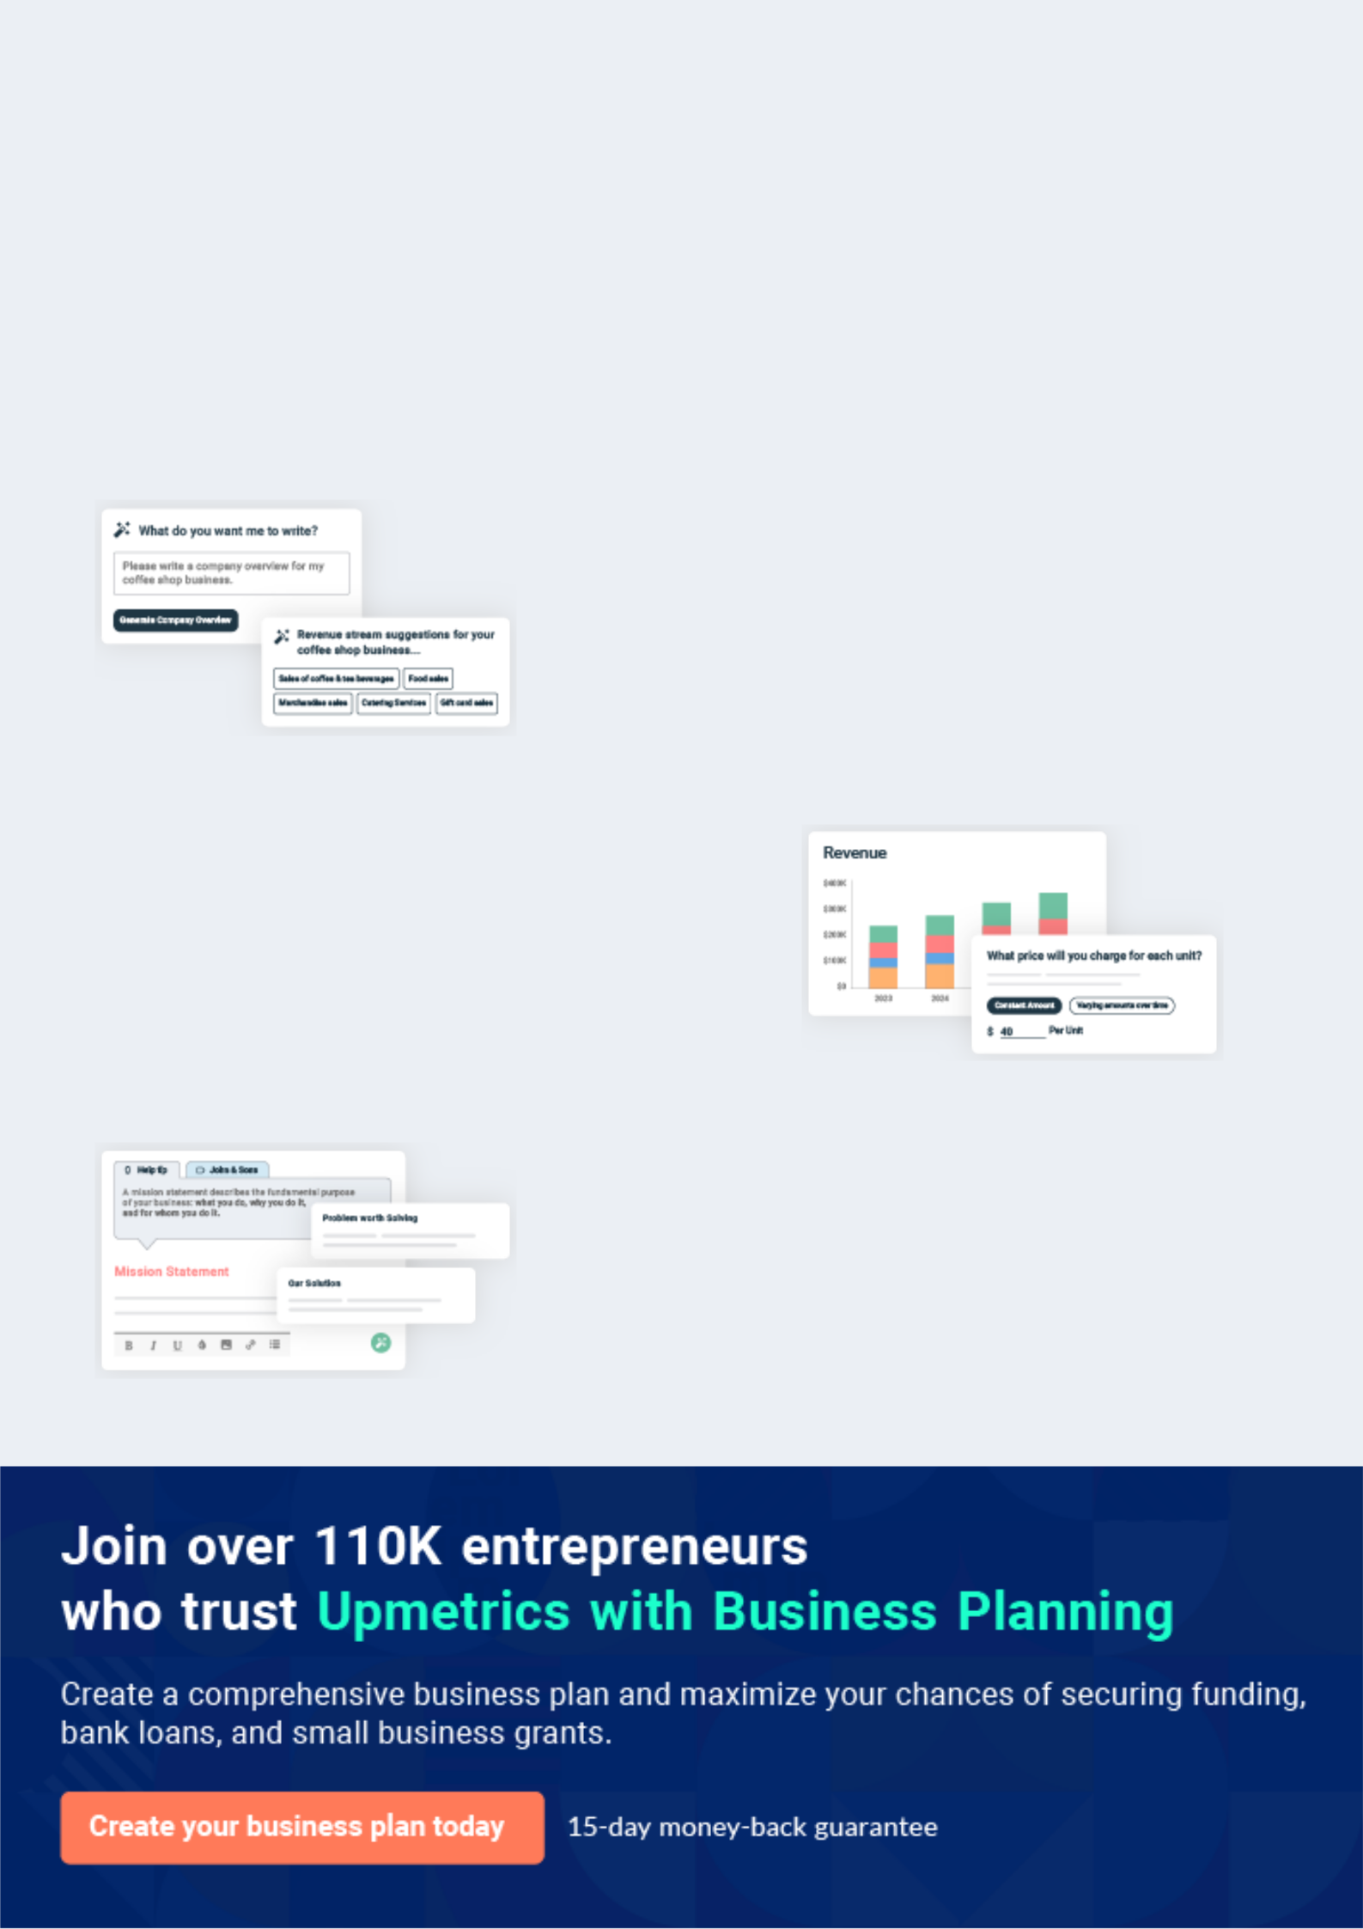
Business planning that’s simpler and faster than you think

Creating a business plan using Upmetrics to start and grow a business is literally the easiest thing in the World. Simply read the instructions and fill in the blanks. It’s as simple as that.

❛ | Upmetrics has everything you need to create a | ❜
❛ | comprehensive business plan. | ❜

AI-powered Upmetrics Assistant

AI-powered insights to streamline your plan

Not sure where to start? Upmetrics’ AI Assistant will automatically generate ideas for each section of your plan and offer improved versions of your writing, adjusting for tone, voice, and grammar or spelling errors.

Financial Forecasting Tool

All the financials are calculated for you

Forget the complex formulas and clumsy spreadsheets — with automatic financials and drag-and-drop forecasting, you can finish your plan faster and be confident that your numbers are accurate.

Business Plan Builder

Guides you like a business mentor

Upmetrics’ step-by-step instructions, prompts, and the library of 400+ sample business plans will guide you through each section of your plan as a business mentor.

1.


Executive Summary

Business Overview

Products & Services

Customer Focus

Operations Plan

Management Team

Keys To Success

Financial Highlights

B4Bakers | Business Plan [YEAR] 5/40

Business Overview

 B4Bakers


B4Bakers is a bakery retail establishment located in southwest Saskatchewan. It expects to catch the interest of a regular loyal customer base with its broad variety of bakery and pastry products. The business also offers cake decorating classes from Wilton, the leading food
To unlock help try Upmetrics! 

Start writing here..

Products & Services

 B4Bakers

B4Bakers offers a broad range of bakery products, all from high-quality ingredients. The bakery provides freshly prepared bakery and pastry products at all times during business operations. Six to eight moderate batches of bakery and pastry products are prepared during the day to
To unlock help try Upmetrics! 

Start writing here..

Customer Focus

 B4Bakers

B4Bakers will primarily serve the residents within a 5-mile radius of our store. The demographics of these customers are as follows:
To unlock help try Upmetrics! 

Start writing here..

B4Bakers | Business Plan [YEAR] 6/40

Operations Plan
To unlock help try Upmetrics!

 B4Bakers

The Bakery will be located in Saskatchewan. The bakery will be situated on a family farm. The family wants to supplement the farm income by setting up this business. The initial costs for establishing The bakery are shown in Table 1.



Start writing here..

Management Team


John Doe

Owner - john.doe@example.com

B4Bakers is led by John Doe who has been in the bakery business for 20 years. While Mr. Doe has never run a bakery himself, he has taught baking classes at the local high school for 20 years and has worked part-time at bakeshops throughout the region over the past 10 years. As such Mr. Doe has an in-depth knowledge of the bakery business including the operations side (e.g., running day-to-day operations) and the business management side (e.g., staffing, marketing, etc.).

Keys To Success

 B4Bakers

B4Bakers is uniquely qualified to succeed due to the following reasons:

• There is currently no upscale bakery in the community we are entering. In addition, we
To unlock help try Upmetrics! 

Start writing here..

B4Bakers | Business Plan [YEAR] 7/40

Financial Highlights

 B4Bakers

B4Bakers is currently seeking $370,000 to launch. Specifically, these funds will be used as follows:
To unlock help try Upmetrics! 

Start writing here..

EBITDA, Net Income
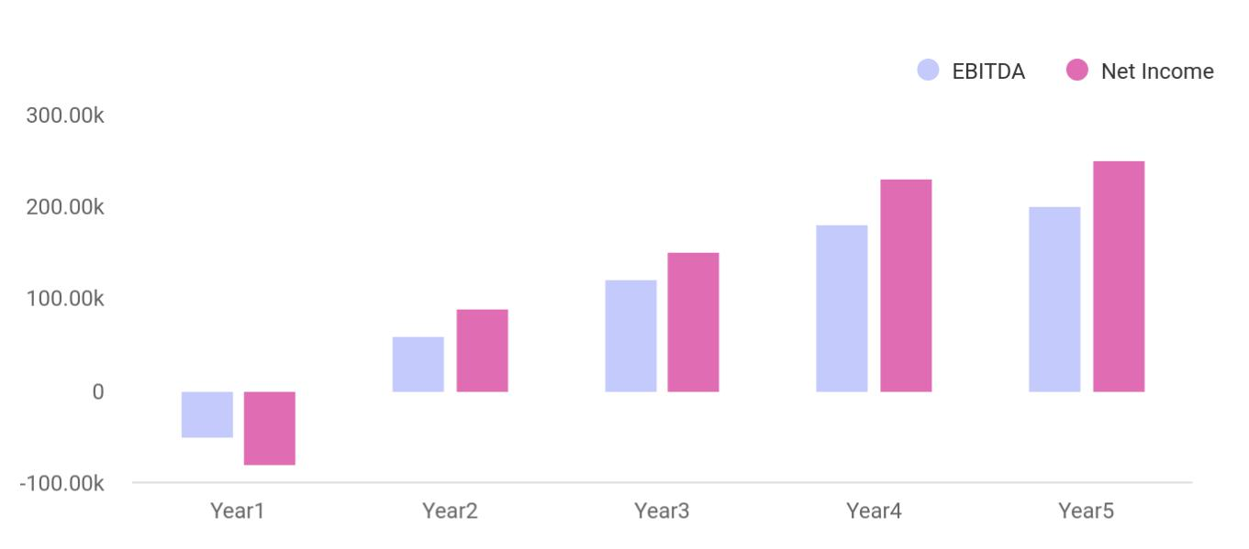

B4Bakers | Business Plan [YEAR] 8/40

2.

Company Overview

About B4Bakers

B4Bakers’s History

Products & Services

Store Design

B4Bakers | Business Plan [YEAR] 9/40

About B4Bakers
To unlock help try Upmetrics!

 B4Bakers

B4Bakers, located in Saskatchewan is a new, upscale bakery focusing on providing organic, healthy, and/or premium baked goods. We also sell breakfast and lunch sandwiches, salads and soups, and serve a variety of coffees and teas.



Start writing here..

B4Bakers’s History

 B4Bakers

Upon returning from Fort Lauderdale, surveying the local customer base, and finding a potential retail location, Mr. doe incorporated B4Bakers as an S-Corporation in Jan 2012.
To unlock help try Upmetrics! 

Start writing here..

Products & Services

 B4Bakers

Below is B4Bakers’s initial menu. All items will be 100% natural and organic. As you can see all items are classified under the following eight main categories:
To unlock help try Upmetrics! 

Start writing here..

B4Bakers | Business Plan [YEAR] 10/40



Soups Breakfast Sandwiches Croissants and Danish


Muffins and Scones Sandwiches and Wraps Salads
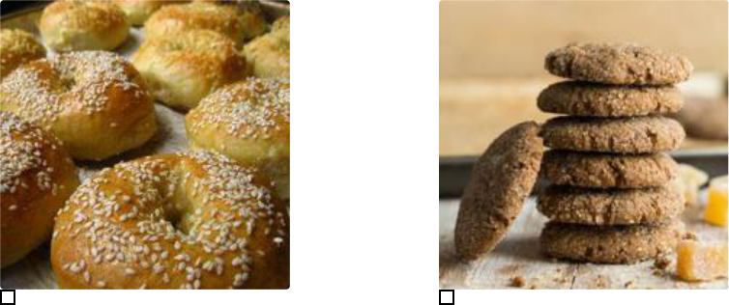

Bagels Cookies and Desserts

B4Bakers | Business Plan [YEAR] 11/40

Store Design

 B4Bakers


To unlock help try Upmetrics! 

Start writing here..

B4Bakers | Business Plan [YEAR] 12/40

3.

Industry Analysis

Industry Statistics & Trends

B4Bakers | Business Plan [YEAR] 13/40

 B4Bakers

B4Bakers directly or indirectly competes with all food service providers nearby our store that offer similar products, mainly breakfast foods, bread, desserts, sandwiches, and salads. The
competition will come from supermarkets, restaurants, coffee shops, bakeries, and other retail
To unlock help try Upmetrics! 

Start writing here..

Industry Statistics & Trends

 B4Bakers

The following industry statistics bode well for B4Bakers.

According to the recent report entitled, “Retail Bakeries Industry in the Canada” by Supplier
To unlock help try Upmetrics! 

Start writing here..

B4Bakers | Business Plan [YEAR] 14/40

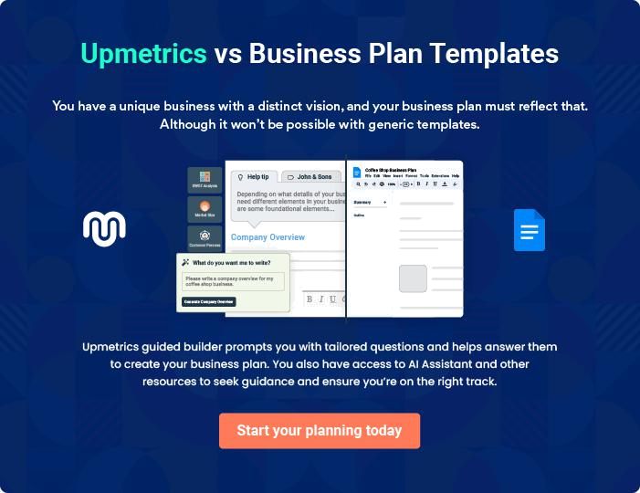

B4Bakers | Business Plan [YEAR] | 15/40

4.

Customer Analysis

Customers

Customer Segments

B4Bakers | Business Plan [YEAR] 16/40

 B4Bakers

B4Bakers will serve the residents of Saskatchewan and the immediately surrounding areas as well as those who work in Saskatchewan.
To unlock help try Upmetrics! 

Start writing here..

Customers



Soccer/stay-at-home moms

The town has a large population of stay-at-home moms who are active in the school and community.
These moms often meet for lunch or coffee and B4Bakers will provide a perfect place for them to congregate. (We also expect mothers to take their children to B4Bakers for after school and weekend snacks and meals.)



Morning commuters

Many local residents drive to neighboring towns or take the nearby train to work. B4Bakers is conveniently located for these individuals to pick up coffee or a breakfast sandwich in the morning or pick up a sandwich in the evening.

Local office workers

Approximately 5,000 individuals work in offices within a quarter mile of our location and we expect a fair portion of these individuals to frequent us during the morning and lunch hours.

Students

there is a middle school and a high school in the town and the high school is within one half mile. Students from these schools will be targeted to frequent B4Bakers.

B4Bakers | Business Plan [YEAR] 17/40

Customer Segments
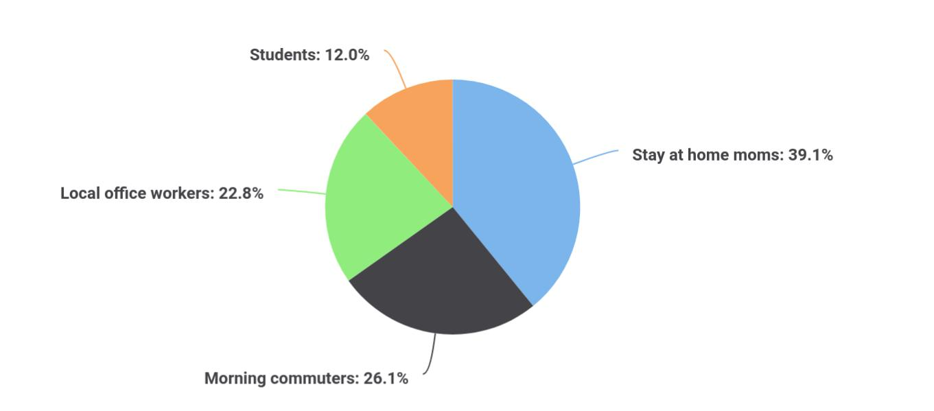

B4Bakers | Business Plan [YEAR] 18/40

5.

Competitive Analysis

Direct & Indirect Competitors

Competitive Pricing

Competitive Advantage

B4Bakers | Business Plan [YEAR] 19/40

Direct & Indirect Competitors
To unlock help try Upmetrics!

The following retailers are located within a 2-mile radius of B4Bakers, thus providing either direct or indirect competition for customers:

 B4Bakers

Joe’s Supermarket is the town’s leading grocery store and has been in business for 32 years.

Joe’s offers a wide array of all the products that you typically find in a grocery store.
To unlock help try Upmetrics! 

Joe’s Supermarket

Start writing here..

 B4Bakers

Old Time Bakery has been in business for 14 years. Old Time offers a variety of baked goods, primarily cookies, and desserts.
To unlock help try Upmetrics! 

Old Time Bakery

Start writing here..

 B4Bakers

Freddy’s Deli has located four stores to the East of us. Freddy’s has been in business for the past 21 years and enjoys great success, primarily due to its prime location (which we will also have).



Freddy’s Deli

Start writing here..

B4Bakers | Business Plan [YEAR] 20/40

Competitive Pricing

 B4Bakers


Here is the pricing of our key competitors:

To unlock help try Upmetrics! 

Start writing here..

Competitive Advantage

The B4Bakers enjoys several advantages over its competitors. These advantage include:


Location

The B4Bakers’s location is near the center of town, giving us access to commuters going and leaving the train station, local office workers, and passerby’s going to local shops. We also offer adequate parking making it easy for customers to patronize us.

100% Natural/ Organic/High-Quality Ingredients

Getting 100% Natural/ Organic baked goods, soups, sandwiches and more in the local market is challenging if not impossible. No other retailer offers direct substitutes or competition for most of our products.

Management

Our management team has years of business and marketing experience that allows us to market and serve customers in a much more sophisticated manner than our competitors.

Relationships

Having lived in the community for 25 years, The B4Bakers knows all of the local leaders, newspapers and other influencers. As such, it will be relatively easy for us to build branding and awareness of our bakery.

B4Bakers | Business Plan [YEAR] 21/40

6.

Marketing Plan

The B4Bakers Brand

Promotions Strategy

Pricing Strategy

B4Bakers | Business Plan [YEAR] 22/40

The B4Bakers Brand
To unlock help try Upmetrics!

 B4Bakers

The B4Bakers brand will focus on the Company’s unique value proposition:

• Offering organic, high-quality food items including baked goods, sandwiches, soups,
To unlock help try Upmetrics! 

Start writing here..

Promotions Strategy

B4Bakers expects its target market to be individuals working and/or living within a 5-mile radius of each of its store. The Company’s promotions strategy to reach these individuals includes:

 B4Bakers

The B4Bakers will blanket neighborhoods surrounding its locations with direct mail pieces. These pieces will provide general information on the B4Bakers, offer discounts, and/or provide other inducements for people to frequent the store.



Direct Mail

Start writing here..

 B4Bakers

We will contact all local and area newspapers and television stations to tell them about the opening and unique value proposition of B4Bakers.
To unlock help try Upmetrics! 

Public Relations

Start writing here..

B4Bakers | Business Plan [YEAR] 23/40

 B4Bakers
To unlock help try Upmetrics!

The B4Bakers will initially advertise in local newspapers and sponsor community events in order to gain awareness.
To unlock help try Upmetrics! 

Advertising

Start writing here..

 B4Bakers

B4Bakers employees will initially give free food samples to passerby’s to enable them to taste the quality of our products and learn about us.
To unlock help try Upmetrics! 

Sampling

Start writing here..

 B4Bakers

B4Bakers will maintain a website and publish a monthly email newsletter to tell customers about new events, products, and more.
To unlock help try Upmetrics! 

Ongoing Customer Communications

Start writing here..

 B4Bakers

Before opening the store, The B4Bakers will organize pre-opening events designed for prospective customers, local merchants, and press contacts. These events will create buzz and awareness for The B4Bakers in the area.



Pre-Opening Events

Start writing here..

B4Bakers | Business Plan [YEAR] 24/40

Pricing Strategy

 B4Bakers

The B4Bakers’ pricing will be moderate so customers feel they receive great value when patronizing the stores.
To unlock help try Upmetrics! 

Start writing here..

B4Bakers | Business Plan [YEAR] 25/40

7.

Operations Plan

Functional Roles

Milestones

B4Bakers | Business Plan [YEAR] 26/40

Functional Roles
To unlock help try Upmetrics!
To unlock help try Upmetrics!
To unlock help try Upmetrics!

In order to execute on the B4Bakers’s business model, the Company needs to perform many functions including the following:

 B4Bakers

- General & Administrative functions including legal, marketing, bookkeeping, etc.

- Sourcing and storing ingredients

• Hiring and training staff 

Administrative Functions

Start writing here..

 B4Bakers

- Food preparation

- Ongoing menu creation and modification

Kitchen Functions

Start writing here..

 B4Bakers

- Order taking and fulfillment (for take-out and dine-in)

- Customer service

- Janitor/maintenance personnel to keep the store clean

Store/Retail Functions

Start writing here..





B4Bakers | Business Plan [YEAR] 27/40

Milestones

 B4Bakers

The B4Bakers expects to achieve the following milestones in the following 5 months:

• Level of Priority Time to Implementation
To unlock help try Upmetrics! 

Start writing here..
B4Bakers | Business Plan [YEAR] 28/40

8.

Management Team

Management Team Members

Hiring Plan

B4Bakers | Business Plan [YEAR] 29/40

Management Team Members

John Doe

Owner - john.doe@example.com

The B4Bakers is led by John Doe who has been in the bakery business for 20 years.

While [Founder] has never run a bakery himself, he has taught baking classes at the local high school for 20 years. Two courses that he taught included:

1. How To Bake Wedding Cakes

This course was designed to give students an overall understanding of baking wedding cakes. The student was taught to bake and decorate traditional and contemporary wedding cakes, and cakes for special occasions.

2. How To Bake Bread

This course was designed to give students an overall understanding of baking bread, and included four units teaching students to bake the following types of bread: Levain, baguettes, pain bordelaise; baguettes, bagels, flatbread; brioche, croissants, and challah; pizza, focaccia, ciabatta.

Mr. Doe has also worked part-time at bakeshops throughout the region over the past 10 years. Specifically, he has worked for Giana’s Bakery where he has prepared all wedding cakes. He has also trained several others in the art of creating commercial cakes and pastries.

Mr. Doe graduated from the University of ABC where he majored in Communications.

Hiring Plan

 B4Bakers

The B4Bakers will serve as the store manager. In order to launch our store, we need to hire the following personnel:
To unlock help try Upmetrics! 

Start writing here..

B4Bakers | Business Plan [YEAR] 30/40

9.

Financial Plan

Revenue and Cost Drivers

Capital Requirements and Use of Funds

Key Assumptions

Financial Projections

Projected Balance Sheet

Cash Flow

B4Bakers | Business Plan [YEAR] 31/40

Revenue and Cost Drivers

 B4Bakers

The B4Bakers’s revenues will come from the sale of natural and organic food products to its customers.
To unlock help try Upmetrics! 

Start writing here..

Capital Requirements and Use of Funds

 B4Bakers

The B4Bakers is seeking total funding of $370,000 to launch its store. The capital will be used for funding capital expenditures, manpower costs, marketing expenses, and working capital.
To unlock help try Upmetrics! 

Start writing here..

Key Assumptions

Number of customers | Per location | Number of locations
per day | Per location | started
FY 1 | 100 | FY 1 | 1
FY 2 | 105 | FY 2 | 0
FY 3 | 110 | FY 3 | 0
FY 4 | 116 | FY 4 | 0
FY 5 | 122 | FY 5 | 0
Average order price | $14.00 | Cost of goods sold
 |  | FY 1 | 23.00%
The annual increase in | 5.00% | FY 2 | 22.00%
order price | 5.00% | FY 2 | 22.00%

B4Bakers | Business Plan [YEAR] 32/40

Number of customers | Per location | Number of locations
per day | Per location | started
 |  | FY 3 | 20.00%
Annual Lease ( per location) | $60,000 | FY 4 | 19.00%
Yearly Lease Increase % | 2.50% | FY 5 | 18.00%

Financial Projections

 | 2024 | 2025 | 2026
Revenue | $700,197.94 | $1,887,865.04 | $3,480,414.46
Bread Sales | $72,000 | $75,600 | $79,380
Unit Sales | 24,000 | 25,200 | 26,460
Unit Price | $3 | $3 | $3
Custom Cake Orders | $37,562.50 | $60,139 | $96,290.50
Unit Sales | 751 | 1,203 | 1,926
Unit Price | $50 | $50 | $50
Coffee and Beverage Sales | $590,635.44 | $1,752,126.04 | $3,304,743.96
Users | 20,227 | 46,767 | 82,570
Recurring Charges | $4 | $4 | $4
Cost Of Sales | $17,410.46 | $21,287.05 | $27,341.51
General Costs | $17,410.46 | $21,287.05 | $27,341.51
Ingredient Costs | $9,600 | $9,792 | $9,987.84
Flour Purchase | $6,000 | $6,120 | $6,242.40
Sugar and Sweeteners | $3,600 | $3,672 | $3,745.44
Purchase | $3,600 | $3,672 | $3,745.44
Baking Supplies and | $7,810.46 | $11,495.05 | $17,353.67
Utensils | $7,810.46 | $11,495.05 | $17,353.67
Baking Pans and Trays | $1,800 | $1,872 | $1,946.88

B4Bakers | Business Plan [YEAR] 33/40

 | 2024 | 2025 | 2026
Packaging Materials | $6,010.46 | $9,623.05 | $15,406.79
Revenue Specific Costs | $0 | $0 | $0
Personnel Costs (Direct | $0 | $0 | $0
Labor) | $0 | $0 | $0

Gross Margin | $682,787.48 | $1,866,577.99 | $3,453,072.95
Gross Margin (%) | 97.51% | 98.87% | 99.21%

Operating Expense | $645,552 | $662,735.04 | $680,520.83
Payroll Expense (Indirect | $587,952 | $602,447.04 | $617,314.08
Labor) | $587,952 | $602,447.04 | $617,314.08
Baking Staff | $208,800 | $215,064 | $221,515.92
Head Baker | $57,600 | $59,328 | $61,107.84
Pastry Chefs | $151,200 | $155,736 | $160,408.08
Sales and Front-End | $229,392 | $233,979.84 | $238,659.36
Sales Associates | $158,592 | $161,763.84 | $164,999.04
Cashiers | $70,800 | $72,216 | $73,660.32
Administrative Staff | $149,760 | $153,403.20 | $157,138.80
Manager | $64,800 | $66,744 | $68,746.32
Administrative Assistants | $84,960 | $86,659.20 | $88,392.48
General Expense | $57,600 | $60,288 | $63,206.75
Facility Costs | $36,000 | $37,140 | $38,316.60
Rent | $30,000 | $30,900 | $31,827
Utilities | $6,000 | $6,240 | $6,489.60
Equipment Maintenance | $4,800 | $5,016 | $5,242.08
Oven and Mixer | $3,600 | $3,780 | $3,969
Maintenance | $3,600 | $3,780 | $3,969

B4Bakers | Business Plan [YEAR] 34/40

 | 2024 | 2025 | 2026
Utensil Replacement | $1,200 | $1,236 | $1,273.08
Marketing and Advertising | $16,800 | $18,132 | $19,648.07
Local Advertising | $9,600 | $10,500 | $11,113.20
Social Media Marketing | $7,200 | $7,632 | $8,534.87
Bad Debt | $0 | $0 | $0
Amortization of Current | $0 | $0 | $0
Assets | $0 | $0 | $0

EBITDA

Additional Expense

Long Term Depreciation

Gain or loss from Sale of Assets

EBIT

Interest Expense

EBT

Income Tax Expense / Benefit

$37,235.48 $1,203,842.95 $2,772,552.12

$15,728.39 | $14,796.53 | $13,817.01
$11,142 | $11,142 | $11,142
$0 | $0 | $0
$26,093.48 | $1,192,700.95 | $2,761,410.12
$4,586.36 | $3,654.52 | $2,675
$21,507.09 | $1,189,046.42 | $2,758,735.11
$0 | $0 | $0

Total Expense | $678,690.85 | $698,818.62 | $721,679.35
Net Income | $21,507.09 | $1,189,046.42 | $2,758,735.11
Net Income (%) | 3.07% | 62.98% | 79.26%

Retained Earning Opening | $0 | $7,507.09 | $1,192,553.51
Owner's Distribution | $14,000 | $4,000 | $4,000

B4Bakers | Business Plan [YEAR] 35/40

 | 2024 | 2025 | 2026
Retained Earning Closing | $7,507.09 | $1,192,553.51 | $3,947,288.62

Projected Balance Sheet

 | 2024 | 2025 | 2026
Assets | $139,293.48 | $1,305,194.43 | $4,039,804.55
Current Assets | $45,435.48 | $1,222,478.43 | $3,968,230.55
Cash | $45,435.48 | $1,222,478.43 | $3,968,230.55
Accounts Receivable | $0 | $0 | $0
Inventory | $0 | $0 | $0
Other Current Assets | $0 | $0 | $0
Long Term Assets | $93,858 | $82,716 | $71,574
Gross Long Term Assets | $105,000 | $105,000 | $105,000
Accumulated Depreciation | ($11,142) | ($22,284) | ($33,426)
Liabilities & Equity | $139,293.45 | $1,305,194.40 | $4,039,804.51
Liabilities | $81,786.36 | $62,640.89 | $42,515.89
Current Liabilities | $19,145.48 | $20,125 | $0
Accounts Payable | $0 | $0 | $0
Income Tax Payable | $0 | $0 | $0
Sales Tax Payable | $0 | $0 | $0
Short Term Debt | $19,145.48 | $20,125 | $0
Long Term Liabilities | $62,640.88 | $42,515.89 | $42,515.89
Long Term Debt | $62,640.88 | $42,515.89 | $42,515.89
Equity | $57,507.09 | $1,242,553.51 | $3,997,288.62
Paid-in Capital | $0 | $0 | $0
B4Bakers | Business Plan [YEAR] |  |  | 36/40
 | 2024 | 2025 | 2026
Common Stock | $0 | $0 | $0
Preferred Stock | $0 | $0 | $0
Owner's Contribution | $50,000 | $50,000 | $50,000
Retained Earnings | $7,507.09 | $1,192,553.51 | $3,947,288.62
Check | $0 | $0 | $0
Cash Flow
 | 2024 | 2025 | 2026
Cash Received | $700,197.94 | $1,887,865.04 | $3,480,414.46
Cash Paid | $667,548.85 | $687,676.62 | $710,537.35
COS & General Expenses | $75,010.46 | $81,575.05 | $90,548.26
Salary & Wages | $587,952 | $602,447.04 | $617,314.08
Interest | $4,586.36 | $3,654.52 | $2,675
Sales Tax | $0 | $0 | $0
Income Tax | $0 | $0 | $0
Net Cash From | $32,649.09 | $1,200,188.42 | $2,769,877.11
Operations | $32,649.09 | $1,200,188.42 | $2,769,877.11
Assets Sell | $0 | $0 | $0
Assets Purchase | $105,000 | $0 | $0
Net Cash From | ($105,000) | $0 | $0
Investments | ($105,000) | $0 | $0
Amount Received | $150,000 | $0 | $0
Loan Received | $100,000 | $0 | $0

B4Bakers | Business Plan [YEAR] 37/40

 | 2024 | 2025 | 2026
Common Stock | $0 | $0 | $0
Preferred Stock | $0 | $0 | $0
Owner's Contribution | $50,000 | $0 | $0
Amount Paid | $32,213.61 | $23,145.47 | $24,124.99
Loan Capital | $18,213.64 | $19,145.48 | $20,125
Dividends & Distributions | $14,000 | $4,000 | $4,000
Net Cash From | $117,786.39 | ($23,145.47) | ($24,124.99)
Financing | $117,786.39 | ($23,145.47) | ($24,124.99)

Summary

Starting Cash | $0 | $45,435.48 | $1,222,478.43
Cash In | $850,197.94 | $1,887,865.04 | $3,480,414.46
Cash Out | $804,762.46 | $710,822.09 | $734,662.34
Change in Cash | $45,435.48 | $1,177,042.95 | $2,745,752.12
Ending Cash | $45,435.48 | $1,222,478.43 | $3,968,230.55

B4Bakers | Business Plan [YEAR] 38/40

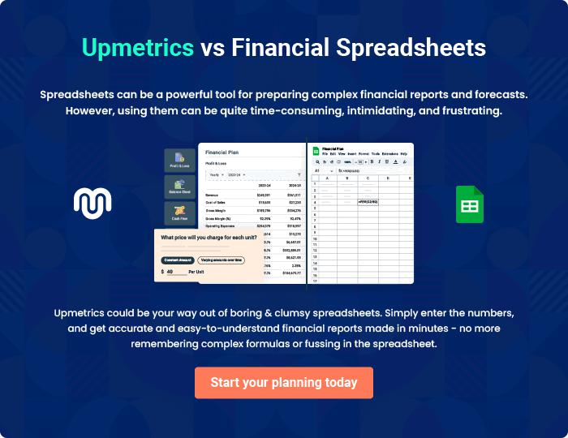

B4Bakers | Business Plan [YEAR] | 39/40

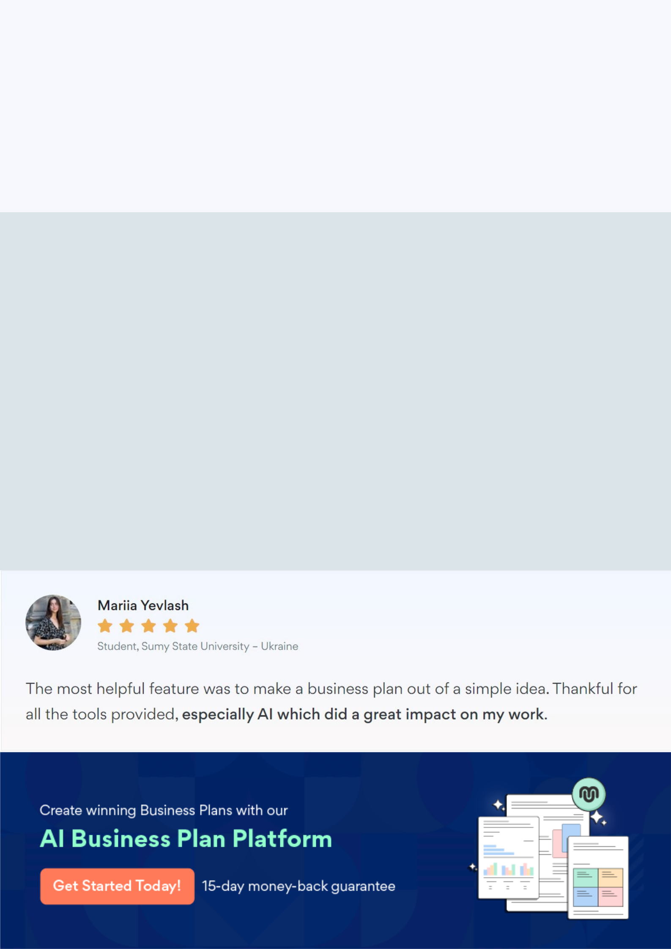
Create a winning business plan that gets you funded

Creating a stunning and investment-ready plan requires no writing, graphic designing, or financial planning expertise.

Upmetrics has all the features required to help you create a comprehensive business plan—from start to finish. Make no mistakes, it’s the modern way of planning to structure ideas, make plans, and create stunning pitch decks to awe investors.

Pitch decks that impress investors

Create pitch decks that provide a visual representation of your business, engage investors, and make them want to invest in your business idea.

Interactive plans in no time

Import business plan sections like—SWOT analysis, comparison tables, and others to create an interactive business plan. No designing skills are required.

Stunning cover page designs

With Upmetrics, you have the liberty to choose from multiple stunning cover page designs. Choose a creative design and make your plan stand out.

Online sharing made simple

Upmetrics makes online sharing quick and easier for users. Easily share your business plans with a link while tracking reader activity.

500+ sample business plans

Simply import a template from our library of sample plans into the editor and start customizing it to make it yours. It takes only a few clicks to get started.

Collaborate with team in real-time

Invite team members, initiate conversations, discuss ideas & strategies, share feedback, and work on a business plan in real-time.

