

Art Gallery

Bringing Joy of Creativity

Business

Plan

[YEAR]

John Doe

10200 Bolsa Ave, Westminster, CA, 92683

- 359-3153 info@example.com http://www.example.com

CONFIDENTIAL

Table of Contents

Executive Summary | 5
The Financing | 6
Mission Statement | 6
Management Team | 7
Sales Forecasts | 7
3 Year profit forecast | 8
Expansion Plan | 8

Company Overview | 9
Ownership | 10
Purpose of starting A Business | 10
How the Business will be started | 10
Startup cost | 11
Funding Required | 11
Management Equity | 13
Exit Strategy | 13

Products and Services | 14
Auction Services | 15
Exhibition Services | 15
Cultural Handicrafts | 16
Art Shop | 16

Market Analysis | 18
Market Trends | 19
Industry Analysis | 19
Marketing Segmentation | 19
Marketing share | 20
Residential Community | 20
Government Institutions | 21
Corporate Sector | 21

Art Gallery | Business Plan [YEAR] 2/40

Business Target | 22
Product Pricing | 22

Sales Strategy | 23
Competitive Analysis | 24
Sales Strategy | 24
Sales Forecast | 24
Sales Forecast for 3 Years | 25

Organisational And Personnel Plan | 27
Corporate Organization | 28
Company Staff | 28
Average Salary of Employees | 29

Financial Plan | 30
Important Assumptions | 31
Brake-even Analysis | 31
Projected Profit and Loss | 31
Projected Cash Flow | 34
Projected Balance Sheet | 36
Business Ratios | 37

Art Gallery | Business Plan [YEAR] 3/40

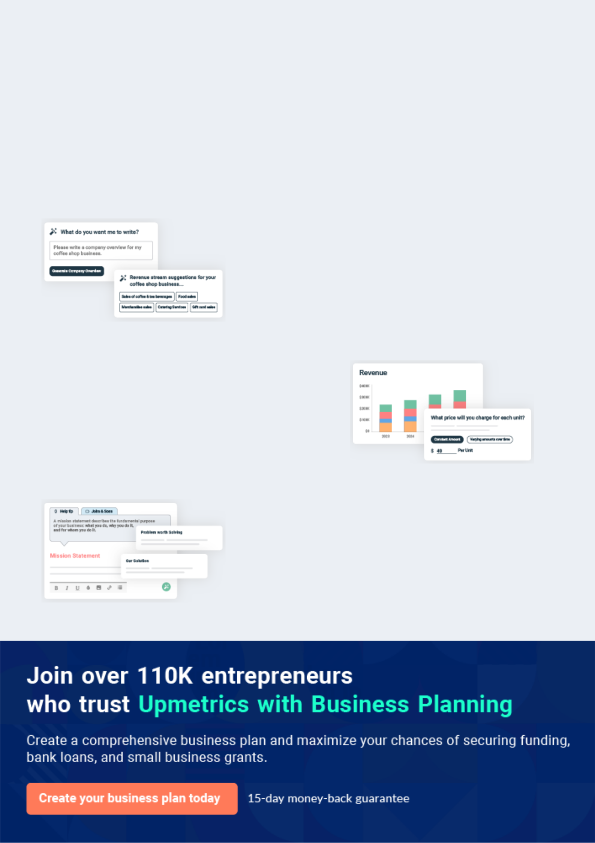
Business planning that’s simpler and faster than you think

Creating a business plan using Upmetrics to start and grow a business is literally the easiest thing in the World. Simply read the instructions and fill in the blanks. It’s as simple as that.

❛ | Upmetrics has everything you need to create a | ❜
❛ | comprehensive business plan. | ❜

AI-powered Upmetrics Assistant

AI-powered insights to streamline your plan

Not sure where to start? Upmetrics’ AI Assistant will automatically generate ideas for each section of your plan and offer improved versions of your writing, adjusting for tone, voice, and grammar or spelling errors.

Financial Forecasting Tool

All the financials are calculated for you

Forget the complex formulas and clumsy spreadsheets — with automatic financials and drag-and-drop forecasting, you can finish your plan faster and be confident that your numbers are accurate.

Business Plan Builder

Guides you like a business mentor

Upmetrics’ step-by-step instructions, prompts, and the library of 400+ sample business plans will guide you through each section of your plan as a business mentor.

1.


Executive Summary

The Financing

Mission Statement

Management Team

Sales Forecasts

Expansion Plan

Art Gallery | Business Plan [YEAR] 5/40

Before you think about how to start an Art Gallery service, you must create a detailed Art Gallery business plan. It will not only guide you in the initial phases of your startup but will also help you later on.
To unlock help try Upmetrics!
To unlock help try Upmetrics!

 Ex :: Art Valley




The purpose of this free business plan is to raise $100,000 for the development of an art gallery while showcasing the expected financials and operations over the next three years. The Art Valley, Inc. (“the Company”) is a New York-based corporation that will provide sales of art from
To unlock help try Upmetrics! 

Start writing here..

The Financing

 Ex :: Art Valley

Mr. Doe is seeking to raise $100,000 from a bank loan. The interest rate and loan agreement are to be further discussed during negotiation. This free business plan assumes that the business will receive a 10-year loan with a 9% fixed interest rate.



Start writing here..

Mission Statement

 Ex :: Art Valley

To provide a platform for new and established artists to promote sales of their art, while concurrently providing the business with a steady stream of revenues and profits which will allow the business to expand to a nationwide level of the next three to five years.
To unlock help try Upmetrics! 

Start writing here..

Art Gallery | Business Plan [YEAR] 6/40

Management Team
To unlock help try Upmetrics!

 Ex :: Art Valley

The Company was founded by John Doe. Mr. Doe has more than 10 years of experience in the art brokering industry. Through his expertise, he will be able to bring the operations of the business to profitability within its first year of operations.



Start writing here..

Sales Forecasts

 Ex :: Art Valley

Mr. Doe expects a strong rate of growth at the start of operations. Below are the expected financials over the next three years.
To unlock help try Upmetrics! 

Start writing here..

Art Gallery | Business Plan [YEAR] 7/40

3 Year profit forecast
To unlock help try Upmetrics!
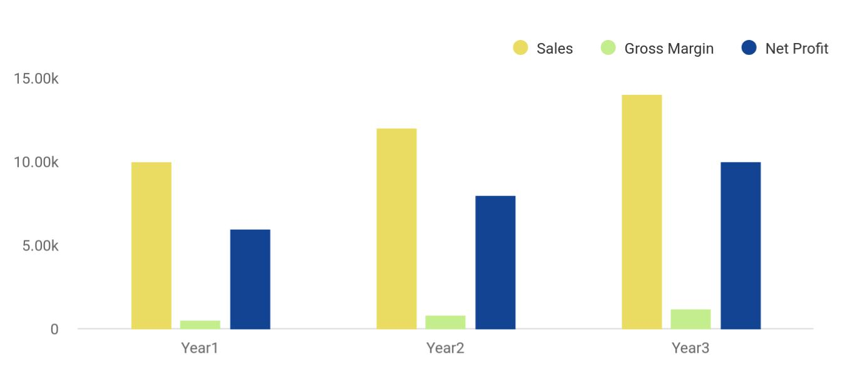

Financial Year | Sales | Gross Margin | Net Profit
Year1 | 10,000 | 500 | 6,000
Year2 | 12,000 | 800 | 8,000
Year3 | 14,000 | 1,200 | 10,000

Expansion Plan

 Ex :: Art Valley

The Founder expects that the business will aggressively expand during the first three years of operation. Mr. Doe intends to implement marketing campaigns that will effectively target individuals and art collectors within the target market.



Start writing here..

Art Gallery | Business Plan [YEAR] 8/40

2.

Company Overview

Ownership

Purpose of starting A Business

How the Business will be started

Funding Required

Management Equity

Exit Strategy

Art Gallery | Business Plan [YEAR] 9/40

Ownership

 Ex :: Art Valley

Art Valley, Inc. The Company is registered as a corporation in the State of New York. It is owned by John Doe, a renowned American artist, entrepreneur, and art collector. John has numerous ancient and precious artworks in his possession, making him one of the richest artists in the
To unlock help try Upmetrics! 

Start writing here..

Purpose of starting A Business

 Ex :: Art Valley

John had been painting his entire life. He left his studies after completing high-school to pursue his passion for art. Within the next 20 years, he had made himself a name in art but he came to the limelight in 2004 when his famous painting ‘The Weeping Laugh’ was sold for $13 Million.
To unlock help try Upmetrics! 

Start writing here..

How the Business will be started

 Ex :: Art Valley

The art gallery will be started in an old museum at Elmwood Avenue, Buffalo, New York in Delaware Park. The museum closed a decade ago and since then the place is not being used for any purpose. That’s why a lot of changes and interior designing woodwork are required and
To unlock help try Upmetrics! 

Start writing here..

Art Gallery | Business Plan [YEAR] 10/40

Startup cost
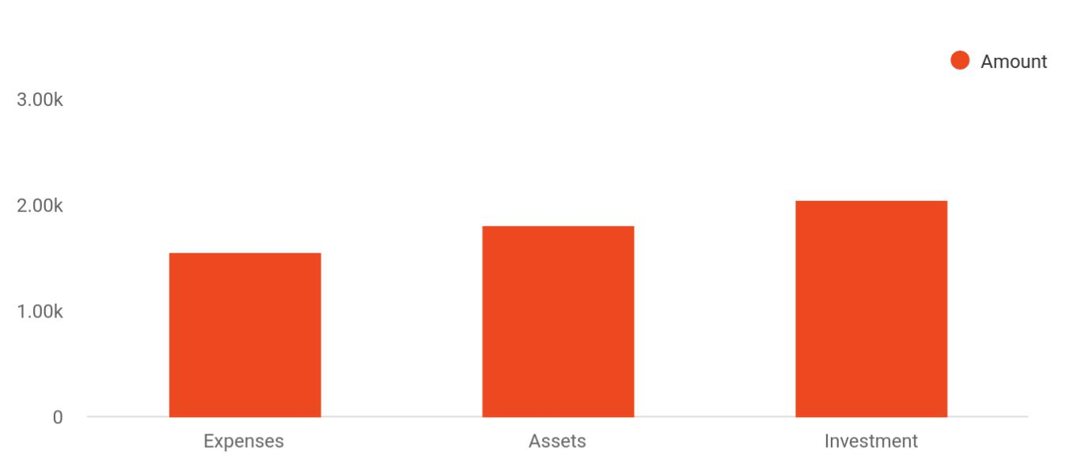

Cost distribution | Amount
Expenses | 1,550
Assets | 1,800
Investment | 2,050

Funding Required

The detailed start-up requirements, start-up funding, start-up expenses, total assets, total funding required, total liabilities, total planned investment, total capital, and liabilities as forecasted by experts, is given below:

Start-up Expenses | Amount
Legal | $75,500
Consultants | $0
Insurance | $62,750
Rent | $22,500
Research and Development | $42,750
Expended Equipment | $42,750
Signs | $1,250
TOTAL START-UP EXPENSES | $247,500
Start-up Assets | $0

Art Gallery | Business Plan [YEAR] 11/40

Start-up Expenses | Amount
Cash Required | $322,500
Start-up Inventory | $52,625
Other Current Assets | $222,500
Long-term Assets | $125,000
TOTAL ASSETS | $121,875
Total Requirements | $245,000
START-UP FUNDING | $0
START-UP FUNDING | $273,125
Start-up Expenses to Fund | $121,875
Start-up Assets to Fund | $195,000
TOTAL FUNDING REQUIRED | $0
Assets | $203,125
Non-cash Assets from Start-up | $118,750
Cash Requirements from Start-up | $0
Additional Cash Raised | $118,750
Cash Balance on Starting Date | $121,875
TOTAL ASSETS | $0
Liabilities and Capital | $0
Liabilities | $0
Current Borrowing | $0
Long-term Liabilities | $0
Accounts Payable (Outstanding Bills) | $0
Other Current Liabilities (interest-free) | $0
TOTAL LIABILITIES | $0
Capital | $0
Planned Investment | $0
Investor 1 | $312,500
Investor 2 | $0

Art Gallery | Business Plan [YEAR] 12/40

Start-up Expenses | Amount
Other | $0
Additional Investment Requirement | $0
TOTAL PLANNED INVESTMENT | $695,000
Loss at Start-up (Start-up Expenses) | $313,125
TOTAL CAPITAL | $221,875
TOTAL CAPITAL AND LIABILITIES | $221,875
Total Funding | $265,000

Management Equity

 Ex :: Art Valley

John Doe owns 100% of the Art Valley, Inc.

To unlock help try Upmetrics! 

Start writing here..

Exit Strategy

 Ex :: Art Valley

If the business is very successful, Mr. Doe may seek to sell the business to a third party for a significant earnings multiple. Most likely, the Company will hire a qualified business broker to sell the business on behalf of the Art Valley. Based on historical numbers, the business could
To unlock help try Upmetrics! 

Start writing here..

Art Gallery | Business Plan [YEAR] 13/40

3.

Products and Services

Auction Services

Exhibition Services

Cultural Handicrafts

Art Shop

Art Gallery | Business Plan [YEAR] 14/40

Before starting an Art Gallery Business, you must take many things into consideration such as you must consider what types of art services will you be providing to your customers. Deciding your services is extremely
To unlock help try Upmetrics!
To unlock help try Upmetrics! 

 Ex :: Art Valley

Art Valley will be an open art gallery where artists can put their artworks on display and tourists or visitors can view them. We will provide the following services to our esteemed customers:
To unlock help try Upmetrics! 

Start writing here..

 Ex :: Art Valley

We will primarily auction or sell the artworks of John and other artists as well as John’s prestigious collection which is expected to drive the most of our revenue. Any artist from all
over the world can put his/her artwork for display at our art gallery on the condition that a fixed
To unlock help try Upmetrics! 

Auction Services

Start writing here..

 Ex :: Art Valley

We will provide an artwork exhibition or display service to the tourists and art lovers. Anyone can enter the gallery and can enjoy the mesmerizing pieces of arts by purchasing an entry ticket throughout the weekend except the first Saturday of every month.

Exhibition Services

Start writing here..



Art Gallery | Business Plan [YEAR] 15/40

 Ex :: Art Valley

This service will be purely provided for the promotion of various cultural products in this modern-day computerized world. Art Valley does not aim to generate any revenue from it
except for the revenue needed for its self-sustainability. The prices of these crafts will be set to
To unlock help try Upmetrics! 

Cultural Handicrafts

Start writing here..

 Ex :: Art Valley

Finally, visitors can also buy various art-related products either for themselves or for their artist friends and family members.
To unlock help try Upmetrics! 

Art Shop

Start writing here..

Art Gallery | Business Plan [YEAR] 16/40

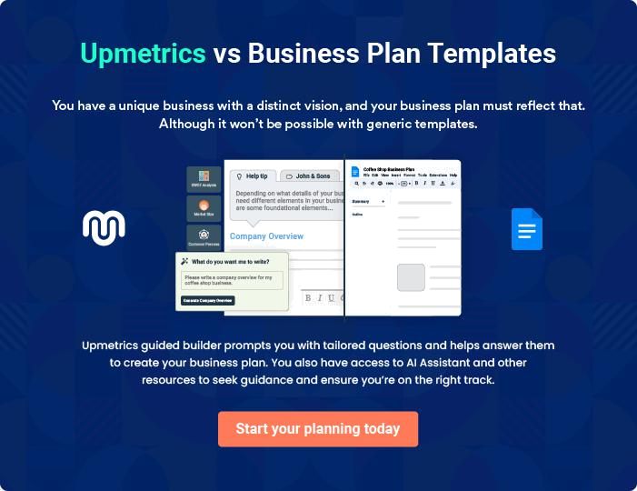

Art Gallery | Business Plan [YEAR] | 17/40

4.

Market Analysis

Market Trends

Industry Analysis

Marketing Segmentation

Business Target

Product Pricing

Art Gallery | Business Plan [YEAR] 18/40

The most important component of an effective Art Gallery business plan is its accurate marketing analysis. If you are starting on a smaller scale, you can do marketing analysis yourself by taking help from this art gallery
To unlock help try Upmetrics! 

Market Trends

 Ex :: Art Valley

The arts & culture market, in general, is a very diverse market. It is estimated that each year about 1.94 billion U.S. dollars are spent by consumers on arts and culture-related goods in the United States as of 2013. Among these contributors are the government (federal, state, and
To unlock help try Upmetrics! 

Start writing here..

Industry Analysis

 Ex :: Art Valley

The direct sale of art in the United States is a $4 billion dollar a year industry that consists of

6,300 companies that operate galleries countrywide. The industry also provides jobs to more
than 25,000 Americans and generates annual payrolls of $631 million dollars. The growth of
To unlock help try Upmetrics! 

Start writing here..

Marketing Segmentation

 Ex :: Art Valley

Our target market is the community living nearby at the 30 minutes’ drive from our gallery and the corporate sector located in the Central Business District of the city. The community consists of all types of people from varying backgrounds. As per the financial position, nearly
To unlock help try Upmetrics! 

Start writing here..

Art Gallery | Business Plan [YEAR] 19/40

Marketing share
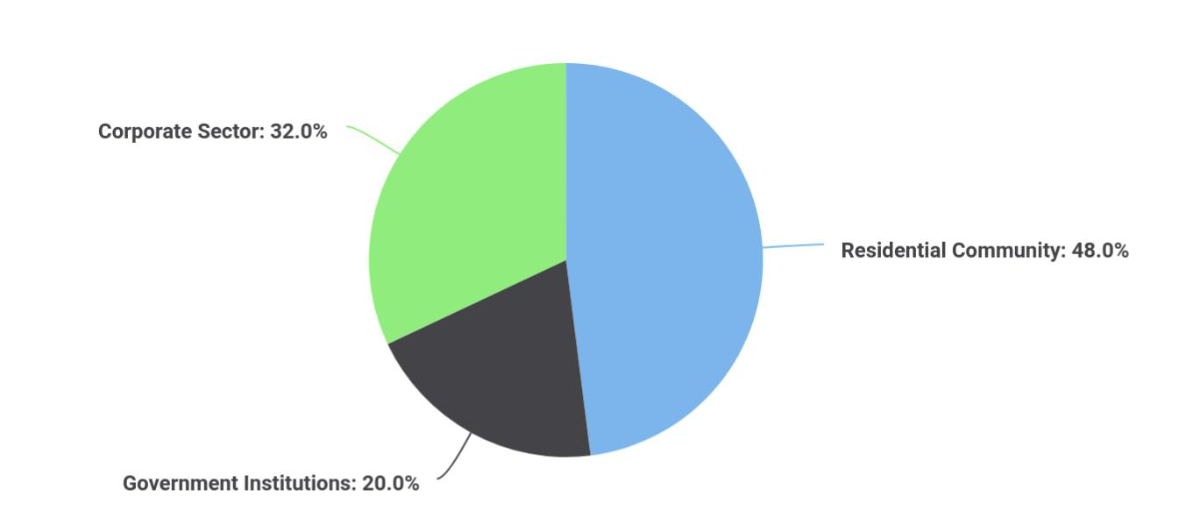

Segments | Market share
Residential Community | 48
Government Institutions | 20
Corporate Sector | 32

The detailed marketing segmentation of our target audience is as follows:

 Ex :: Art Valley

The first category of our customers includes the community residing in the residential zones of the city at a 30 minutes’ drive from our gallery. The residential community is extremely diverse comprising of people belonging to various age groups and varying needs. This customer group,
To unlock help try Upmetrics! 

Residential Community

Start writing here..

Art Gallery | Business Plan [YEAR] 20/40

 Ex :: Art Valley

The second category comprises various government institutions including federal, state, and local level institutions. These government organizations often take great interest in purchase unique artworks for displaying in their institutions, hence they will also contribute to our
To unlock help try Upmetrics! 

Government Institutions

Start writing here..

 Ex :: Art Valley

The second-biggest consumer of our services will be the corporate sector located in the Central Business District of the city. There are hundreds of local, national, and multinational businesses and companies located within a 15 km radius of our office. It has been found that the corporate
To unlock help try Upmetrics! 

Corporate Sector

Start writing here..

The detailed market analysis of our potential customers is given in the following table:

Potential | Growth | Year 1 | Year 2 | Year 3 | Year 4 | Year 5 | CAGR
Customers
Residential | 48% | 22,334 | 32,344 | 43,665 | 52,544 | 66,432 | 10.00%
Community
Government | 18% | 11,433 | 13,344 | 16,553 | 18,745 | 20,545 | 13.43%
Institutions
Corporate Sector | 34% | 18,322 | 19,455 | 20,655 | 22,867 | 24,433 | 15.32%
Total | 100% | 52,089 | 65,143 | 80,873 | 94,156 | 111,410 | 9.54%

Art Gallery | Business Plan [YEAR] 21/40

Business Target
To unlock help try Upmetrics!

 Ex :: Art Valley

We aim to become one of the biggest art galleries in the city within the next five years of our startup. Our main business targets to be achieved as milestones over the course of the next three years are as follows:



Start writing here..

Product Pricing

 Ex :: Art Valley

Product and service pricing is one of the most important factors in deciding the strategy of a startup. Selecting the price for the services is a difficult task because one has to attract customers while yielding a profit at the same time. These two things cannot be achieved at the
To unlock help try Upmetrics! 

Start writing here..

Art Gallery | Business Plan [YEAR] 22/40

5.

Sales Strategy

Competitive Analysis

Sales Strategy

Sales Forecast

Art Gallery | Business Plan [YEAR] 23/40

Like marketing analysis, sales strategy is also an important component of a steam art gallery business plan. After identifying the market trends, the market demand, and the potential customers of the startup, the next step is
To unlock help try Upmetrics! 

Competitive Analysis

 Ex :: Art Valley

Art Industry is one of the biggest industries of the United States. Considering the unique and dynamic nature of this industry, one has to introduce something innovative before even thinking about how to start an art business. That’s why John has already made preparations for entering
To unlock help try Upmetrics! 

Start writing here..

Sales Strategy

 Ex :: Art Valley

After carrying out a detailed analysis, our experts came up with the following brilliant ideas to advertise and sell ourselves.
To unlock help try Upmetrics! 

Start writing here..

Sales Forecast

 Ex :: Art Valley

Considering our competitive advantages, our lower rates, the quality of our services, and our unparalleled customer service, our sales pattern is expected to increase with years. The largest contribution to the sales will be by John’s collected artworks which will be purchased by high-
To unlock help try Upmetrics! 

Start writing here..

Art Gallery | Business Plan [YEAR] 24/40

Sales Forecast for 3 Years
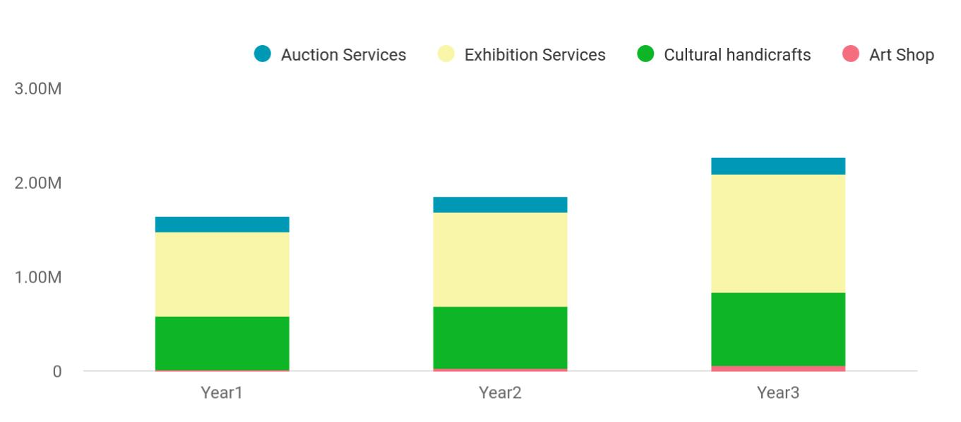

Financial Year | Auction Services | Exhibition Services | Cultural handicrafts | Art Shop
Year1 | 158,745 | 895,665 | 568,654 | 12,451
Year2 | 164,548 | 1,004,512 | 658,457 | 24,578
Year3 | 186,541 | 1,245,587 | 784,512 | 56,452

The detailed information about sales forecast, total unit sales, total sales is given in the following table:

 | Year 1 | Year 2 | Year 3
Unit Sales
Auction Services | 1,873,300 | 2,603,200 | 2,582,400
Exhibition Services | 802,370 | 815,430 | 823,540
Cultural Handicrafts | 539,320 | 770230 | 1,002,310
Art Shop | 265,450 | 322,390 | 393,320
TOTAL UNIT SALES | 3,480,440 | 4,511,250 | 4,801,570
Unit Prices
Auction Services | $140,000.00 | $150,050.00 | $160.00
Exhibition Services | $600.00 | $800.00 | $1,000.00
Cultural Handicrafts | $700.00 | $800.00 | $900.00
Art Shop | $650.00 | $750.00 | $850.00
Sales

Art Gallery | Business Plan [YEAR] 25/40

 | Year 1 | Year 2 | Year 3
Auction Services | $2,180,000 | $2,740,000 | $3,300,000
Exhibition Services | $120,050 | $194,500 | $268,500
Cultural Handicrafts | $50,110 | $71,600 | $93,000
Art Shop | $139,350 | $194,600 | $249,850
TOTAL SALES
Direct Unit Costs
Auction Services | $0.70 | $0.80 | $0.90
Exhibition Services | $0.40 | $0.45 | $0.50
Cultural Handicrafts | $0.30 | $0.35 | $0.40
Art Shop | $3.00 | $3.50 | $4.00
Direct Cost of Sales
Auction Services | $983,000 | $1,830,000 | $2,677,000
Exhibition Services | $66,600 | $119,900 | $173,200
Cultural Handicrafts | $17,900 | $35,000 | $52,100
Art Shop | $19,400 | $67,600 | $115,800
Subtotal Direct Cost of Sales | $294,100 | $699,400 | $1,104,700

Art Gallery | Business Plan [YEAR] 26/40

6.

Organisational And Personnel Plan

Corporate Organization

Company Staff

Average Salary of Employees

Art Gallery | Business Plan [YEAR] 27/40

You have to plan everything before you even think about how to open an art gallery. The personnel plan is also an important component of an art gallery business plan since it gives you an estimate of the staff required for your
To unlock help try Upmetrics! 

Corporate Organization

Company Staff

 Ex :: Art Valley

John will act as the General Manager of the Art Valley while he will initially hire the following people for the startup:
To unlock help try Upmetrics! 

Start writing here..

Art Gallery | Business Plan [YEAR] 28/40

Average Salary of Employees

The following table shows the forecast data about employees and their salaries for the next three years.

 | Year 1 | Year 2 | Year 3
Accountant | $85,000 | $95,000 | $105,000
Sales Executives | $85,000 | $92,000 | $109,000
Auctioneer | $41,000 | $44,000 | $48,000
Art Shop Manager | $16,600 | $17,300 | $18,000
Cleaners | $350,000 | $420,000 | $590,000
Assistants | $600,000 | $633,000 | $700,000
Inventory Manager | $63,300 | $70,000 | $76,700
Front Desk Officer | $20,000 | $23,300 | $30,000
Security Officers | $400,000 | $450,000 | $520,000
Total Salaries | $1,175,900 | $1,299,600 | $1,571,700

Art Gallery | Business Plan [YEAR] 29/40

7.

Financial Plan

Important Assumptions

Brake-even Analysis

Projected Profit and Loss

Projected Cash Flow

Projected Balance Sheet

Business Ratios

Art Gallery | Business Plan [YEAR] 30/40

The last component of an art gallery business plan is an in-depth financial plan. The financial plan crafts a detailed map of all the expenses needed for the startup and how these expenses will be met by the earned profits. It is
To unlock help try Upmetrics! 

Important Assumptions

The financial projections of the company are forecasted on the basis of the following assumptions. These assumptions are quite conservative and are expected to show deviation but to a limited level such that the company’s major financial strategy will not be affected.

 | Year 1 | Year 2 | Year 3
Plan Month | 1 | 2 | 3
Current Interest Rate | 10,00% | 11,00% | 12,00%
Long-term Interest Rate | 10,00% | 10,00% | 10,00%
Tax Rate | 26,42% | 27,76% | 28,12%
Other | 0 | 0 | 0

Brake-even Analysis

Monthly Units Break-even | 5530
Monthly Revenue Break-even | $159 740
Assumptions:
Average Per-Unit Revenue | $260,87
Average Per-Unit Variable Cost | $0,89
Estimated Monthly Fixed Cost | $196 410

Projected Profit and Loss

 | 2024 | 2025 | 2026
Revenue | $657,117.20 | $1,302,613.30 | $2,307,933.80
Artwork Sales | $397,955 | $714,680 | $1,283,460

Art Gallery | Business Plan [YEAR] 31/40

 | 2024 | 2025 | 2026
Unit Sales | 796 | 1,429 | 2,567
Unit Price | $500 | $500 | $500
Art Exhibitions | $56,769.20 | $80,940.80 | $115,403.40
Unit Sales | 2,838 | 4,047 | 5,770
Unit Price | $20 | $20 | $20
Art Classes | $202,393 | $506,992.50 | $909,070.40
Users | 269 | 528 | 918
Recurring Charges | $100 | $100 | $100

Cost Of Sales | $145,713.50 | $167,658.39 | $200,451.42
General Costs | $145,713.50 | $167,658.39 | $200,451.42
Artwork Procurement | $126,571.17 | $135,426.13 | $147,927.33
Artwork Purchase | $120,000 | $122,400 | $124,848
Artwork Shipping | $6,571.17 | $13,026.13 | $23,079.33
Art Class Materials | $19,142.33 | $32,232.26 | $52,524.09
Painting Supplies | $6,000 | $6,180 | $6,365.40
Class Equipment | $13,142.33 | $26,052.26 | $46,158.69
Revenue Specific Costs | $0 | $0 | $0
Personnel Costs (Direct | $0 | $0 | $0
Labor) | $0 | $0 | $0

Gross Margin | $511,403.70 | $1,134,954.91 | $2,107,482.38
Gross Margin (%) | 77.83% | 87.13% | 91.31%

Operating Expense | $617,579.57 | $685,775.57 | $782,252.67

Art Gallery | Business Plan [YEAR] 32/40

 | 2024 | 2025 | 2026
Payroll Expense (Indirect | $467,016 | $477,405.12 | $488,045.52
Labor) | $467,016 | $477,405.12 | $488,045.52
Gallery Staff | $207,000 | $212,148 | $217,429.20
Gallery Manager | $100,800 | $103,824 | $106,938.72
Sales Assistants | $106,200 | $108,324 | $110,490.48
Art Instructors | $144,096 | $147,625.92 | $151,245.84
Lead Art Instructor | $64,800 | $66,744 | $68,746.32
Junior Art Instructors | $79,296 | $80,881.92 | $82,499.52
Administrative Staff | $115,920 | $117,631.20 | $119,370.48
Office Manager | $55,200 | $56,304 | $57,430.08
Administrative Assistants | $60,720 | $61,327.20 | $61,940.40
General Expense | $150,563.57 | $208,370.45 | $294,207.15
Gallery Operations | $50,224.14 | $61,802.18 | $76,115.47
Utility Bills | $26,082.44 | $31,184.73 | $37,285.12
Gallery Maintenance | $24,141.70 | $30,617.45 | $38,830.35
Marketing and Promotion | $81,998.19 | $127,182.93 | $197,555.36
Advertising | $45,998.19 | $91,182.93 | $161,555.36
Event Hosting | $36,000 | $36,000 | $36,000
Administrative Costs | $18,341.24 | $19,385.34 | $20,536.32
Office Supplies | $6,341.24 | $7,145.34 | $8,051.52
Legal and Professional | $12,000 | $12,240 | $12,484.80
Fees | $12,000 | $12,240 | $12,484.80
Bad Debt | $0 | $0 | $0
Amortization of Current | $0 | $0 | $0
Assets | $0 | $0 | $0

EBITDA | ($106,175.87) | $449,179.34 | $1,325,229.71

Art Gallery | Business Plan [YEAR] 33/40

Additional Expense

Long Term Depreciation

Gain or loss from Sale of Assets

EBIT

Interest Expense

EBT

Income Tax Expense / Benefit
2024 2025 2026

$59,626.93 | $57,692.77 | $55,639.31
$54,480 | $54,480 | $54,480
$0 | $0 | $0
($160,655.87) | $394,699.34 | $1,270,749.71
$5,146.94 | $3,212.76 | $1,159.29
($165,802.80) | $391,486.57 | $1,269,590.40
$0 | $0 | $0

Total Expense | $822,920 | $911,126.73 | $1,038,343.40
Net Income | ($165,802.80) | $391,486.57 | $1,269,590.40
Net Income (%) | (25.23%) | 30.05% | 55.01%
Retained Earning Opening | $0 | ($165,802.80) | $225,683.77
Owner's Distribution | $0 | $0 | $0
Retained Earning Closing | ($165,802.80) | $225,683.77 | $1,495,274.17
Projected Cash Flow
 | 2024 | 2025 | 2026
Cash Received | $657,117.20 | $1,302,613.30 | $2,307,933.80
Cash Paid | $768,440 | $856,646.73 | $983,863.40
COS & General Expenses | $296,277.07 | $376,028.84 | $494,658.57
Salary & Wages | $467,016 | $477,405.12 | $488,045.52

Art Gallery | Business Plan [YEAR] 34/40

2024 2025 2026

Interest

Sales Tax

Income Tax

Net Cash From

Operations

Assets Sell

Assets Purchase

Net Cash From

Investments

Amount Received

Loan Received

Common Stock

Preferred Stock

Owner's Contribution

Amount Paid

Loan Capital

Dividends & Distributions

Net Cash From

Financing

Summary

$5,146.94 | $3,212.76 | $1,159.29
$0 | $0 | $0
$0 | $0 | $0
($111,322.80) | $445,966.57 | $1,324,070.40

$0 | $0 | $0
$600,000 | $0 | $0
($600,000) | $0 | $0

$250,000 | $0 | $0
$100,000 | $0 | $0
$0 | $0 | $0
$0 | $0 | $0
$150,000 | $0 | $0
$31,359.35 | $33,293.51 | $35,347.12
$31,359.34 | $33,293.52 | $35,347.14
$0 | $0 | $0
$218,640.65 | ($33,293.51) | ($35,347.12)

Starting Cash | $0 | ($492,682.15) | ($80,009.09)
Cash In | $907,117.20 | $1,302,613.30 | $2,307,933.80
Cash Out | $1,399,799.35 | $889,940.24 | $1,019,210.52
Change in Cash | ($492,682.15) | $412,673.06 | $1,288,723.28

Art Gallery | Business Plan [YEAR] 35/40

 | 2024 | 2025 | 2026
Ending Cash | ($492,682.15) | ($80,009.09) | $1,208,714.19

Projected Balance Sheet

 | 2024 | 2025 | 2026
Assets | $52,837.85 | $411,030.91 | $1,645,274.19
Current Assets | ($492,682.15) | ($80,009.09) | $1,208,714.19
Cash | ($492,682.15) | ($80,009.09) | $1,208,714.19
Accounts Receivable | $0 | $0 | $0
Inventory | $0 | $0 | $0
Other Current Assets | $0 | $0 | $0
Long Term Assets | $545,520 | $491,040 | $436,560
Gross Long Term Assets | $600,000 | $600,000 | $600,000
Accumulated Depreciation | ($54,480) | ($108,960) | ($163,440)
Liabilities & Equity | $52,837.86 | $411,030.91 | $1,645,274.17
Liabilities | $68,640.66 | $35,347.14 | $0
Current Liabilities | $33,293.52 | $35,347.14 | $0
Accounts Payable | $0 | $0 | $0
Income Tax Payable | $0 | $0 | $0
Sales Tax Payable | $0 | $0 | $0
Short Term Debt | $33,293.52 | $35,347.14 | $0
Long Term Liabilities | $35,347.14 | $0 | $0
Long Term Debt | $35,347.14 | $0 | $0
Equity | ($15,802.80) | $375,683.77 | $1,645,274.17
Paid-in Capital | $0 | $0 | $0
Art Gallery | Business Plan [YEAR] |  |  | 36/40
 | 2024 |  |  | 2025 | 2026
Common Stock | $0 |  |  | $0 | $0
Preferred Stock | $0 |  |  | $0 | $0
Owner's Contribution | $150,000 |  | $150,000 |  | $150,000
Retained Earnings | ($165,802.80) |  | $225,683.77 |  | $1,495,274.17
Check | $0 |  |  | $0 | $0
Business Ratios
 |  | Year 1 | Year 2 | Year 3 | Industry Profile
Sales Growth |  | 4,35% | 30,82% | 63,29% | 4,00%
Percent of Total Assets
Accounts Receivable |  | 5,61% | 4,71% | 3,81% | 9,70%
Inventory |  | 1,85% | 1,82% | 1,79% | 9,80%
Other Current Assets |  | 1,75% | 2,02% | 2,29% | 27,40%
Total Current Assets |  | 138,53% | 150,99% | 163,45% | 54,60%
Long-term Assets |  | -9,47% | -21,01% | -32,55% | 58,40%
TOTAL ASSETS |  | 100,00% | 100,00% | 100,00% | 100,00%
Current Liabilities |  | 4,68% | 3,04% | 2,76% | 27,30%
Long-term Liabilities |  | 0,00% | 0,00% | 0,00% | 25,80%
Total Liabilities |  | 4,68% | 3,04% | 2,76% | 54,10%
NET WORTH |  | 99,32% | 101,04% | 102,76% | 44,90%
Percent of Sales
Sales |  | 100,00% | 100,00% | 100,00% | 100,00%
Gross Margin |  | 94,18% | 93,85% | 93,52% | 0,00%
Selling, General & Administrative Expenses |  | 74,29% | 71,83% | 69,37% | 65,20%
Advertising Expenses |  | 2,06% | 1,11% | 0,28% | 1,40%
Profit Before Interest and Taxes |  | 26,47% | 29,30% | 32,13% | 2,86%

Art Gallery | Business Plan [YEAR] 37/40

 | Year 1 | Year 2 | Year 3 | Industry Profile
Main Ratios
Current | 25,86 | 29,39 | 32,92 | 1,63
Quick | 25,4 | 28,88 | 32,36 | 0,84
Total Debt to Total Assets | 2,68% | 1,04% | 0,76% | 67,10%
Pre-tax Return on Net Worth | 66,83% | 71,26% | 75,69% | 4,40%
Pre-tax Return on Assets | 64,88% | 69,75% | 74,62% | 9,00%
Additional Ratios | Year 1 | Year 2 | Year 3
Net Profit Margin | 19,20% | 21,16% | 23,12% | N.A.
Return on Equity | 47,79% | 50,53% | 53,27% | N.A.
Activity Ratios
Accounts Receivable Turnover | 4,56 | 4,56 | 4,56 | N.A.
Collection Days | 92 | 99 | 106 | N.A.
Inventory Turnover | 19,7 | 22,55 | 25,4 | N.A.
Accounts Payable Turnover | 14,17 | 14,67 | 15,17 | N.A.
Payment Days | 27 | 27 | 27 | N.A.
Total Asset Turnover | 1,84 | 1,55 | 1,26 | N.A.
Debt Ratios
Debt to Net Worth | 0 | -0,02 | -0,04 | N.A.
Current Liab. to Liab. | 1 | 1 | 1 | N.A.
Liquidity Ratios
Net Working Capital | $120 943 | $140 664 | $160 385 | N.A.
Interest Coverage | 0 | 0 | 0 | N.A.
Additional Ratios
Assets to Sales | 0,45 | 0,48 | 0,51 | N.A.
Current Debt/Total Assets | 4% | 3% | 2% | N.A.
Acid Test | 23,66 | 27,01 | 30,36 | N.A.
Sales/Net Worth | 1,68 | 1,29 | 0,9 | N.A.
Dividend Payout | 0 | 0 | 0 | N.A.

Art Gallery | Business Plan [YEAR] 38/40

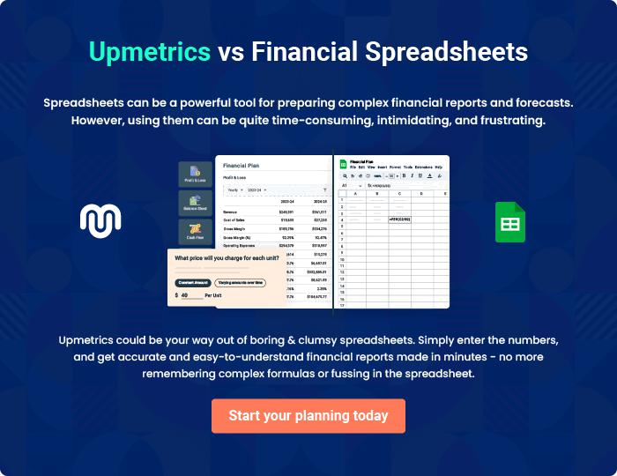

Art Gallery | Business Plan [YEAR] | 39/40


Create a winning business plan that gets you funded

Creating a stunning and investment-ready plan requires no writing, graphic designing, or financial planning expertise.

Upmetrics has all the features required to help you create a comprehensive business plan—from start to finish. Make no mistakes, it’s the modern way of planning to structure ideas, make plans, and create stunning pitch decks to awe investors.

Pitch decks that impress investors

Create pitch decks that provide a visual representation of your business, engage investors, and make them want to invest in your business idea.

Interactive plans in no time

Import business plan sections like—SWOT analysis, comparison tables, and others to create an interactive business plan. No designing skills are required.

Stunning cover page designs

With Upmetrics, you have the liberty to choose from multiple stunning cover page designs. Choose a creative design and make your plan stand out.

Online sharing made simple

Upmetrics makes online sharing quick and easier for users. Easily share your business plans with a link while tracking reader activity.

500+ sample business plans

Simply import a template from our library of sample plans into the editor and start customizing it to make it yours. It takes only a few clicks to get started.

Collaborate with team in real-time

Invite team members, initiate conversations, discuss ideas & strategies, share feedback, and work on a business plan in real-time.

