

Advertising

Agency

We believe in work that sells

Business

Plan

[YEAR]

John Doe

10200 Bolsa Ave, Westminster, CA, 92683

- 359-3153 info@example.com http://www.example.com

CONFIDENTIAL

Table of Contents

Executive Summary | 5
Introduction | 6
Mission Statement | 6
Vision Statement | 6
Financial Highlights | 7
3 Year profit forecast | 7

Business Summary | 8
Company Ownership | 9
Startup Summary | 9
Startup | 10

Products and Services | 12
Services | 13
Market Analysis
Market Analysis | 15
Market Segmentation | 16
Market Analysis | 16
Business Owners | 17
Institutions & Organizations | 17
Online Companies | 17
Business Target | 18
Market Trends | 18
Strategy
Strategy | 19
Competitive Analysis | 20
Sales Strategy | 20
Sales Forecast | 21
Sales Yearly | 21
Detailed Sales Forecast | 21

Advertising Agency | Business Plan [YEAR] 2/35

Management Plan | 23
Personnel Plan | 24
Average Salaries | 24
Financial Plan
Financial Plan | 25
Important Assumptions | 26
Brake-even Analysis | 26
Projected Profit and Loss | 27
Projected Cash Flow | 29
Projected Balance Sheet | 31
Business Ratios | 32

Advertising Agency | Business Plan [YEAR] 3/35

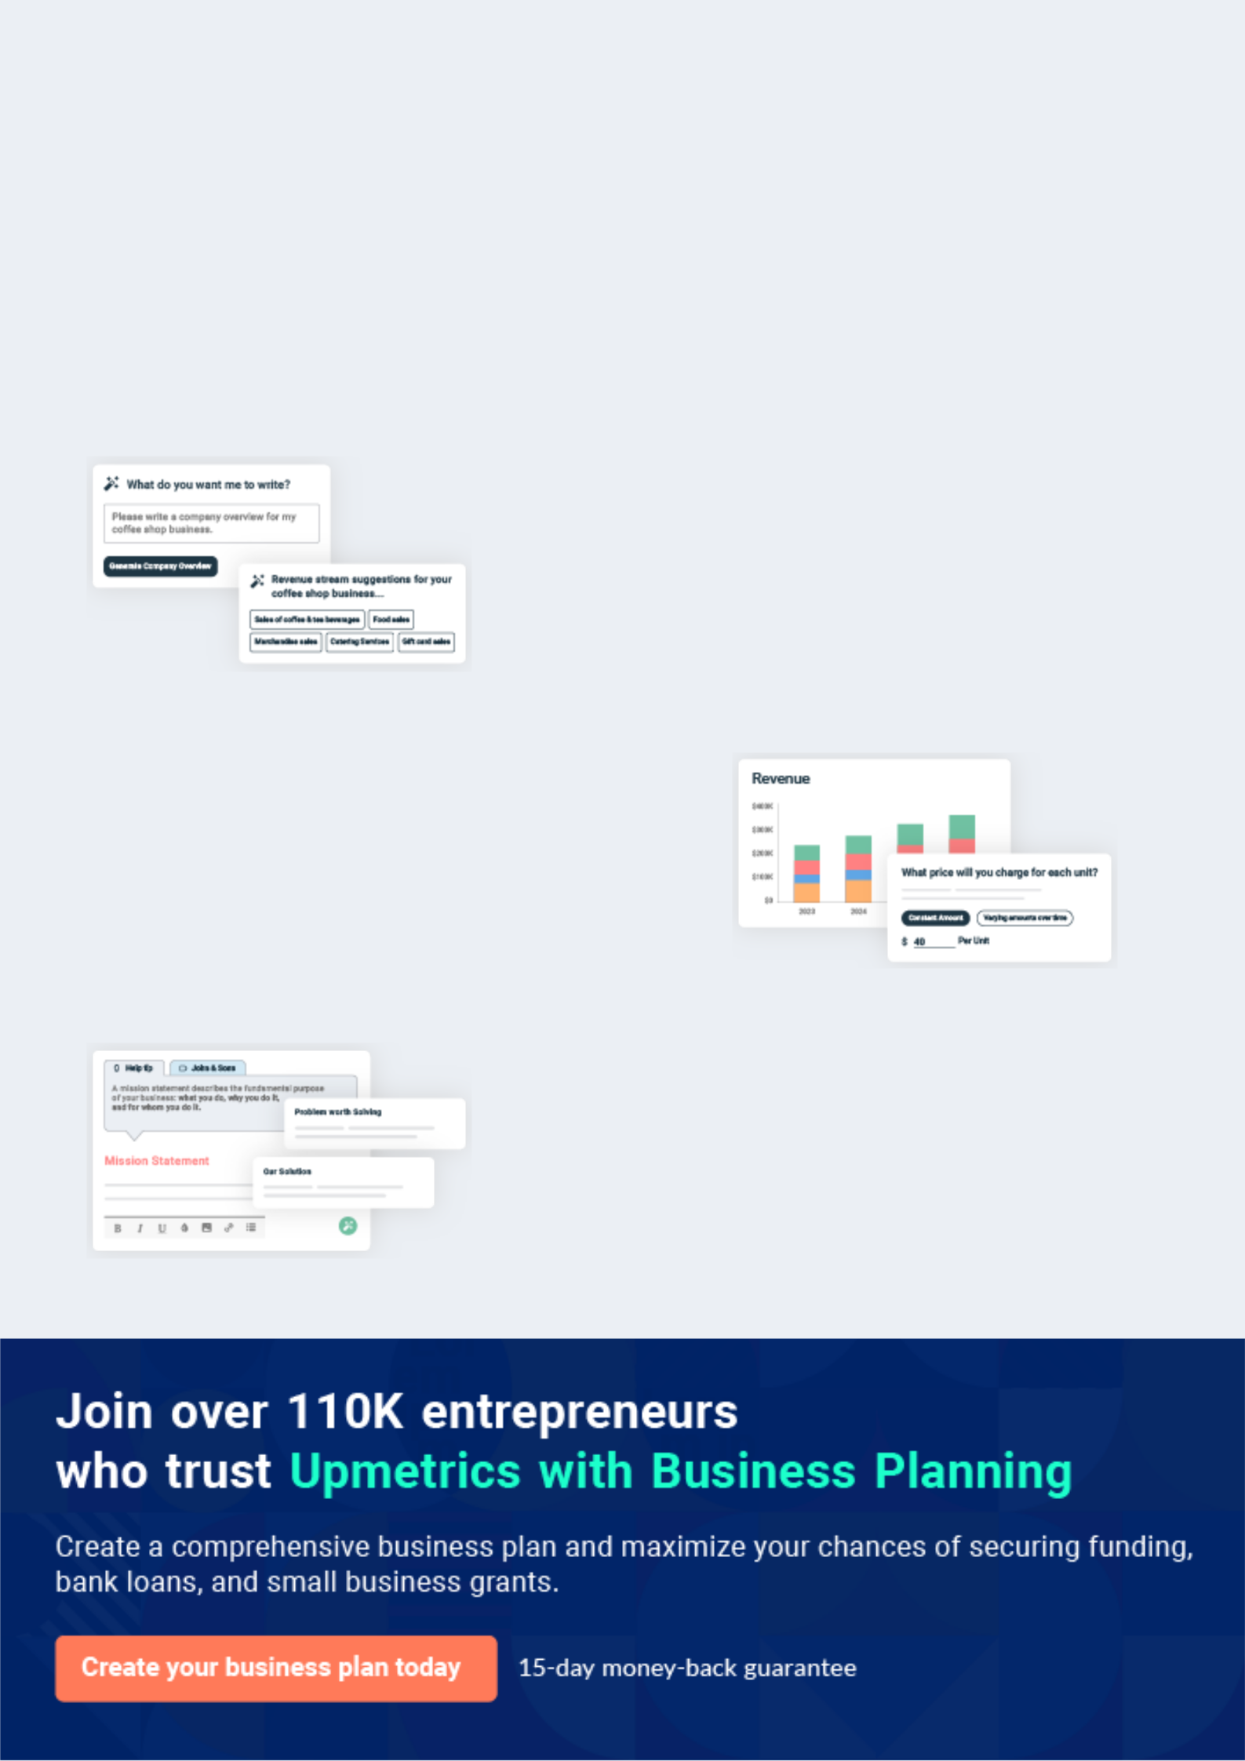
Business planning that’s simpler and faster than you think

Creating a business plan using Upmetrics to start and grow a business is literally the easiest thing in the World. Simply read the instructions and fill in the blanks. It’s as simple as that.

❛ | Upmetrics has everything you need to create a | ❜
❛ | comprehensive business plan. | ❜

AI-powered Upmetrics Assistant

AI-powered insights to streamline your plan

Not sure where to start? Upmetrics’ AI Assistant will automatically generate ideas for each section of your plan and offer improved versions of your writing, adjusting for tone, voice, and grammar or spelling errors.

Financial Forecasting Tool

All the financials are calculated for you

Forget the complex formulas and clumsy spreadsheets — with automatic financials and drag-and-drop forecasting, you can finish your plan faster and be confident that your numbers are accurate.

Business Plan Builder

Guides you like a business mentor

Upmetrics’ step-by-step instructions, prompts, and the library of 400+ sample business plans will guide you through each section of your plan as a business mentor.

1.


Executive Summary

Introduction

Mission Statement

Vision Statement

Financial Highlights

Advertising Agency | Business Plan [YEAR] 5/35

Before you think about how to start an Advertising business, you must create a detailed Advertising Agency business plan. It will not only guide you in the initial phases of your startup but will also help you later on.
To unlock help try Upmetrics!
To unlock help try Upmetrics! 

Introduction

 Apex Advertising


Established in March 2018, Apex Advertising is a U.S based and world-class advertising agency that will be located in Los Angeles – California. We have been able to secure a standard and well – positioned office facility in a central business district in Inglewood. Apex Advertising
To unlock help try Upmetrics! 

Start writing here..

Mission Statement

 Apex Advertising

Our mission is to provide professional and highly creative result-oriented advertising services and other related advisory and consulting services that will assist businesses, individuals, and non-profit organizations in promoting their brands and reaching out to a wide range of potential
To unlock help try Upmetrics! 

Start writing here..

Vision Statement

 Apex Advertising

Our vision is to establish a standard and world-class advertising agency whose services and brand will not only be accepted in the United States of America but also in other parts of the world.



Start writing here..

Advertising Agency | Business Plan [YEAR] 6/35

Financial Highlights

 Apex Advertising

The company is seeking $2.5 million of financing to fund the acquisition of Vihaan Advertising and its initial operations. This funding will cover the purchase of Vihaan Advertising, marketing, purchase of extra software, and hardware. Projected revenues for 1999 to 2001 are $200,000,
To unlock help try Upmetrics! 

Start writing here..

3 Year profit forecast
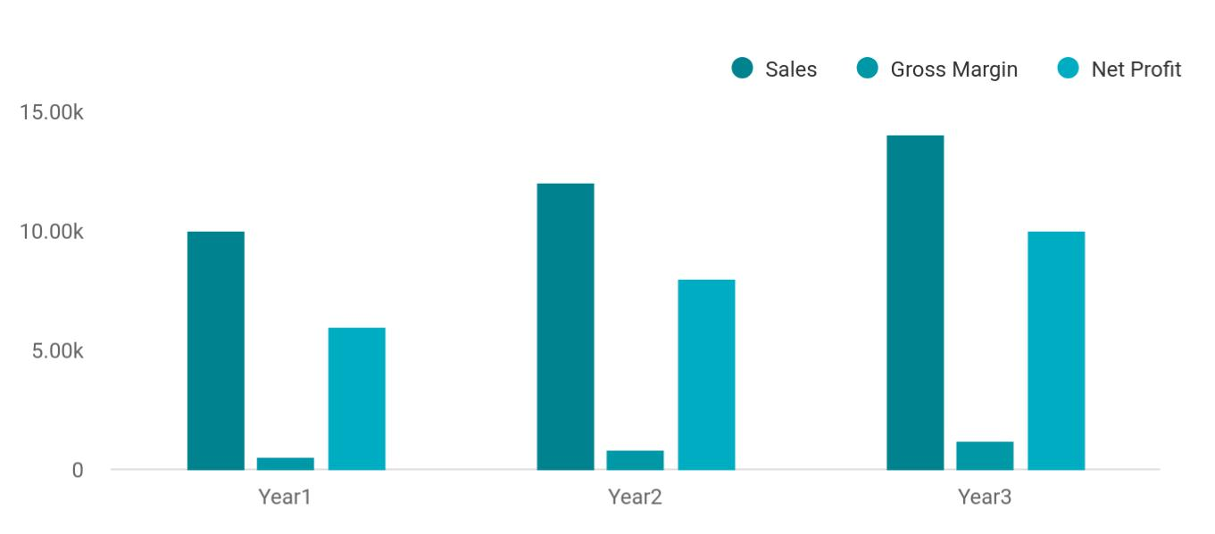

Financial Year | Sales | Gross Margin | Net Profit
Year1 | 10,000 | 500 | 6,000
Year2 | 12,000 | 800 | 8,000
Year3 | 14,000 | 1,200 | 10,000

Advertising Agency | Business Plan [YEAR] 7/35

2.

Business Summary

Company Ownership

Startup Summary

Advertising Agency | Business Plan [YEAR] 8/35

 Apex Advertising
To unlock help try Upmetrics!

Apex Advertising is a registered and licensed advertisement company located in Los Angeles – California, owned by Albert Finney. The business will be based on advertising and marketing small and large businesses in Los Angeles by traditional means of making billboards and by
To unlock help try Upmetrics! 

Start writing here..

Company Ownership

 Apex Advertising

Apex Advertising is founded by Albert Finney and her friend and business partner for many years Lesly Henderson. They both graduated from the University of California, Beckley with BA in Mass Communications and they have a combined experience that revolves around corporate
To unlock help try Upmetrics! 

Start writing here..

Startup Summary

 Apex Advertising

Albert Finney and Lesly Henderson will invest equally in the company. They will also secure a long-term business loan. The following table and chart show the projected initial start-up costs of Apex Advertising.



Start writing here..

Advertising Agency | Business Plan [YEAR] 9/35

Startup
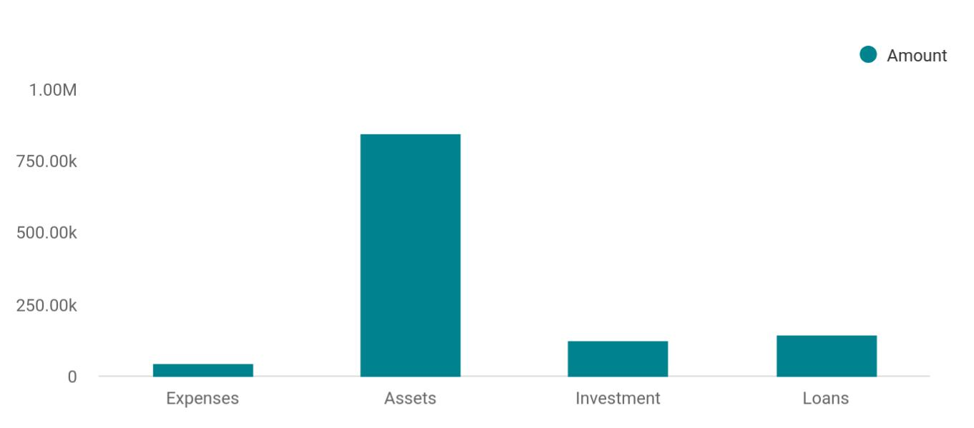

Category | Amount
Expenses | 45,124
Assets | 845,411
Investment | 124,511
Loans | 145,212

Startup Expenses | Amount
Legal | $1,000
Stationery etc. | $1,000
Brochures | $1,000
Advertising | $20,000
Expensed Computer Equipment/Software | $10,000
Insurance | $0
Rent | $1,500
Research and Development | $0
Other | $0
TOTAL START-UP EXPENSES | $34,500
Startup Assets
Cash Required | $155,500

Advertising Agency | Business Plan [YEAR] 10/35

Startup Expenses | Amount
Other Current Assets | $10,000
Long-term Assets | $0
TOTAL ASSETS | $165,500
Total Requirements | $200,000

Advertising Agency | Business Plan [YEAR] 11/35

3.

Products and Services

Services

Advertising Agency | Business Plan [YEAR] 12/35

Before starting an Advertising Agency, you must take many things into consideration such as you must consider what types of advertising services will you be providing to your clients. Deciding your services is extremely
To unlock help try Upmetrics! 

 Apex Advertising

The services offered by Apex Advertising cover an advertising project in its entirety, from the original concept to post-campaign evaluation. To adopt additional paths for advertisement besides traditional means Albert has decided to start a digital marketing agency. The service
To unlock help try Upmetrics! 

Start writing here..

Services


Printing innovative Designing appealing

flyers and brochures and unique billboards

Making business
Making related
cards and invitation
banners and flags
cards

Advertising through Advertising using the

social media sites, technique of search

websites, and emails engine optimization

Advertising Agency | Business Plan [YEAR] 13/35

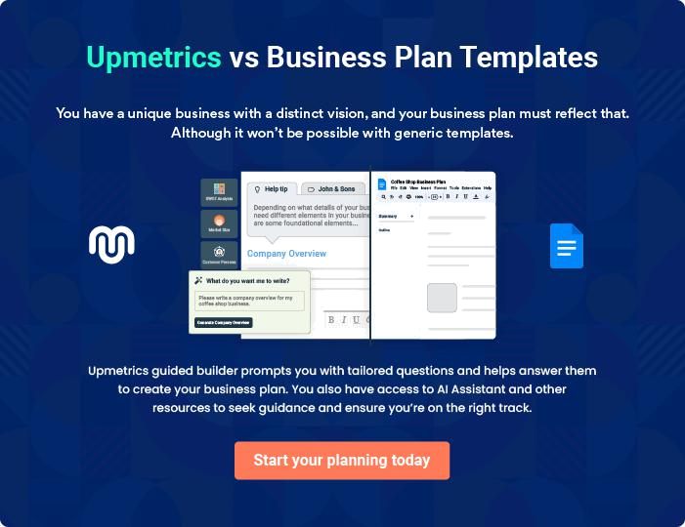

Advertising Agency | Business Plan [YEAR] | 14/35

4.

Market Analysis

Market Segmentation

Business Target

Market Trends

Advertising Agency | Business Plan [YEAR] 15/35

The most important component of an effective Advertising Agency business plan is its accurate market analysis. If you are starting on a smaller scale, you can do the market analysis yourself by taking help from this Advertising
To unlock help try Upmetrics!
To unlock help try Upmetrics! 

 Apex Advertising

The next important step you have to take if you are looking for how to start your own marketing agency is to do an accurate market analysis. You need to figure out what others in the same business are doing and what additional services you’ll have to provide to take a lead upon
To unlock help try Upmetrics! 

Start writing here..

Market Segmentation

 Apex Advertising

To know and focus on the demands of its customers, Apex Advertising has divided its customers into the following target groups. The detailed marketing segmentation of our target audience is as follows:



Start writing here..

Market Analysis
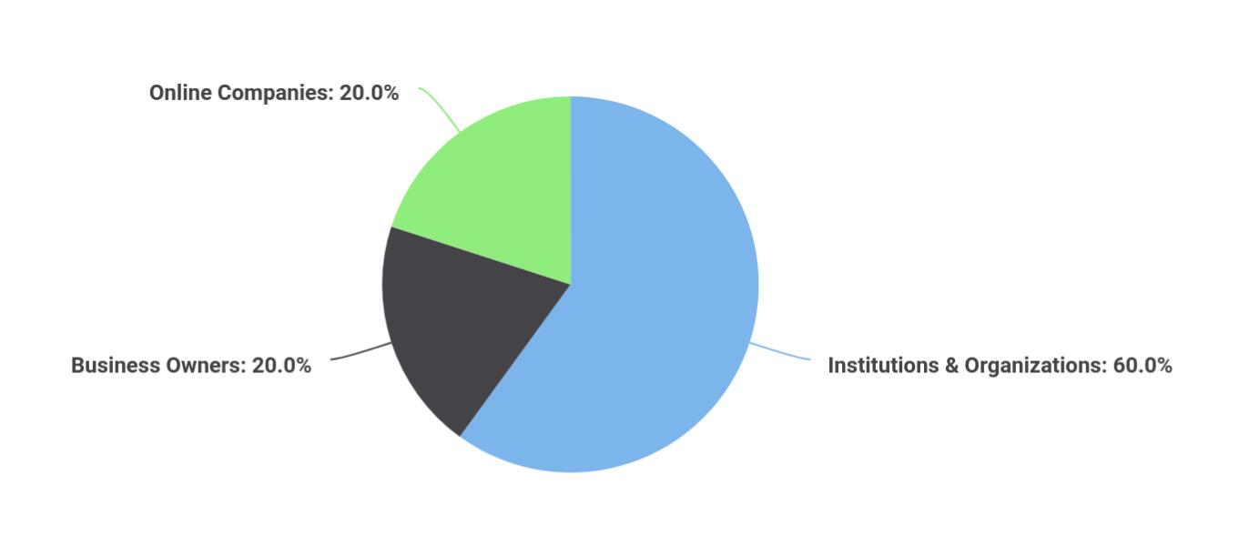

Financial Year Units Sold

Institutions & Organizations 60

Advertising Agency | Business Plan [YEAR] 16/35

To unlock help try Upmetrics!
Financial Year | Units Sold
Business Owners | 20
Online Companies | 20

 Apex Advertising

The biggest category of our customers will be the owners of small and large businesses based in Austin. They will avail of our services of designing billboards and printing brochures for them as well as the services of our experts to make their website SEO friendly._{To unlock help try Upmetrics!} 

Business Owners

Start writing here..

 Apex Advertising

Our second target group comprises various institutions and organizations located in Austin including public-sector organizations, schools, colleges and universities, political parties, sports organizations, and non-profit organizations. They will need our services to promote their ideas
To unlock help try Upmetrics! 

Institutions & Organizations

Start writing here..

 Apex Advertising

Our third target group will be the online companies not just restricted to Austin but to anywhere in the United States. They will avail just our services of social media marketing, developing websites, and SEO their content.



Online Companies

Start writing here..

Potential Customers | Growth | Year 1 | Year 2 | Year 3 | Year 4 | Year 5 | CAGR
Institutions & Organizations | 32% | 11 433 | 13 344 | 16 553 | 18 745 | 20 545 | 13,43%
Business Owners | 48% | 22 334 | 32 344 | 43 665 | 52 544 | 66 432 | 10,00%
Online Companies | 20% | 12 867 | 14 433 | 15 999 | 17 565 | 19 131 | 15,32%

Advertising Agency | Business Plan [YEAR] 17/35

Potential Customers | Growth | Year 1 | Year 2 | Year 3 | Year 4 | Year 5 | CAGR
Total | 100% | 46 634 | 60 121 | 76 217 | 88 854 | 106 108 | 9,54%

Business Target

 Apex Advertising

We aim at extending our services to several cities through our online servicing. Our financial goals to be achieved over the course of three years are:
To unlock help try Upmetrics! 

Start writing here..

Market Trends

 Apex Advertising

The entrepreneurs when they are taking a startup, can’t focus on each and everything by themselves and they want the services of some professional and trustee organization to do marketing work for their business. According to a report by IBISWorld, stats have shown a
To unlock help try Upmetrics! 

Start writing here..

Advertising Agency | Business Plan [YEAR] 18/35

5.

Strategy

Competitive Analysis

Sales Strategy

Advertising Agency | Business Plan [YEAR] 19/35

After identifying the market demand, market trends, and the potential customers of the startup, the next step is to define an effective strategy for attracting those clients. Like marketing analysis, sales strategy is also an
To unlock help try Upmetrics! 

 Apex Advertising

Apex Advertising's strategy is to utilize the extensive network of contacts both Albert and Lesly have with companies already sold on the value of email marketing. In addition, Promerit will use its internal expertise to launch an email marketing campaign directed at a select group of
To unlock help try Upmetrics! 

Start writing here..

Competitive Analysis

 Apex Advertising

Our biggest competitive advantage is that our company will not only be making billboards and banners but in addition to these, we will be hiring IT Experts and Web Developers to advertise through digital media. Our skilled and experienced employees will make your website SEO
To unlock help try Upmetrics! 

Start writing here..

Sales Strategy

 Apex Advertising

We’ll ensure a 25% increase in our website traffic every month and a gradual increase in our means to convert that traffic to our customers.
To unlock help try Upmetrics! 

Start writing here..

Advertising Agency | Business Plan [YEAR] 20/35

 Apex Advertising

The following is the sales forecast for three years. We have no cost of sales, as all of our deliverables is electronic, and our labor costs are included in the Personnel table.
To unlock help try Upmetrics! 

Sales Forecast

Start writing here..

Sales Yearly
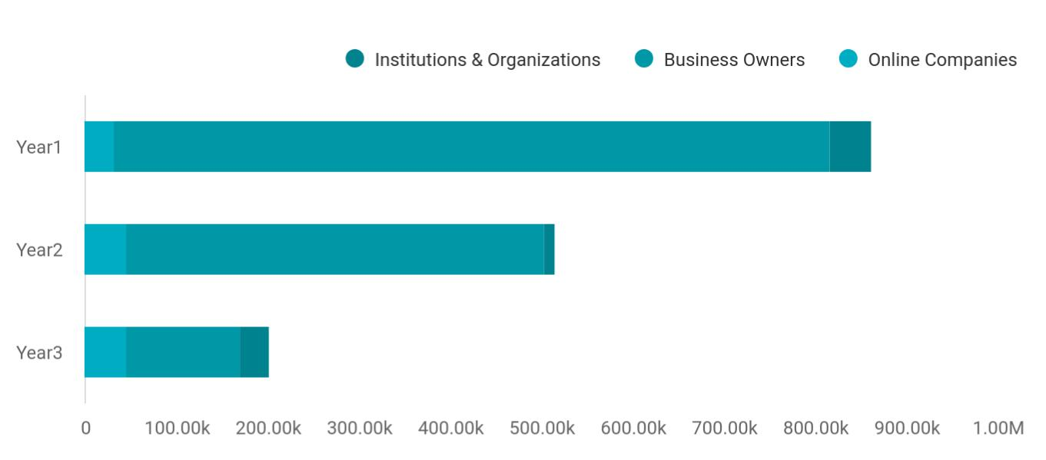

Financial Year | Institutions & Organizations | Business Owners | Online Companies
Year1 | 45,784 | 784,574 | 32,125
Year2 | 12,451 | 457,844 | 45,125
Year3 | 32,541 | 124,515 | 45,125

Detailed Sales Forecast

Detailed sales forecast data is provided in below table:

Sales Forecast | Year 1 | Year 2 | Year 3
Unit Sales
Flyers & brochures | 1 887 030 | 2 680 320 | 2 588 240
Billboards, banners & flags | 802 370 | 815 430 | 823 540

Advertising Agency | Business Plan [YEAR] 21/35

Sales Forecast | Year 1 | Year 2 | Year 3
Business & invitation cards | 539 320 | 770230 | 1 002 310
Digital advertising | 265 450 | 322 390 | 393 320
TOTAL UNIT SALES | 3 494 170 | 4 588 370 | 4 807 410
Unit Prices
Flyers & brochures | $140,00 | $150,00 | $160,00
Billboards, banners & flags | $600,00 | $800,00 | $1 000,00
Business & invitation cards | $700,00 | $800,00 | $900,00
Digital advertising | $650,00 | $750,00 | $850,00
Sales
Flyers & brochures | $2 149 800 | $2 784 000 | $3 383 200
Billboards, banners & flags | $120 050 | $194 500 | $268 500
Business & invitation cards | $50 110 | $71 600 | $93 000
Digital advertising | $139 350 | $194 600 | $249 850
TOTAL SALES
Flyers & brochures | $0,70 | $0,80 | $0,90
Billboards, banners & flags | $0,40 | $0,45 | $0,50
Business & invitation cards | $0,30 | $0,35 | $0,40
Digital advertising | $3,00 | $3,50 | $4,00
Direct Cost of Sales
Flyers & brochures | $989 300 | $1 839 000 | $2 679 700
Billboards, banners & flags | $66 600 | $119 900 | $173 200
Business & invitation cards | $17 900 | $35 000 | $52 100
Digital advertising | $19 400 | $67 600 | $115 800
Subtotal Direct Cost of Sales | $1 294 100 | $1 699 400 | $2 104 700

Advertising Agency | Business Plan [YEAR] 22/35

6.

Management Plan

Personnel Plan

Average Salaries

Advertising Agency | Business Plan [YEAR] 23/35

The management plan is also an important component of an advertising agency business plan since it gives you an estimate of the staff required for your startup as well as the costs incurred on their salaries. So, make sure to
To unlock help try Upmetrics! 

Personnel Plan

 Apex Advertising

In addition to Albert and Lesly, there will be other staff members as follow:

• 1 Accountant to maintain financial and other records
To unlock help try Upmetrics! 

Start writing here..

Average Salaries

Personnel | Year 1 | Year 2 | Year 3
Accountant | $85 000 | $95 000 | $105 000
Receptionist | $45 000 | $50 000 | $55 000
Graphic Artists | $152 000 | $159 000 | $166 000
SEO Specialists | $152 000 | $159 000 | $166 000
Web Developers | $152 000 | $159 000 | $166 000
Technicians | $145 000 | $152 000 | $159 000
General Assistants | $50 000 | $55 000 | $60 000
Cleaner | $42 000 | $45 000 | $48 000
Driver | $42 000 | $45 000 | $48 000
Total Salaries | $304 000 | $318 000 | $332 000

Advertising Agency | Business Plan [YEAR] 24/35

7.

Financial Plan

Important Assumptions

Brake-even Analysis

Projected Profit and Loss

Projected Cash Flow

Projected Balance Sheet

Business Ratios

Advertising Agency | Business Plan [YEAR] 25/35

The last component of an Advertising Agency Business plan is an in-depth financial plan. The financial plan crafts a detailed map of all the expenses needed for the startup and how these expenses will be met by the earned
To unlock help try Upmetrics!
To unlock help try Upmetrics! 

 Apex Advertising

The company is seeking $2.5 million of financing to fund the acquisition of Vihaan Advertising and its initial operations. This funding will cover the purchase of Vihaan Advertising, marketing, purchase of extra software, and hardware.



Start writing here..

Important Assumptions

The financial projections of the company are forecast on the basis of the following assumptions. These assumptions are quite conservative and are expected to show deviation but to a limited level such that the company’s major financial strategy will not be affected.

 | Year 1 | Year 2 | Year 3
Plan Month | 1 | 2 | 3
Current Interest Rate | 10,00% | 11,00% | 12,00%
Long-term Interest Rate | 10,00% | 10,00% | 10,00%
Tax Rate | 26,42% | 27,76% | 28,12%
Other | 0 | 0 | 0

Brake-even Analysis

Monthly Units Break-even | 5530
Monthly Revenue Break-even | $159 740
Assumptions:
Average Per-Unit Revenue | $260,87
Average Per-Unit Variable Cost | $0,89
Estimated Monthly Fixed Cost | $196 410

Advertising Agency | Business Plan [YEAR] 26/35

Projected Profit and Loss

 | 2024 | 2025 | 2026
Revenue | $892,440 | $1,847,412 | $2,756,250
Digital Marketing Services | $192,000 | $217,392 | $342,560
Unit Sales | 120 | 136 | 214
Unit Price | $1,600 | $1,600 | $1,600
Social Media Advertising | $580,440 | $1,500,580 | $2,250,430
Users | 86 | 155 | 213
Recurring Charges | $1,000 | $1,000 | $1,000
Brand Strategy Consulting | $120,000 | $129,440 | $163,260
Unit Sales | 60 | 65 | 82
Unit Price | $2,000 | $2,000 | $2,000
Cost Of Sales | $168,170.90 | $326,022.52 | $494,609.29
General Costs | $168,170.90 | $326,022.52 | $494,609.29
Digital Marketing Costs | $132,941.60 | $266,957.68 | $394,527.80
Software Subscriptions | $8,000 | $8,320 | $8,652.80
Freelancer Fees | $124,941.60 | $258,637.68 | $385,875
Advertising and Promotion | $35,229.30 | $59,064.84 | $100,081.49
Costs | $35,229.30 | $59,064.84 | $100,081.49
Advertising Spend | $23,875.68 | $42,877.45 | $77,001.95
Promotional Materials | $11,353.62 | $16,187.39 | $23,079.54
Revenue Specific Costs | $0 | $0 | $0
Personnel Costs (Direct | $0 | $0 | $0
Labor) | $0 | $0 | $0
Gross Margin | $724,269.10 | $1,521,389.48 | $2,261,640.71

Advertising Agency | Business Plan [YEAR] 27/35

Gross Margin (%)

Operating Expense

Payroll Expense (Indirect Labor)

Management Team

Creative Director

Account Manager

Creative Team

Graphic Designer

Copywriter

Support Staff

Administrative Assistant

IT Support Specialist

General Expense

Office and Administrative Expenses

Office Rent

Utilities

Marketing and Advertising Expenses

Online Advertising

Print Advertising

Technology and Communication Expenses

Website Maintenance

Communication Tools

Bad Debt

2024 | 2025 | 2026
81.16% | 82.35% | 82.05%

$700,575.67 | $804,195.83 | $927,509.60
$593,448 | $615,009.84 | $637,392
$200,160 | $209,318.40 | $218,900.76
$115,200 | $120,960 | $127,008
$84,960 | $88,358.40 | $91,892.76
$289,800 | $298,494 | $307,448.88
$165,600 | $170,568 | $175,685.04
$124,200 | $127,926 | $131,763.84
$103,488 | $107,197.44 | $111,042.36
$43,008 | $44,298.24 | $45,627.24
$60,480 | $62,899.20 | $65,415.12
$107,127.67 | $189,185.99 | $290,117.60
$33,748.79 | $47,272.78 | $66,328.65
$28,384 | $40,468.84 | $57,699.28
$5,364.79 | $6,803.94 | $8,629.37
$60,539.22 | $120,955.83 | $189,147.72
$44,622 | $92,370.60 | $137,812.50
$15,917.22 | $28,585.23 | $51,335.22
$12,839.66 | $20,957.38 | $34,641.23
$7,162.84 | $12,863.55 | $23,101.43
$5,676.82 | $8,093.83 | $11,539.80
$0 | $0 | $0

Advertising Agency | Business Plan [YEAR] 28/35

Amortization of Current Assets

EBITDA

Additional Expense

Long Term Depreciation

Gain or loss from Sale of Assets

EBIT

Interest Expense

EBT

Income Tax Expense / Benefit

Total Expense

Net Income

Net Income (%)

Retained Earning Opening

Owner's Distribution

Retained Earning Closing

2024 | 2025 | 2026
$0 | $0 | $0

$23,693.43 $717,193.65 $1,334,131.11

$12,838.93 | $10,904.77 | $8,851.31
$7,692 | $7,692 | $7,692
$0 | $0 | $0
$16,001.43 | $709,501.65 | $1,326,439.11
$5,146.94 | $3,212.76 | $1,159.29
$10,854.50 | $706,288.88 | $1,325,279.80
$0 | $0 | $0

$881,585.50 | $1,141,123.12 | $1,430,970.20
$10,854.50 | $706,288.88 | $1,325,279.80
1.22% | 38.23% | 48.08%

$0 | ($7,145.50) | $681,143.38
$18,000 | $18,000 | $18,000
($7,145.50) | $681,143.38 | $1,988,423.18

Projected Cash Flow

 | 2024 | 2025 | 2026
Cash Received | $892,440 | $1,847,412 | $2,756,250

Advertising Agency | Business Plan [YEAR] 29/35

 | 2024 | 2025 | 2026
Cash Paid | $873,893.50 | $1,133,431.12 | $1,423,278.20
COS & General Expenses | $275,298.57 | $515,208.51 | $784,726.89
Salary & Wages | $593,448 | $615,009.84 | $637,392
Interest | $5,146.94 | $3,212.76 | $1,159.29
Sales Tax | $0 | $0 | $0
Income Tax | $0 | $0 | $0
Net Cash From | $18,546.50 | $713,980.88 | $1,332,971.80
Operations | $18,546.50 | $713,980.88 | $1,332,971.80

Assets Sell | $0 | $0 | $0
Assets Purchase | $35,000 | $0 | $0
Net Cash From | ($35,000) | $0 | $0
Investments | ($35,000) | $0 | $0

Amount Received | $250,000 | $0 | $0
Loan Received | $100,000 | $0 | $0
Common Stock | $150,000 | $0 | $0
Preferred Stock | $0 | $0 | $0
Owner's Contribution | $0 | $0 | $0
Amount Paid | $49,359.35 | $51,293.51 | $53,347.12
Loan Capital | $31,359.34 | $33,293.52 | $35,347.14
Dividends & Distributions | $18,000 | $18,000 | $18,000
Net Cash From | $200,640.65 | ($51,293.51) | ($53,347.12)
Financing | $200,640.65 | ($51,293.51) | ($53,347.12)

Summary

Starting Cash | $0 | $184,187.15 | $846,874.52

Advertising Agency | Business Plan [YEAR] 30/35

 | 2024 | 2025 | 2026
Cash In | $1,142,440 | $1,847,412 | $2,756,250
Cash Out | $958,252.85 | $1,184,724.63 | $1,476,625.32
Change in Cash | $184,187.15 | $662,687.37 | $1,279,624.68
Ending Cash | $184,187.15 | $846,874.52 | $2,126,499.20

Projected Balance Sheet

 | 2024 | 2025 | 2026
Assets | $211,495.15 | $866,490.52 | $2,138,423.20
Current Assets | $184,187.15 | $846,874.52 | $2,126,499.20
Cash | $184,187.15 | $846,874.52 | $2,126,499.20
Accounts Receivable | $0 | $0 | $0
Inventory | $0 | $0 | $0
Other Current Assets | $0 | $0 | $0
Long Term Assets | $27,308 | $19,616 | $11,924
Gross Long Term Assets | $35,000 | $35,000 | $35,000
Accumulated Depreciation | ($7,692) | ($15,384) | ($23,076)
Liabilities & Equity | $211,495.16 | $866,490.52 | $2,138,423.18
Liabilities | $68,640.66 | $35,347.14 | $0
Current Liabilities | $33,293.52 | $35,347.14 | $0
Accounts Payable | $0 | $0 | $0
Income Tax Payable | $0 | $0 | $0
Sales Tax Payable | $0 | $0 | $0
Short Term Debt | $33,293.52 | $35,347.14 | $0
Long Term Liabilities | $35,347.14 | $0 | $0

Advertising Agency | Business Plan [YEAR] 31/35

 | 2024 |  |  | 2025 |  | 2026
Long Term Debt | $35,347.14 |  |  | $0 |  | $0
Equity | $142,854.50 |  | $831,143.38 |  |  | $2,138,423.18
Paid-in Capital | $0 |  |  | $0 |  | $0
Common Stock | $150,000 |  | $150,000 |  |  | $150,000
Preferred Stock | $0 |  |  | $0 |  | $0
Owner's Contribution | $0 |  |  | $0 |  | $0
Retained Earnings | ($7,145.50) |  | $681,143.38 |  |  | $1,988,423.18
Check | $0 |  |  | $0 |  | $0
Business Ratios
 |  | Year 1 | Year 2 |  | Year 3 | Industry Profile
Sales Growth |  | 4,35% | 30,82% |  | 63,29% | 4,00%
Percent of Total Assets
Accounts Receivable |  | 5,61% | 4,71% |  | 3,81% | 9,70%
Inventory |  | 1,85% | 1,82% |  | 1,79% | 9,80%
Other Current Assets |  | 1,75% | 2,02% |  | 2,29% | 27,40%
Total Current Assets |  | 138,53% | 150,99% |  | 163,45% | 54,60%
Long-term Assets |  | -9,47% | -21,01% |  | -32,55% | 58,40%
TOTAL ASSETS |  | 100,00% | 100,00% |  | 100,00% | 100,00%
Current Liabilities |  | 4,68% | 3,04% |  | 2,76% | 27,30%
Long-term Liabilities |  | 0,00% | 0,00% |  | 0,00% | 25,80%
Total Liabilities |  | 4,68% | 3,04% |  | 2,76% | 54,10%
NET WORTH |  | 99,32% | 101,04% |  | 102,76% | 44,90%
Percent of Sales
Sales |  | 100,00% | 100,00% |  | 100,00% | 100,00%

Advertising Agency | Business Plan [YEAR] 32/35

 | Year 1 | Year 2 | Year 3 | Industry Profile
Gross Margin | 94,18% | 93,85% | 93,52% | 0,00%
Selling, General & Administrative Expenses | 74,29% | 71,83% | 69,37% | 65,20%
Advertising Expenses | 2,06% | 1,11% | 0,28% | 1,40%
Profit Before Interest and Taxes | 26,47% | 29,30% | 32,13% | 2,86%
Main Ratios
Current | 25,86 | 29,39 | 32,92 | 1,63
Quick | 25,4 | 28,88 | 32,36 | 0,84
Total Debt to Total Assets | 2,68% | 1,04% | 0,76% | 67,10%
Pre-tax Return on Net Worth | 66,83% | 71,26% | 75,69% | 4,40%
Pre-tax Return on Assets | 64,88% | 69,75% | 74,62% | 9,00%
Additional Ratios
Net Profit Margin | 19,20% | 21,16% | 23,12% | N.A.
Return on Equity | 47,79% | 50,53% | 53,27% | N.A.
Activity Ratios
Accounts Receivable Turnover | 4,56 | 4,56 | 4,56 | N.A.
Collection Days | 92 | 99 | 106 | N.A.
Inventory Turnover | 19,7 | 22,55 | 25,4 | N.A.
Accounts Payable Turnover | 14,17 | 14,67 | 15,17 | N.A.
Payment Days | 27 | 27 | 27 | N.A.
Total Asset Turnover | 1,84 | 1,55 | 1,26 | N.A.
Debt Ratios
Debt to Net Worth | 0 | -0,02 | -0,04 | N.A.
Current Liab. to Liab. | 1 | 1 | 1 | N.A.
Liquidity Ratios
Net Working Capital | $120 943 | $140 664 | $160 385 | N.A.
Interest Coverage | 0 | 0 | 0 | N.A.
Additional Ratios
Assets to Sales | 0,45 | 0,48 | 0,51 | N.A.

Advertising Agency | Business Plan [YEAR] 33/35

 | Year 1 | Year 2 | Year 3 | Industry Profile
Current Debt/Total Assets | 4% | 3% | 2% | N.A.
Acid Test | 23,66 | 27,01 | 30,36 | N.A.
Sales/Net Worth | 1,68 | 1,29 | 0,9 | N.A.
Dividend Payout | 0 | 0 | 0 | N.A.
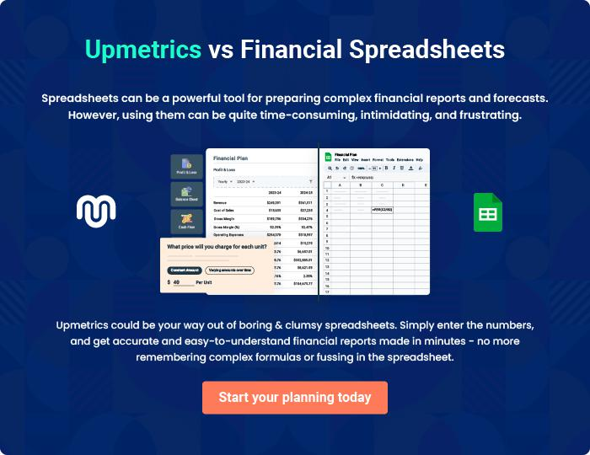

Advertising Agency | Business Plan [YEAR] 34/35


Create a winning business plan that gets you funded

Creating a stunning and investment-ready plan requires no writing, graphic designing, or financial planning expertise.

Upmetrics has all the features required to help you create a comprehensive business plan—from start to finish. Make no mistakes, it’s the modern way of planning to structure ideas, make plans, and create stunning pitch decks to awe investors.

Pitch decks that impress investors

Create pitch decks that provide a visual representation of your business, engage investors, and make them want to invest in your business idea.

Interactive plans in no time

Import business plan sections like—SWOT analysis, comparison tables, and others to create an interactive business plan. No designing skills are required.

Stunning cover page designs

With Upmetrics, you have the liberty to choose from multiple stunning cover page designs. Choose a creative design and make your plan stand out.

Online sharing made simple

Upmetrics makes online sharing quick and easier for users. Easily share your business plans with a link while tracking reader activity.

500+ sample business plans

Simply import a template from our library of sample plans into the editor and start customizing it to make it yours. It takes only a few clicks to get started.

Collaborate with team in real-time

Invite team members, initiate conversations, discuss ideas & strategies, share feedback, and work on a business plan in real-time.

