

Accounting Firm

Don’t just business, accurate it


Business
Plan

[YEAR]

Prepared By

John Doe

10200 Bolsa Ave, Westminster, CA, 92683

info@example.com

(650) 359-3153 http://www.example.com

Table of Contents

Executive Summary | 5
Product and Services | 6
Vision Statement | 6
Mission Statement | 7

Business Overview | 8
Business Structure | 9
Roles and Responsibilities | 9
Chief Executive Office | 9
Accounting and Tax Consultants | 9
Admin and HR Manager | 10
Marketing and Sales Executive | 10
Accountant | 10
Client Service Executive / Front Desk Officer | 10
SWOT Analysis
SWOT Analysis | 11
Market Analysis
Market Analysis | 14
Market Trends | 15
Target Market | 15
Competitive Advantage | 15
Sales And Marketing Strategy
Sales And Marketing Strategy | 16
Sources of Income | 17
Sales Forecast | 17
No. of clients v/s Revenue Chart | 18
Pricing Strategy | 18
Payment Options | 18
Publicity and Advertising Strategy
Publicity and Advertising Strategy | 19

Accounting Firm | Business Plan [YEAR] 2/31

Financial Plan | 21
Financial Projections and Costing | 22
Generating Funds/Startup Capital | 22
Projected Cash Flow | 22
Cash Flow | 22
Projected Balance Sheet | 24
Balance Sheet | 24
Projected Profit & Loss | 25
Profit & Loss | 25
Sustainability and Expansion Strategy
Sustainability and Expansion Strategy | 29

Accounting Firm | Business Plan [YEAR] 3/31

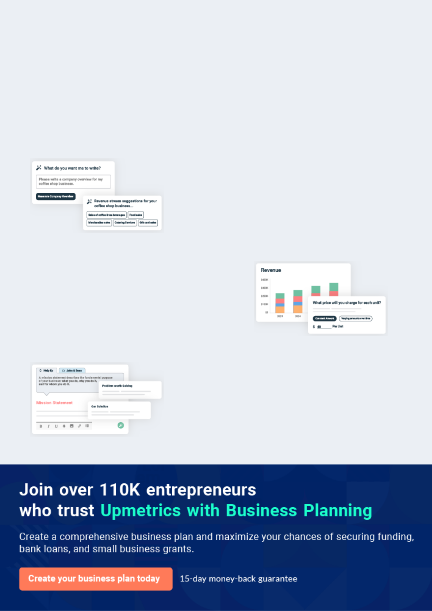
Business planning that’s simpler and faster than you think

Creating a business plan using Upmetrics to start and grow a business is literally the easiest thing in the World. Simply read the instructions and fill in the blanks. It’s as simple as that.

❛ | Upmetrics has everything you need to create a | ❜
❛ | comprehensive business plan. | ❜

AI-powered Upmetrics Assistant

AI-powered insights to streamline your plan

Not sure where to start? Upmetrics’ AI Assistant will automatically generate ideas for each section of your plan and offer improved versions of your writing, adjusting for tone, voice, and grammar or spelling errors.

Financial Forecasting Tool

All the financials are calculated for you

Forget the complex formulas and clumsy spreadsheets — with automatic financials and drag-and-drop forecasting, you can finish your plan faster and be confident that your numbers are accurate.

Business Plan Builder

Guides you like a business mentor

Upmetrics’ step-by-step instructions, prompts, and the library of 400+ sample business plans will guide you through each section of your plan as a business mentor.

1.


Executive Summary

Product and Services

Vision Statement

Mission Statement

Accounting Firm | Business Plan [YEAR] 5/31

 Five Zero


Five Zero Financial Consulting, LLC is a registered and licensed financial consulting firm with bias in accounting services and will be based in New York City – New York. The company will handle all aspects of accounting related services; services such as auditing accounting
To unlock help try Upmetrics! 

Start writing here..

Product and Services

 Five Zero

Five Zero Financial Consulting, LLC is going to offer varieties of services within the scope of the financial consulting services industry in the United States of America. Our intention of starting our accounting services firm is to work with both smaller organizations (startups and mom and
To unlock help try Upmetrics! 

Start writing here..

Vision Statement

 Five Zero

Our vision is to build an accounting service firm brand that will become the number one choice for both smaller businesses and corporate clients in the whole of New York City – New York. Our vision reflects our values: integrity, service, excellence, and teamwork.
To unlock help try Upmetrics! 

Start writing here..

Accounting Firm | Business Plan [YEAR] 6/31

Mission Statement

 Five Zero

Our mission is to provide professional, reliable, and trusted accounting services that assist startups, corporate organizations, and non-profit organizations in handling their accounting cum financial related concern. We will position the business to become one of the leading
To unlock help try Upmetrics! 

Start writing here..

Accounting Firm | Business Plan [YEAR] 7/31

2.

Business Overview

Business Structure

Roles and Responsibilities

Accounting Firm | Business Plan [YEAR] 8/31

Business Structure

 Five Zero

Normally we would have settled for two or three staff members, but as part of our plan to build a standard accounting services firm in New York City – New York, we have perfected plans to get it right from the beginning which is why we are going the extra mile to ensure that we have
To unlock help try Upmetrics! 

Start writing here..

Roles and Responsibilities

 Five Zero

• Increases management’s effectiveness by recruiting, selecting, orienting, training, coaching, counseling, and disciplining managers; communicating values, strategies, and
objectives; assigning accountabilities; planning, monitoring, and appraising job results;
To unlock help try Upmetrics! 

Chief Executive Office

Start writing here..

 Five Zero


- Responsible for providing accounting advice to corporate clients

- Provides accounting advice to individuals and small businesses
• Responsible for handling accounts preparation To unlock help try Upmetrics! 

Accounting and Tax Consultants

Start writing here..

Accounting Firm | Business Plan [YEAR] 9/31

 Five Zero

• Responsible for overseeing the smooth running of HR and administrative tasks for the organization
• Designs job descriptions with KPI to drive performance management for clients
To unlock help try Upmetrics! 

Admin and HR Manager

Start writing here..

 Five Zero

• Identifies, priorities, and reaches out to new partners, and business opportunities at all.

• Identifies development opportunities; follows up on development leads and contacts;
participates in the structuring and financing of projects; assures the completion of
To unlock help try Upmetrics! 

Marketing and Sales Executive

Start writing here..

 Five Zero

• Responsible for preparing financial reports, budgets, and financial statements for the organization
• creates reports from the information concerning the financial transactions recorded by
To unlock help try Upmetrics! 

Accountant

Start writing here..

 Five Zero

• Welcomes guests and clients by greeting them in person or on the telephone; answering or directing inquiries.
• Ensures that all contacts with clients (e-mail, walk-In center, SMS, or phone) provide the
To unlock help try Upmetrics! 

Client Service Executive / Front Desk Officer

Start writing here..

Accounting Firm | Business Plan [YEAR] 10/31

3.

SWOT Analysis

Accounting Firm | Business Plan [YEAR] 11/31

 Five Zero

Five Zero Financial Consulting, LLC engaged the services of a core professional in the area of business consulting and structuring to assist the firm in building a well–structured accounting services firm that can favorably compete in the highly competitive financial consulting services
To unlock help try Upmetrics! 

Start writing here..


Strength

Our core strength lies in the power of our team; our workforce. We have a team that can go all the way to give our clients value for their money; a team that is trained and equipped to pay attention to details and to deliver excellent jobs. We are well-positioned and we know we will attract loads of clients from the first day we open our door for business.


Weakness

As a new accounting services firm, it might take some time for our organization to break into the market and gain acceptance especially from corporate clients in the already saturated financial consulting services industry; that is perhaps our major weakness. So also, we may not have the required cash to give our business the kind of publicity we would have loved to.


Opportunity

The opportunities in the financial consulting services industry are massive considering the number of mom and pop businesses, startups, and of course corporate organizations that can’t afford to do without the services of accounting service providers. As a standard and well-positioned accounting service provider, we are ready to take advantage of any opportunity that comes our way.

Threat

Some of the threats that we are likely going to face as an accounting service firm operating in the United States are unfavorable government policies, the arrival of a competitor within our location of operations, and global economic downturn which usually affects purchasing/spending power. There is hardly anything we can do as regards these threats other than to be optimistic that things will continue to work for our good.

Accounting Firm | Business Plan [YEAR] 12/31

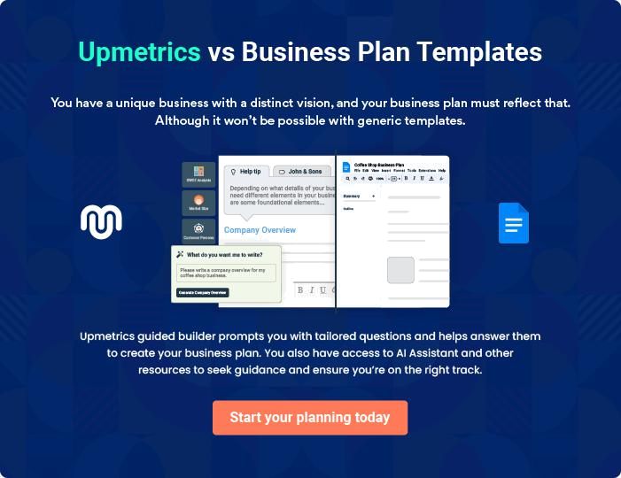

Accounting Firm | Business Plan [YEAR] | 13/31

4.

Market Analysis

Market Trends

Target Market

Competitive Advantage

Accounting Firm | Business Plan [YEAR] 14/31

Market Trends

 Five Zero

The financial consulting services industry is indeed a very large industry and of course, it is one industry that works for businesses across different industries. If you are conversant with the trend in the financial consulting services industry, you will agree that loads of mom and pops,
To unlock help try Upmetrics! 

Start writing here..

Target Market

 Five Zero

The demographic and psychographic composition of those who need the services of accounting services providers cuts across both small businesses and large corporations.
To unlock help try Upmetrics! 

Start writing here..

Competitive Advantage

 Five Zero

The level of competition in the financial consulting services industry depends largely on the location of the business and of course the niche of your financial consulting services. If you
can successfully create a unique brand identity for your accounting services firm or carve out a
To unlock help try Upmetrics! 

Start writing here..

Accounting Firm | Business Plan [YEAR] 15/31

5.

Sales And Marketing Strategy

Sources of Income

Sales Forecast

Pricing Strategy

Accounting Firm | Business Plan [YEAR] 16/31

 Five Zero
To unlock help try Upmetrics!

We are mindful of the fact that there are stiffer competitions amongst accounting service firms and other related financial consulting service providers in the United States of America; hence we have been able to hire some of the best business developers to handle our sales and
To unlock help try Upmetrics! 

Start writing here..

Sources of Income

 Five Zero

Five Zero Financial Consulting, LLC is established with the aim of maximizing profits in the financial consulting industry and we are going to go all the way to ensure that we do all it takes to attract clients on a regular basis and sign ‘retainer – ship’ with most of our clients.
To unlock help try Upmetrics! 

Start writing here..

Sales Forecast

 Five Zero

One thing is certain, there would always be a mom and pop shops, startups, NGOs, and corporate organizations that would need the services of professional accounting services firms.



Start writing here..

Accounting Firm | Business Plan [YEAR] 17/31

No. of clients v/s Revenue Chart
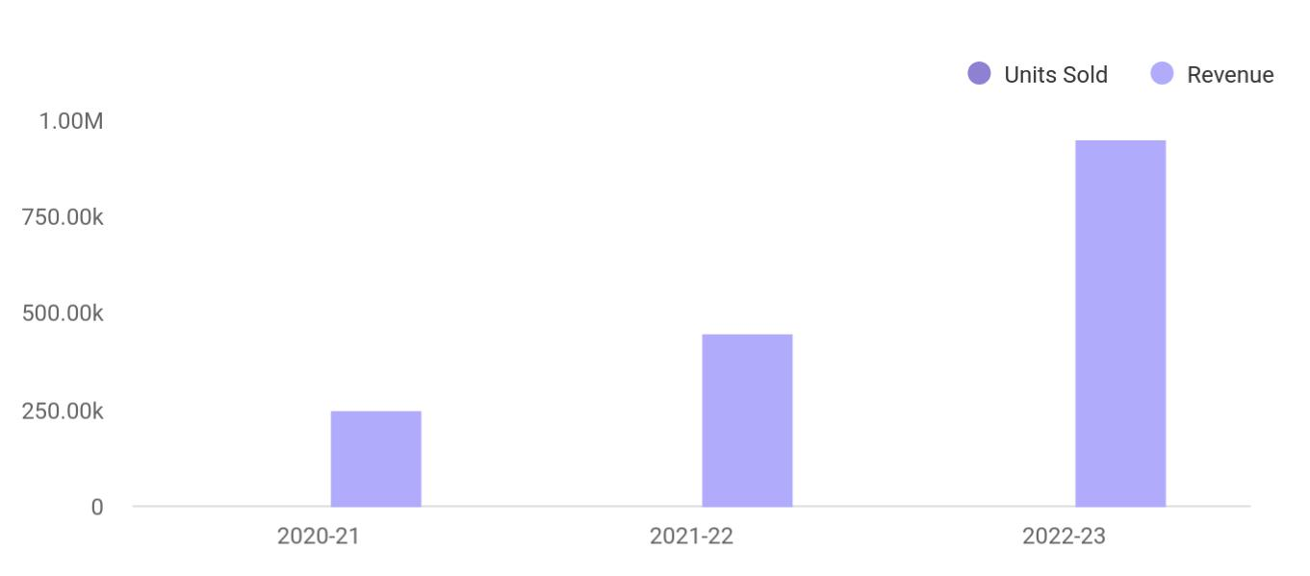

Financial Year | Units Sold | Revenue
2020-21 | 1,550 | 250,000
2021-22 | 1,800 | 450,000
2022-23 | 2,050 | 950,000

Pricing Strategy

 Five Zero

Hourly billing for financial consulting services is a long–time tradition in the industry. However, for some types of financial consultancy services, flat fees make more sense because they allow clients to better predict consultancy costs. As a result of this, Five Zero Financial
To unlock help try Upmetrics! 

Start writing here..

 Five Zero

The payment policy adopted by Five Zero Financial Consulting, LLC is all-inclusive because we are quite aware that different customers prefer different payment options as it suits them but at the same time, we will ensure that we abide by the financial rules and regulation of the United
To unlock help try Upmetrics! 

Payment Options

Start writing here..

Accounting Firm | Business Plan [YEAR] 18/31

6.

Publicity and Advertising Strategy

Accounting Firm | Business Plan [YEAR] 19/31

 Five Zero

We have been able to work with our brand and publicity consultants to help us map out publicity and advertising strategies that will help us walk our way into the heart of our target market. We are set to take the financial consulting services industry by storm which is why we
To unlock help try Upmetrics! 

Start writing here..

Accounting Firm | Business Plan [YEAR] 20/31

7.

Financial Plan

Financial Projections and Costing

Generating Funds/Startup Capital

Projected Cash Flow

Projected Balance Sheet

Projected Profit & Loss

Accounting Firm | Business Plan [YEAR] 21/31

Financial Projections and Costing

 Five Zero

Starting an accounting services firm can be cost-effective; this is so because, on the average, you are not expected to acquire expensive machines and equipment.
To unlock help try Upmetrics! 

Start writing here..

Generating Funds/Startup Capital

 Five Zero

Five Zero Financial Consulting, LLC is a business that will be owned and managed by Rowland Pence and his business partner Stanford Darlington. They are the sole financial of the firm, but may likely welcome partners later which is why they decided to restrict the sourcing of the
To unlock help try Upmetrics! 

Start writing here..

Projected Cash Flow

Cash Flow

 | 2024 | 2025 | 2026
Cash Received | $1,487,528.57 | $3,392,715.80 | $6,024,674.22
Cash Paid | $1,511,849.14 | $1,612,916.10 | $1,742,485.02
COS & General Expenses | $127,782.34 | $200,906.86 | $302,012.73
Salary & Wages | $1,378,050 | $1,408,236 | $1,439,104.80
Interest | $6,016.82 | $3,773.25 | $1,367.48
Sales Tax | $0 | $0 | $0
Income Tax | $0 | $0 | $0
Net Cash From | ($24,320.57) | $1,779,799.70 | $4,282,189.20
Operations | ($24,320.57) | $1,779,799.70 | $4,282,189.20

Accounting Firm | Business Plan [YEAR] 22/31

2024 2025 2026

Assets Sell | $0 | $0 | $0
Assets Purchase | $35,000 | $0 | $0
Net Cash From | ($35,000) | $0 | $0
Investments | ($35,000) | $0 | $0

Amount Received | $150,000 | $0 | $0
Loan Received | $100,000 | $0 | $0
Common Stock | $0 | $0 | $0
Preferred Stock | $0 | $0 | $0
Owner's Contribution | $50,000 | $0 | $0
Amount Paid | $51,035.72 | $43,279.28 | $45,685.02
Loan Capital | $31,035.70 | $33,279.27 | $35,685.03
Dividends & Distributions | $20,000 | $10,000 | $10,000
Net Cash From | $98,964.28 | ($43,279.28) | ($45,685.02)
Financing | $98,964.28 | ($43,279.28) | ($45,685.02)

Summary

Starting Cash | $0 | $39,643.71 | $1,776,164.13
Cash In | $1,637,528.57 | $3,392,715.80 | $6,024,674.22
Cash Out | $1,597,884.86 | $1,656,195.38 | $1,788,170.04
Change in Cash | $39,643.71 | $1,736,520.42 | $4,236,504.18
Ending Cash | $39,643.71 | $1,776,164.13 | $6,012,668.31

Accounting Firm | Business Plan [YEAR] 23/31

Projected Balance Sheet

Balance Sheet

 | 2024 | 2025 | 2026
Assets | $66,795.71 | $1,795,468.13 | $6,024,124.31
Current Assets | $39,643.71 | $1,776,164.13 | $6,012,668.31
Cash | $39,643.71 | $1,776,164.13 | $6,012,668.31
Accounts Receivable | $0 | $0 | $0
Inventory | $0 | $0 | $0
Other Current Assets | $0 | $0 | $0
Long Term Assets | $27,152 | $19,304 | $11,456
Gross Long Term Assets | $35,000 | $35,000 | $35,000
Accumulated Depreciation | ($7,848) | ($15,696) | ($23,544)

Liabilities & Equity | $66,795.72 | $1,795,468.15 | $6,024,124.33
Liabilities | $68,964.29 | $35,685.02 | $0
Current Liabilities | $33,279.27 | $35,685.02 | $0
Accounts Payable | $0 | $0 | $0
Income Tax Payable | $0 | $0 | $0
Sales Tax Payable | $0 | $0 | $0
Short Term Debt | $33,279.27 | $35,685.02 | $0
Long Term Liabilities | $35,685.02 | $0 | $0
Long Term Debt | $35,685.02 | $0 | $0
Equity | ($2,168.57) | $1,759,783.13 | $6,024,124.33
Paid-in Capital | $0 | $0 | $0
Common Stock | $0 | $0 | $0
Preferred Stock | $0 | $0 | $0

Accounting Firm | Business Plan [YEAR] 24/31

 | 2024 | 2025 | 2026
Owner's Contribution | $50,000 | $50,000 | $50,000
Retained Earnings | ($52,168.57) | $1,709,783.13 | $5,974,124.33
Check | $0 | $0 | $0
Projected Profit & Loss
Profit & Loss
 | 2024 | 2025 | 2026
Revenue | $1,487,528.57 | $3,392,715.80 | $6,024,674.22
Tax Preparation Services | $477,528 | $857,574 | $1,540,066.50
Unit Sales | 3,184 | 5,717 | 10,267
Unit Price | $150 | $150 | $150
Accounting and | $934,871.60 | $2,414,858 | $4,292,029.60
Bookkeeping | $934,871.60 | $2,414,858 | $4,292,029.60
Users | 1,282 | 2,834 | 4,830
Recurring Charges | $80 | $80 | $80
Consultancy Services | $75,128.97 | $120,283.80 | $192,578.12
Cost Of Sales | $40,312.94 | $69,370.74 | $109,343.32
General Costs | $40,312.94 | $69,370.74 | $109,343.32
Office Supplies and | $20,875.29 | $40,047.15 | $66,489.14
Software | $20,875.29 | $40,047.15 | $66,489.14
Office Supplies | $6,000 | $6,120 | $6,242.40
Accounting Software | $14,875.29 | $33,927.15 | $60,246.74
Subscription | $14,875.29 | $33,927.15 | $60,246.74
Professional Services and | $19,437.65 | $29,323.59 | $42,854.18
Utilities | $19,437.65 | $29,323.59 | $42,854.18

Accounting Firm | Business Plan [YEAR] 25/31

 | 2024 | 2025 | 2026
Legal and Consulting Fees | $12,000 | $12,360 | $12,730.80
Utilities | $7,437.65 | $16,963.59 | $30,123.38
Revenue Specific Costs | $0 | $0 | $0
Personnel Costs (Direct | $0 | $0 | $0
Labor) | $0 | $0 | $0

Gross Margin | $1,447,215.63 | $3,323,345.06 | $5,915,330.90
Gross Margin (%) | 97.29% | 97.96% | 98.19%

Operating Expense | $1,465,519.40 | $1,539,772.12 | $1,631,774.21
Payroll Expense (Indirect | $1,378,050 | $1,408,236 | $1,439,104.80
Labor) | $1,378,050 | $1,408,236 | $1,439,104.80
Management Team | $262,500 | $270,375 | $278,486.28
Managing Partner | $150,000 | $154,500 | $159,135
Financial Manager | $112,500 | $115,875 | $119,351.28
Accountants | $1,022,400 | $1,042,848 | $1,063,705.20
Senior Accountant | $417,600 | $425,952 | $434,470.80
Junior Accountant | $604,800 | $616,896 | $629,234.40
Support Staff | $93,150 | $95,013 | $96,913.32
Office Administrator | $51,750 | $52,785 | $53,840.76
Receptionist | $41,400 | $42,228 | $43,072.56
General Expense | $87,469.40 | $131,536.12 | $192,669.41
Office Expenses | $43,437.65 | $53,683.59 | $68,264.40
Rent | $36,000 | $36,720 | $38,141.02
Utilities | $7,437.65 | $16,963.59 | $30,123.38
Marketing and Advertising | $26,875.29 | $46,287.15 | $72,977.54

Accounting Firm | Business Plan [YEAR] 26/31

 | 2024 | 2025 | 2026
Digital Marketing | $12,000 | $12,360 | $12,730.80
Print Advertising | $14,875.29 | $33,927.15 | $60,246.74
Professional Services | $17,156.46 | $31,565.38 | $51,427.47
Legal Services | $6,000 | $6,120 | $6,242.40
IT Support | $11,156.46 | $25,445.38 | $45,185.07
Bad Debt | $0 | $0 | $0
Amortization of Current | $0 | $0 | $0
Assets | $0 | $0 | $0

EBITDA

Additional Expense

Long Term Depreciation

Gain or loss from Sale of Assets

EBIT

Interest Expense

EBT

Income Tax Expense / Benefit

Total Expense

Net Income

Net Income (%)

($18,303.77) $1,783,572.94 $4,283,556.69

$13,864.80 | $11,621.24 | $9,215.49
$7,848 | $7,848 | $7,848
$0 | $0 | $0
($26,151.77) | $1,775,724.94 | $4,275,708.69
$6,016.82 | $3,773.25 | $1,367.48
($32,168.57) | $1,771,951.70 | $4,274,341.20
$0 | $0 | $0

$1,519,697.14 | $1,620,764.10 | $1,750,333.02
($32,168.57) | $1,771,951.70 | $4,274,341.20
(2.16%) | 52.23% | 70.95%

Retained Earning Opening | $0 | ($52,168.57) | $1,709,783.13

Accounting Firm | Business Plan [YEAR] 27/31

 | 2024 | 2025 | 2026
Owner's Distribution | $20,000 | $10,000 | $10,000
Retained Earning Closing | ($52,168.57) | $1,709,783.13 | $5,974,124.33
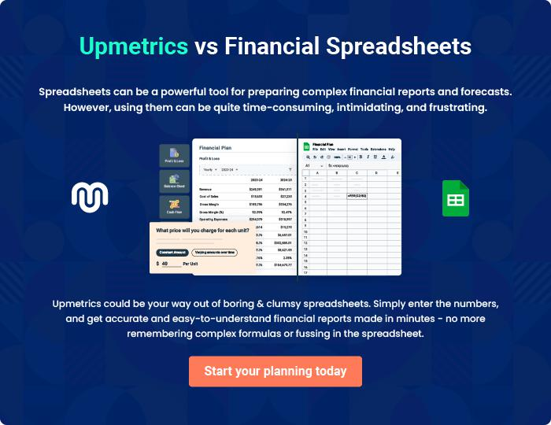

Accounting Firm | Business Plan [YEAR] 28/31

8.

Sustainability and

Expansion Strategy

Accounting Firm | Business Plan [YEAR] 29/31

 Five Zero

The future of a business lies in the number of loyal customers that have the capacity and competence of the employees, their investment strategy, and the business structure. If all of these factors are missing from a business (company), then it won’t be too long before the
To unlock help try Upmetrics! 

Start writing here..

Accounting Firm | Business Plan [YEAR] 30/31


Create a winning business plan that gets you funded

Creating a stunning and investment-ready plan requires no writing, graphic designing, or financial planning expertise.

Upmetrics has all the features required to help you create a comprehensive business plan—from start to finish. Make no mistakes, it’s the modern way of planning to structure ideas, make plans, and create stunning pitch decks to awe investors.

Pitch decks that impress investors

Create pitch decks that provide a visual representation of your business, engage investors, and make them want to invest in your business idea.

Interactive plans in no time

Import business plan sections like—SWOT analysis, comparison tables, and others to create an interactive business plan. No designing skills are required.

Stunning cover page designs

With Upmetrics, you have the liberty to choose from multiple stunning cover page designs. Choose a creative design and make your plan stand out.

Online sharing made simple

Upmetrics makes online sharing quick and easier for users. Easily share your business plans with a link while tracking reader activity.

500+ sample business plans

Simply import a template from our library of sample plans into the editor and start customizing it to make it yours. It takes only a few clicks to get started.

Collaborate with team in real-time

Invite team members, initiate conversations, discuss ideas & strategies, share feedback, and work on a business plan in real-time.

