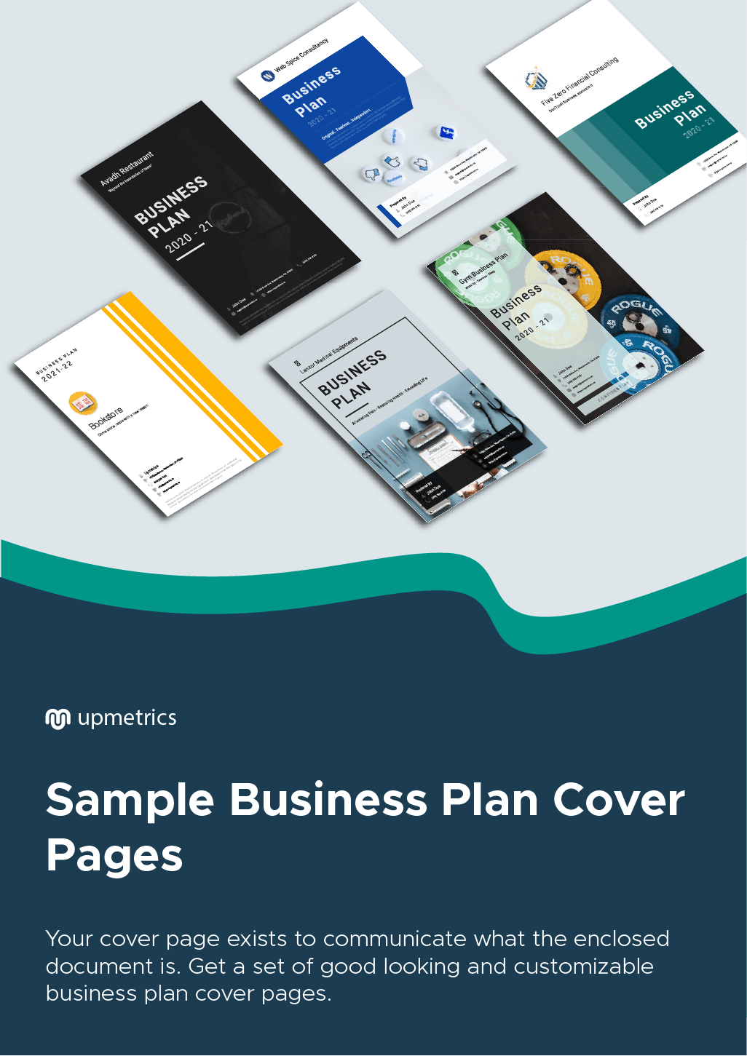

| **Hi There!**  Thanks for downloading these cover page samples.    You Can Edit Your Own Version To Fit Your Needs. |
| --- |
| **What is a Sample Business Plan Cover Page?**  The business plan cover page is an integral part of the business plan. It is the first page of your business plan that highlights the key information of your company like a company logo, company name, address, and other key information.  By Looking at the business plan cover page, a banker or investor can get a quick idea about the purpose of the presented document.  Your business plan cover should be neat, clean, attractive, and professional enough to draw your reader's attention. |

| Learn More About Business Planning  Download Upmetrics’s free Business Plan Samples on how to plan your business. | Sample Business Plan |
| --- | --- |
| [**200+ Sample Busines Plans**](https://upmetrics.co/call-to-download?utm_source=cover-page-samples&utm_medium=sample-plans&utm_campaign=download&discount=WELCOME-10) | |

BUSINESS PLAN

[YEAR]

John & Sons

Because world champs need to look good.

John Doe

10200 Bolsa Ave, Westminster, CA, 92683

(650) 359-3153

[info@upmetrics.co](mailto:info@upmetrics.co)

<https://upmetrics.co>



Mobile Application

Creating Solutions Everywhere

Business

Plan

[YEAR]

John Doe

10200 Bolsa Ave, Westminster, CA, 92683

(650) 359-3153

[info@upmetrics.co](mailto:info@upmetrics.co)

<https://upmetrics.co>

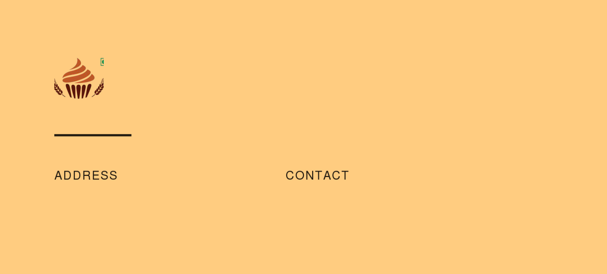B4Bakers

10200 Bolsa Ave, Westminster, CA, 92683

(650) 359-3153

https://upmetrics.co

info@upmetrics.co



**Business Plan**

John Doe

Enhancing Life around great food



Subway Food Franchisee

**BUSINESS PLAN**

The Place Where Fresh is the Taste

**Prepared By**

John Doe

10200 Bolsa Ave, Westminster, CA, 92683

[info@upmetrics.co](mailto:info@upmetrics.co)

(650) 359-3153 <https://upmetrics.co>

 CRM Software

**Business Plan**

A SAAS Business Plan

**Prepared By**

John Doe

10200 Bolsa Ave, Westminster, CA, 92683

[info@upmetrics.co](mailto:info@upmetrics.co)

(650) 359-3153 <https://upmetrics.co>