
Record Label Company


Business
Plan

[YEAR]
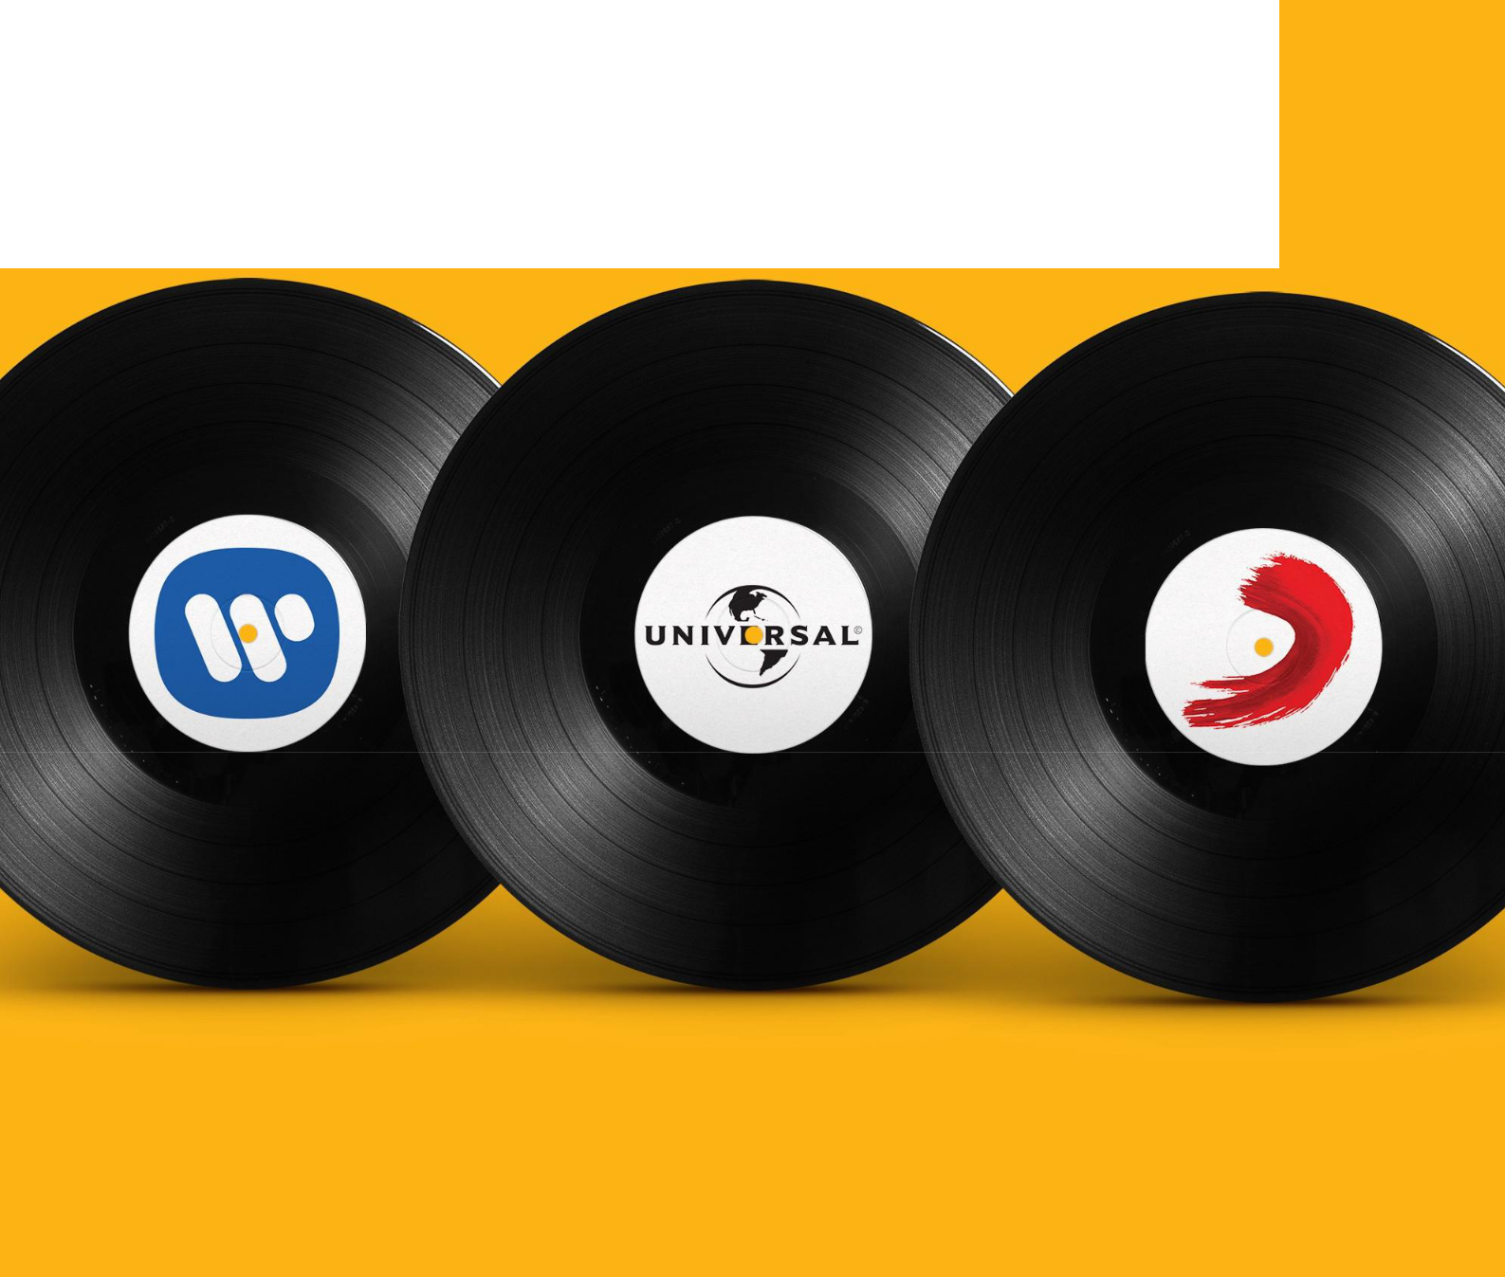

Bring music to life

Information provided in this business plan is unique to this business and confidential; therefore, anyone reading this plan agrees not to disclose any of the information in this business plan without prior written permission of the Company

Prepared By | 10200 Bolsa Ave, Westminster, CA, 92683
John Doe | info@example.com
(650) 359-3153 | http://www.example.com

Table of Contents

Executive Summary | 5
Introduction | 6
Mission | 6
Objectives | 6
Keys to Success | 7
Financial Highlights | 7
3 Year profit forecast | 8

Business Summary | 9
Start-up Summary | 10
Startup cost | 10
Funding Required | 11
Ownership | 12
Products and Services
Products and Services | 13
Market Analysis
Market Analysis | 15
Market Segmentation | 16
Market Analysis | 16
Target Market Segment Strategy | 17
Service Business Analysis | 17
Competition and Buying Patterns | 18
Strategy
Strategy | 19
Sales Strategy | 20
Sales Forecast | 20
Sales Yearly | 21
Detailed Sales Forecast | 21
Marketing Strategy | 22
Competitive Edge | 22
Milestones | 23

Record Label Company | Business Plan [YEAR] 2/38

Web Plan Summary | 24
Website Marketing Strategy | 25
Development Requirements | 25
Management Plan
Management Plan | 26
Personnel Plan | 27
Financial Plan
Financial Plan | 28
Important Assumptions | 29
Brake-even Analysis | 29
Projected Profit and Loss | 30
Projected Cash Flow | 33
Projected Balance Sheet | 34
Business Ratios | 35

Record Label Company | Business Plan [YEAR] 3/38

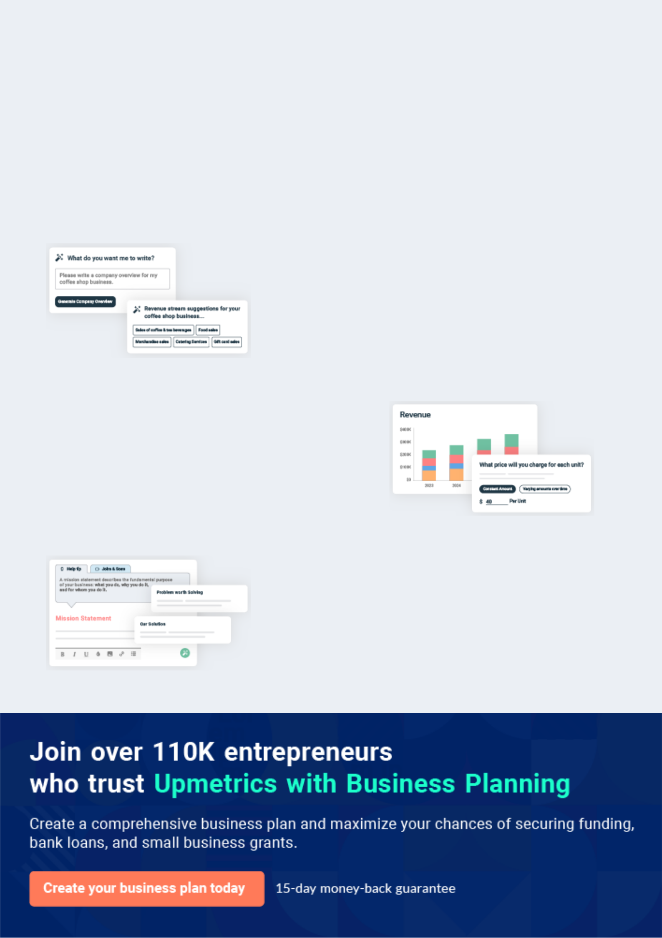
Business planning that’s simpler and faster than you think

Creating a business plan using Upmetrics to start and grow a business is literally the easiest thing in the World. Simply read the instructions and fill in the blanks. It’s as simple as that.

❛ | Upmetrics has everything you need to create a | ❜
❛ | comprehensive business plan. | ❜

AI-powered Upmetrics Assistant

AI-powered insights to streamline your plan

Not sure where to start? Upmetrics’ AI Assistant will automatically generate ideas for each section of your plan and offer improved versions of your writing, adjusting for tone, voice, and grammar or spelling errors.

Financial Forecasting Tool

All the financials are calculated for you

Forget the complex formulas and clumsy spreadsheets — with automatic financials and drag-and-drop forecasting, you can finish your plan faster and be confident that your numbers are accurate.

Business Plan Builder

Guides you like a business mentor

Upmetrics’ step-by-step instructions, prompts, and the library of 400+ sample business plans will guide you through each section of your plan as a business mentor.

1.


Executive Summary

Introduction

Mission

Objectives

Keys to Success

Financial Highlights

Record Label Company | Business Plan [YEAR] 5/38

Before you think about how to start a Record Label business, you must create a detailed Record Label business plan. It will not only guide you in the initial phases of your startup but will also help you later on.
To unlock help try Upmetrics!
To unlock help try Upmetrics!

Introduction

 Fearless Records




Fearless Records is a standard record label company that proposes to be based in 500 Madison Avenue New York, NY 10011, USA. Our aim of starting this business is to work in
tandem with both established and upcoming music artists in the United States of America and
To unlock help try Upmetrics! 

Start writing here..

Mission

 Fearless Records

Fearless Records exists as a locally based record label whose mission is to promote local music groups, increasing live appearances and record sales. Fearless Records have been established to promote its bands and at the same time make a fair profit.
To unlock help try Upmetrics! 

Start writing here..

Objectives

 Fearless Records

To become the premier local music label, based on CD sales, within three years.

Sign at least five groups within the first three years.
Reach profitability within three years.


Start writing here..

Record Label Company | Business Plan [YEAR] 6/38

Keys to Success

 Fearless Records

- Choose promising bands to promote.

- Do not sign up for too many bands, otherwise, the effectiveness of promotion will be
diluted. | To unlock help try Upmetrics! 

Start writing here..

Financial Highlights

 Fearless Records

The company's start-up requirements are $55,464, of which $7,600 will be provided for by the owner's personal investment. The rest will be obtained through loans.
To unlock help try Upmetrics! 

Start writing here..

Record Label Company | Business Plan [YEAR] 7/38

3 Year profit forecast
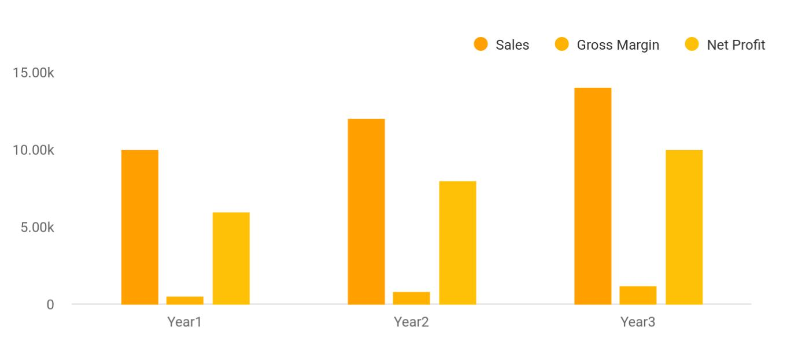

Financial Year | Sales | Gross Margin | Net Profit
Year1 | 10,000 | 500 | 6,000
Year2 | 12,000 | 800 | 8,000
Year3 | 14,000 | 1,200 | 10,000

Record Label Company | Business Plan [YEAR] 8/38

2.

Business Summary

Start-up Summary

Funding Required

Ownership

Record Label Company | Business Plan [YEAR] 9/38

 Fearless Records

Fearless Records, located in New York is a new, independent record label focusing on alternative rock music.
To unlock help try Upmetrics! 

Start writing here..

Start-up Summary

 Fearless Records

Fearless Records will purchase the following equipment needed for the start-up phase of the business:
To unlock help try Upmetrics! 

Start writing here..

Startup cost
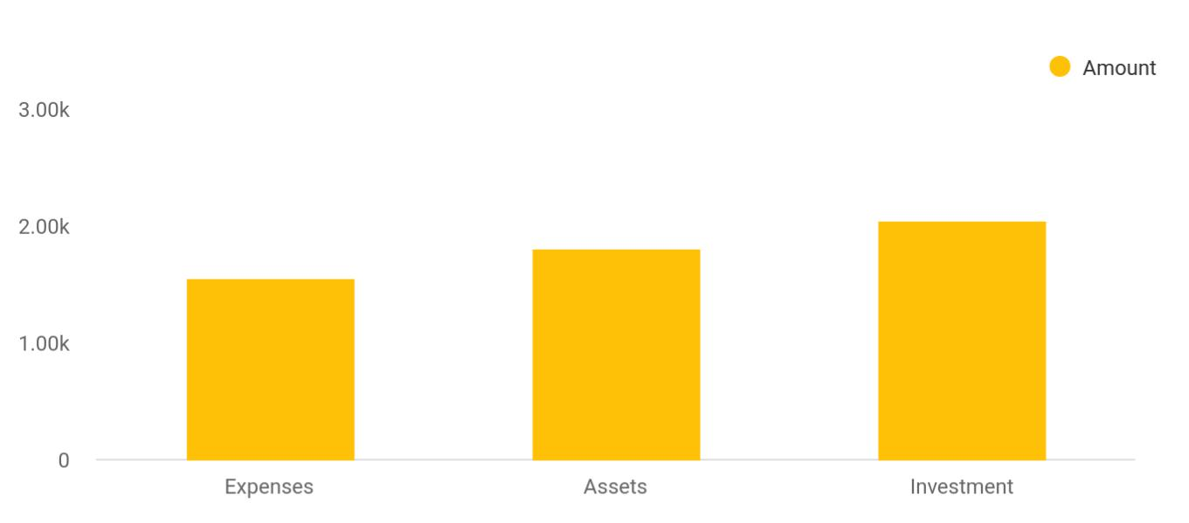

Cost distribution | Amount
Expenses | 1,550
Assets | 1,800
Investment | 2,050

Record Label Company | Business Plan [YEAR] 10/38

Funding Required

The detailed startup requirements and expenses are given in the table below.

START-UP FUNDING | AMOUNT
Start-up Expenses to Fund | $6,650
Start-up Assets to Fund | $21,350
TOTAL FUNDING REQUIRED | $28,000
Assets
Non-cash Assets from Start-up | $2,000
Cash Requirements from Start-up | $19,350
Additional Cash Raised | $0
Cash Balance on Starting Date | $19,350
TOTAL ASSETS | $21,350
Liabilities and Capital
Liabilities
Current Borrowing | $0
Long-term Liabilities | $0
Accounts Payable (Outstanding Bills) | $0
Other Current Liabilities (interest-free) | $0
TOTAL LIABILITIES | $0
Capital
Planned Investment
Dexter Clinton | $10,000
Family and Friends | $18,000
Other | $0
Additional Investment Requirement | $0
TOTAL PLANNED INVESTMENT | $28,000
Loss at Start-up (Start-up Expenses) | ($6,650)
TOTAL CAPITAL | $21,350

Record Label Company | Business Plan [YEAR] 11/38

To unlock help try Upmetrics!
START-UP FUNDING | AMOUNT
TOTAL CAPITAL AND LIABILITIES | $21,350
Total Funding | $28,000

Ownership

 Fearless Records

The company has been founded and is primarily owned by Dexter Clinton. Dexter has invested personal funds in the business and will seek additional investment money from friends and family.



Start writing here..

Record Label Company | Business Plan [YEAR] 12/38

3.

Products and Services

Record Label Company | Business Plan [YEAR] 13/38

Before starting a Record Label company, you must take many things into consideration such as you must consider what types of services will you be providing to your clients. Deciding your services is extremely important since
To unlock help try Upmetrics! 

 Fearless Records

Fearless Records is a new, Portland, New York-based record label. Fearless Records is taking a new, unusual approach to band promotion and CD sales. Instead of competing with the large, ultra-competitive national record labels, as well as the larger Indie labels, Fearless Records will
To unlock help try Upmetrics! 

Start writing here..
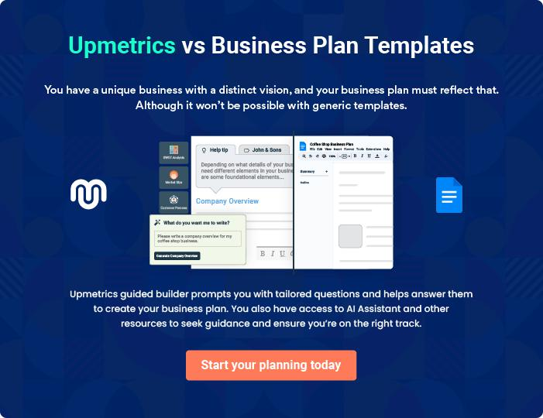

Record Label Company | Business Plan [YEAR] 14/38

4.

Market Analysis

Market Segmentation

Target Market Segment Strategy

Service Business Analysis

Record Label Company | Business Plan [YEAR] 15/38

The most important component of an effective Record Label business plan is its accurate marketing analysis. If you are starting on a smaller scale, you can do marketing analysis yourself by taking help from this Record Label
To unlock help try Upmetrics! 

 Fearless Records

Fearless Records will target two primary market segments, record stores and consumers at live shows. These will be the sources of income so they will be the main targets. Initially, Fearless Records focus will be to develop visibility within the community, enough to be able to sign up
To unlock help try Upmetrics! 

Start writing here..

Market Segmentation

 Fearless Records

Fearless Records has identified two target market segments which will be the main targeted customers.
To unlock help try Upmetrics! 

Start writing here..

Market Analysis
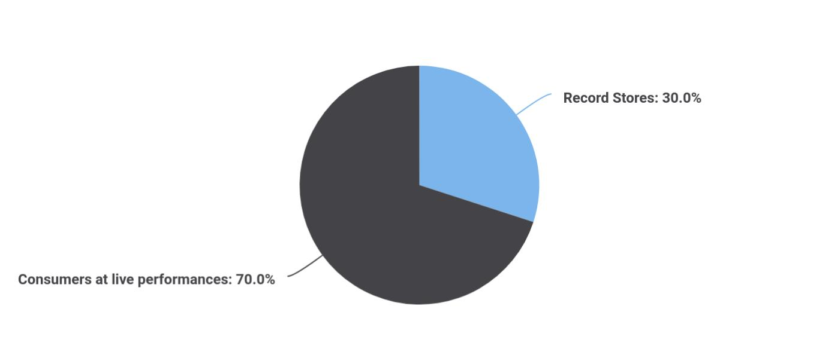

Financial Year Units Sold

Record Stores 30

Record Label Company | Business Plan [YEAR] 16/38

Financial Year Units Sold

Consumers at live performances 70

Potential Customers | Growth | Year 1 | Year 2 | Year 3 | Year 4 | Year 5 | CAGR
Record stores | 5% | 23 | 24 | 25 | 26 | 27 | 4.09%
Consumers at live | 7% | 18,776 | 20,090 | 21,496 | 23,001 | 24,611 | 7.00%
performances
Total | 7.00% | 18,799 | 20,114 | 21,521 | 23,027 | 24,638 | 7.00%

Target Market Segment Strategy

 Fearless Records

Fearless Records has chosen these two distinct market segments because they are the main source of revenue. Fearless Records will remain focused on their important marketing activities aimed at developing visibility for the record label, however, ultimately it comes down to CD
To unlock help try Upmetrics! 

Start writing here..

Service Business Analysis

 Fearless Records

In general, the record industry, at least when based on overall sales, is a highly concentrated national industry. There are several huge international corporations that control the bulk of record sales. For bands looking to break through into national stardom and significant record
To unlock help try Upmetrics! 

Start writing here..

Record Label Company | Business Plan [YEAR] 17/38

 Fearless Records

National record labels - Atlantic, Sony, BMG labels, etc. These distributors care about one thing, CD sales. The more CDs they sell, the more money they make. Bands do not get much individual attention. They are carefully trained to develop mass appeal. Commercialization is
To unlock help try Upmetrics! 

Competition and Buying Patterns

Start writing here..

Record Label Company | Business Plan [YEAR] 18/38

5.

Strategy

Sales Strategy

Marketing Strategy

Competitive Edge

Milestones

Record Label Company | Business Plan [YEAR] 19/38

After identifying the market demand, market trends, and the potential customers of the startup, the next step is to define an effective strategy for attracting those clients. Like marketing analysis, sales strategy is also an
To unlock help try Upmetrics! 

 Fearless Records

Fearless Records will leverage their competitive edge of low overhead and low band count ensuring intimate specialized care and promotion for the lucky few bands that it represents.
Fearless Records will employ a marketing strategy that concentrates on developing a large web
To unlock help try Upmetrics! 

Start writing here..

Sales Strategy

 Fearless Records

Fearless Records' sales strategy will focus on the two main sources of revenue: record retailers and consumers at shows. Fearless Records will be in constant communication, always attempting to negotiate agreements for record sales with retailers. Because Fearless Records
To unlock help try Upmetrics! 

Start writing here..

 Fearless Records

Sales will be slow initially. It is forecasted that the first two compilation CDs will be handed out for free. Sales revenue is not anticipated yet. By the third compilation, Fearless Records will have signed two bands and this will be the beginning of revenue-generating CD sales. Once
To unlock help try Upmetrics! 

Sales Forecast

Start writing here..

Record Label Company | Business Plan [YEAR] 20/38

Sales Yearly
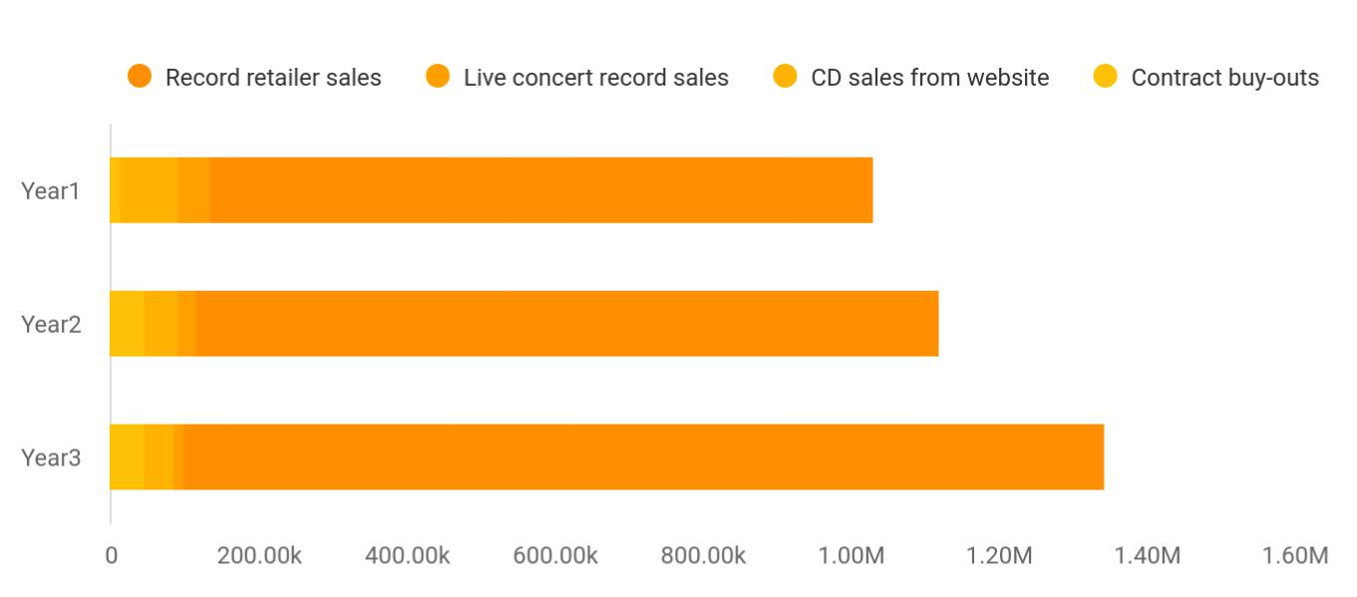

Financial Year | Record retailer sales | Live concert recores | CD sales from wees | Contract buy-outs
Year1 | 895,665 | 45,000 | 78,451 | 12,354
Year2 | 1,004,512 | 24,512 | 45,784 | 45,522
Year3 | 1,245,587 | 12,458 | 41,215 | 45,112

Detailed Sales Forecast

Detailed sales forecast data is provided in below table:

SALES FORECAST | YEAR 1 | YEAR 2 | YEAR 3
Sales
Record retailer sales | $0 | $28,090 | $39,076
Live concert record sales | $0 | $19,000 | $24,090
CD sales from website | $0 | $15,070 | $25,600
Contract buy-outs | $0 | $20,000 | $55,000
TOTAL SALES | $0 | $82,160 | $143,766
Direct Cost of Sales
Record retailer sales | $0 | $11,236 | $15,630
Live concert record sales | $0 | $6,650 | $8,432
CD sales from website | $0 | $5,275 | $8,960
Contract buy-outs | $0 | $0 | $0

Record Label Company | Business Plan [YEAR] 21/38

SALES FORECAST | YEAR 1 | YEAR 2 | YEAR 3
Subtotal Direct Cost of Sales | $0 | $23,161 | $33,022

Marketing Strategy

 Fearless Records

Fearless Records' marketing strategy recognizes the fact that the value in the label is intrinsically based on their reputation within the music community. Mt Hood Records needs to be known as a premier label, creating a compelling reason for bands to sign up with them.
To unlock help try Upmetrics! 

Start writing here..

Competitive Edge

 Fearless Records

Fearless Records will employ a two-pronged competitive edge. The first edge prong is having a low overhead. Fearless Records' office will be in Dexter's home. There is not an immediate need for offices, as all work can be transacted from her home office. Additionally, unlike many record
To unlock help try Upmetrics! 

Start writing here..

Record Label Company | Business Plan [YEAR] 22/38

Milestones

Several milestones have been established and will act as a set of goals and a tracking mechanism for achieving the goals. While the milestones are initially static, they can be dynamic if needed. Please see the following table for detail regarding the milestones.

Milestone | Start Date | End Date | Budget | Manager | Department
Business plan completion | 1/1/2021 | 2/15/2021 | $0 | Dexter | Business
 |  |  |  |  | Development
First compilation released | 2/15/2021 | 5/1/2021 | $0 | Dexter | Marketing
Second compilation | 5/1/2021 | 9/15/2021 | $0 | Dexter | Marketing
released
The first band signed | 2/15/2021 | 10/30/2021 | $0 | Dexter | Sales
First revenue stream | 10/30/2021 | 2/28/2022 | $0 | Dexter | Sales
Band representation | 10/30/2021 | 6/30/2022 | $0 | Dexter | Sales
currently full
Totals |  |  | $0

Record Label Company | Business Plan [YEAR] 23/38

6.

Web Plan Summary

Website Marketing Strategy

Development Requirements

Record Label Company | Business Plan [YEAR] 24/38

 Fearless Records
To unlock help try Upmetrics!
To unlock help try Upmetrics!

Fearless Records' website will be an excellent source of information dissemination and CD sales.
To unlock help try Upmetrics! 

Start writing here..

Website Marketing Strategy

 Fearless Records

The site will be linked to the various Portland entertainment guides such as Willamette Weekly. Fearless Records will also submit the site to several different search engines. Lastly, the URL address will be prominent on all printed material and correspondence.

Start writing here..

Development Requirements

 Fearless Records

The site will be developed by a computer science student.

Start writing here..





Record Label Company | Business Plan [YEAR] 25/38

7.

Management Plan

Personnel Plan

Record Label Company | Business Plan [YEAR] 26/38

The management plan is also an important component of a Record Label business plan since it gives you an estimate of the staff required for your
startup as well as the costs incurred on their salaries. So, make sure to duly
To unlock help try Upmetrics! 

 Fearless Records

Dexter Clinton first got her feet wet in music after college. After graduating with a Bachelor of Arts degree, Dexter and band-mates of 180 South decided to start their own record label to support a regional tour. The goal of the record label was primarily self-promotion and personal
To unlock help try Upmetrics! 

Start writing here..

Personnel Plan

 Fearless Records

Dexter will be the primary employee. She will be working long hours, often with her husband's help, but after some sweat equity, the business model will begin producing revenue. Dexter will not take a salary for the first two years in order to build the business. For year three she will
To unlock help try Upmetrics! 

Start writing here..

PERSONNEL PLAN | YEAR 1 | YEAR 2 | YEAR 3
Dexter | $0 | $0 | $30,000
Sales | $0 | $12,000 | $13,000
Distribution | $1,600 | $12,000 | $13,000
TOTAL PEOPLE | 1 | 3 | 3
Total Payroll | $1,600 | $24,000 | $56,000

Record Label Company | Business Plan [YEAR] 27/38

8.

Financial Plan

Important Assumptions

Brake-even Analysis

Projected Profit and Loss

Projected Cash Flow

Projected Balance Sheet

Business Ratios

Record Label Company | Business Plan [YEAR] 28/38

The last component of a Record Label Business plan is an in-depth financial plan. The financial plan crafts a detailed map of all the expenses needed for the startup and how these expenses will be met by the earned profits. It is
To unlock help try Upmetrics! 

 Fearless Records

The following sections presents important financial information.

To unlock help try Upmetrics! 

Start writing here..

Important Assumptions

The financial projections of the company are forecast on the basis of the following assumptions. These assumptions are quite conservative and are expected to show deviation but to a limited level such that the company’s major financial strategy will not be affected.

 | Year 1 | Year 2 | Year 3
Plan Month | 1 | 2 | 3
Current Interest Rate | 10,00% | 11,00% | 12,00%
Long-term Interest Rate | 10,00% | 10,00% | 10,00%
Tax Rate | 26,42% | 27,76% | 28,12%
Other | 0 | 0 | 0

Brake-even Analysis

Monthly Units Break-even | 5530
Monthly Revenue Break-even | $159 740
Assumptions:
Average Per-Unit Revenue | $260,87
Average Per-Unit Variable Cost | $0,89
Estimated Monthly Fixed Cost | $196 410

Record Label Company | Business Plan [YEAR] 29/38

Projected Profit and Loss

 | 2024 | 2025 | 2026
Revenue | $967,563.90 | $1,126,256.25 | $1,318,688.25
Music Sales | $115,200 | $120,960 | $127,008
Unit Sales | 96,000 | 100,800 | 105,840
Unit Price | $1.20 | $1.20 | $1.20
Concerts and Live | $450,000 | $495,000 | $544,500
Performances | $450,000 | $495,000 | $544,500
Unit Sales | 15 | 17 | 18
Unit Price | $30,000 | $30,000 | $30,000
Merchandising | $402,363.90 | $510,296.25 | $647,180.25
Unit Sales | 26,824 | 34,020 | 43,145
Unit Price | $15 | $15 | $15

Cost Of Sales | $228,496.09 | $251,161.39 | $279,906.82
General Costs | $228,496.09 | $251,161.39 | $279,906.82
Marketing and Distribution | $184,236.22 | $195,029.22 | $208,717.45
Costs | $184,236.22 | $195,029.22 | $208,717.45
Advertising | $40,236.22 | $51,029.22 | $64,717.45
Distribution fees | $144,000 | $144,000 | $144,000
Music Production Costs | $44,259.87 | $56,132.17 | $71,189.37
Studio Rental | $30,847.84 | $39,122.60 | $49,617.04
Producer Fees | $13,412.03 | $17,009.57 | $21,572.33
Revenue Specific Costs | $0 | $0 | $0
Personnel Costs (Direct | $0 | $0 | $0
Labor) | $0 | $0 | $0

Record Label Company | Business Plan [YEAR] 30/38

 | 2024 | 2025 | 2026
Gross Margin | $739,067.81 | $875,094.86 | $1,038,781.43
Gross Margin (%) | 76.38% | 77.70% | 78.77%

Operating Expense | $526,562.35 | $565,735.56 | $610,935.79
Payroll Expense (Indirect | $356,700 | $365,889 | $375,323.52
Labor) | $356,700 | $365,889 | $375,323.52
Management Team | $142,500 | $146,775 | $151,178.28
Label Manager | $75,000 | $77,250 | $79,567.56
Marketing Director | $67,500 | $69,525 | $71,610.72
Creative Staff | $108,000 | $110,160 | $112,363.20
Producer | $57,600 | $58,752 | $59,927.04
Sound Engineer | $50,400 | $51,408 | $52,436.16
Administrative Staff | $106,200 | $108,954 | $111,782.04
Administrative Assistant | $43,200 | $44,064 | $44,945.28
HR Manager | $63,000 | $64,890 | $66,836.76
General Expense | $169,862.35 | $199,846.56 | $235,612.26
Studio and Production | $51,009.14 | $61,377.28 | $73,878.37
Costs | $51,009.14 | $61,377.28 | $73,878.37
Studio Rental | $45,644.35 | $54,573.34 | $65,249
Equipment Maintenance | $5,364.79 | $6,803.94 | $8,629.37
Marketing and Promotion | $60,378.21 | $69,167.22 | $79,432.74
Advertising Campaigns | $48,378.21 | $56,312.82 | $65,934.42
Social Media Promotion | $12,000 | $12,854.40 | $13,498.32
Operational Costs | $58,475 | $69,302.06 | $82,301.15
Office Rent | $39,123.72 | $46,776.93 | $55,927.39
Utilities | $19,351.28 | $22,525.13 | $26,373.76

Record Label Company | Business Plan [YEAR] 31/38

Bad Debt

Amortization of Current Assets

EBITDA

Additional Expense

Long Term Depreciation

Gain or loss from Sale of Assets

EBIT

Interest Expense

EBT

Income Tax Expense / Benefit

Total Expense

Net Income

Net Income (%)

Retained Earning Opening

Owner's Distribution

Retained Earning Closing

2024 | 2025 | 2026
$0 | $0 | $0
$0 | $0 | $0

$212,505.46 $309,359.30 $427,845.64

$17,423.53 | $16,878.30 | $16,299.41
$14,664 | $14,664 | $14,664
$0 | $0 | $0
$197,841.46 | $294,695.30 | $413,181.64
$2,759.52 | $2,214.28 | $1,635.41
$195,081.93 | $292,481 | $411,546.23
$0 | $0 | $0

$772,481.97 | $833,775.25 | $907,142.02
$195,081.93 | $292,481 | $411,546.23
20.16% | 25.97% | 31.21%

$0 | $188,081.93 | $478,562.93
$7,000 | $2,000 | $2,000
$188,081.93 | $478,562.93 | $888,109.16

Record Label Company | Business Plan [YEAR] 32/38

Projected Cash Flow

 | 2024 | 2025 | 2026
Cash Received | $967,563.90 | $1,126,256.25 | $1,318,688.25
Cash Paid | $757,817.97 | $819,111.24 | $892,478.02
COS & General Expenses | $398,358.44 | $451,007.94 | $515,519.09
Salary & Wages | $356,700 | $365,889 | $375,323.52
Interest | $2,759.52 | $2,214.28 | $1,635.41
Sales Tax | $0 | $0 | $0
Income Tax | $0 | $0 | $0
Net Cash From | $209,745.93 | $307,145.01 | $426,210.23
Operations | $209,745.93 | $307,145.01 | $426,210.23
Assets Sell | $0 | $0 | $0
Assets Purchase | $70,000 | $0 | $0
Net Cash From | ($70,000) | $0 | $0
Investments | ($70,000) | $0 | $0
Amount Received | $150,000 | $0 | $0
Loan Received | $50,000 | $0 | $0
Common Stock | $0 | $0 | $0
Preferred Stock | $0 | $0 | $0
Owner's Contribution | $100,000 | $0 | $0
Amount Paid | $15,840.15 | $11,385.38 | $11,964.27
Loan Capital | $8,840.16 | $9,385.40 | $9,964.27
Dividends & Distributions | $7,000 | $2,000 | $2,000
Net Cash From | $134,159.85 | ($11,385.38) | ($11,964.27)
Financing | $134,159.85 | ($11,385.38) | ($11,964.27)

Record Label Company | Business Plan [YEAR] 33/38

 | 2024 | 2025 | 2026
Summary
Starting Cash | $0 | $273,905.78 | $569,665.41
Cash In | $1,117,563.90 | $1,126,256.25 | $1,318,688.25
Cash Out | $843,658.12 | $830,496.62 | $904,442.29
Change in Cash | $273,905.78 | $295,759.63 | $414,245.96
Ending Cash | $273,905.78 | $569,665.41 | $983,911.37
Projected Balance Sheet
 | 2024 | 2025 | 2026
Assets | $329,241.78 | $610,337.41 | $1,009,919.37
Current Assets | $273,905.78 | $569,665.41 | $983,911.37
Cash | $273,905.78 | $569,665.41 | $983,911.37
Accounts Receivable | $0 | $0 | $0
Inventory | $0 | $0 | $0
Other Current Assets | $0 | $0 | $0
Long Term Assets | $55,336 | $40,672 | $26,008
Gross Long Term Assets | $70,000 | $70,000 | $70,000
Accumulated Depreciation | ($14,664) | ($29,328) | ($43,992)
Liabilities & Equity | $329,241.77 | $610,337.37 | $1,009,919.33
Liabilities | $41,159.84 | $31,774.44 | $21,810.17
Current Liabilities | $9,385.40 | $9,964.27 | $0
Accounts Payable | $0 | $0 | $0
Income Tax Payable | $0 | $0 | $0

Record Label Company | Business Plan [YEAR] 34/38

 | 2024 |  |  | 2025 |  | 2026
Sales Tax Payable | $0 |  |  | $0 |  | $0
Short Term Debt | $9,385.40 |  | $9,964.27 |  |  | $0
Long Term Liabilities | $31,774.44 |  | $21,810.17 |  |  | $21,810.17
Long Term Debt | $31,774.44 |  | $21,810.17 |  |  | $21,810.17
Equity | $288,081.93 |  | $578,562.93 |  |  | $988,109.16
Paid-in Capital | $0 |  |  | $0 |  | $0
Common Stock | $0 |  |  | $0 |  | $0
Preferred Stock | $0 |  |  | $0 |  | $0
Owner's Contribution | $100,000 |  | $100,000 |  |  | $100,000
Retained Earnings | $188,081.93 |  | $478,562.93 |  |  | $888,109.16
Check | $0 |  |  | $0 |  | $0
Business Ratios
 |  | Year 1 | Year 2 |  | Year 3 | Industry Profile
Sales Growth |  | 4,35% | 30,82% |  | 63,29% | 4,00%
Percent of Total Assets
Accounts Receivable |  | 5,61% | 4,71% |  | 3,81% | 9,70%
Inventory |  | 1,85% | 1,82% |  | 1,79% | 9,80%
Other Current Assets |  | 1,75% | 2,02% |  | 2,29% | 27,40%
Total Current Assets |  | 138,53% | 150,99% |  | 163,45% | 54,60%
Long-term Assets |  | -9,47% | -21,01% |  | -32,55% | 58,40%
TOTAL ASSETS |  | 100,00% | 100,00% |  | 100,00% | 100,00%
Current Liabilities |  | 4,68% | 3,04% |  | 2,76% | 27,30%
Long-term Liabilities |  | 0,00% | 0,00% |  | 0,00% | 25,80%
Total Liabilities |  | 4,68% | 3,04% |  | 2,76% | 54,10%

Record Label Company | Business Plan [YEAR] 35/38

 | Year 1 | Year 2 | Year 3 | Industry Profile
NET WORTH | 99,32% | 101,04% | 102,76% | 44,90%
Percent of Sales
Sales | 100,00% | 100,00% | 100,00% | 100,00%
Gross Margin | 94,18% | 93,85% | 93,52% | 0,00%
Selling, General & Administrative Expenses | 74,29% | 71,83% | 69,37% | 65,20%
Advertising Expenses | 2,06% | 1,11% | 0,28% | 1,40%
Profit Before Interest and Taxes | 26,47% | 29,30% | 32,13% | 2,86%
Main Ratios
Current | 25,86 | 29,39 | 32,92 | 1,63
Quick | 25,4 | 28,88 | 32,36 | 0,84
Total Debt to Total Assets | 2,68% | 1,04% | 0,76% | 67,10%
Pre-tax Return on Net Worth | 66,83% | 71,26% | 75,69% | 4,40%
Pre-tax Return on Assets | 64,88% | 69,75% | 74,62% | 9,00%
Additional Ratios
Net Profit Margin | 19,20% | 21,16% | 23,12% | N.A.
Return on Equity | 47,79% | 50,53% | 53,27% | N.A.
Activity Ratios
Accounts Receivable Turnover | 4,56 | 4,56 | 4,56 | N.A.
Collection Days | 92 | 99 | 106 | N.A.
Inventory Turnover | 19,7 | 22,55 | 25,4 | N.A.
Accounts Payable Turnover | 14,17 | 14,67 | 15,17 | N.A.
Payment Days | 27 | 27 | 27 | N.A.
Total Asset Turnover | 1,84 | 1,55 | 1,26 | N.A.
Debt Ratios
Debt to Net Worth | 0 | -0,02 | -0,04 | N.A.
Current Liab. to Liab. | 1 | 1 | 1 | N.A.
Liquidity Ratios
Net Working Capital | $120 943 | $140 664 | $160 385 | N.A.

Record Label Company | Business Plan [YEAR] 36/38

 | Year 1 | Year 2 | Year 3 | Industry Profile
Interest Coverage | 0 | 0 | 0 | N.A.
Additional Ratios
Assets to Sales | 0,45 | 0,48 | 0,51 | N.A.
Current Debt/Total Assets | 4% | 3% | 2% | N.A.
Acid Test | 23,66 | 27,01 | 30,36 | N.A.
Sales/Net Worth | 1,68 | 1,29 | 0,9 | N.A.
Dividend Payout | 0 | 0 | 0 | N.A.
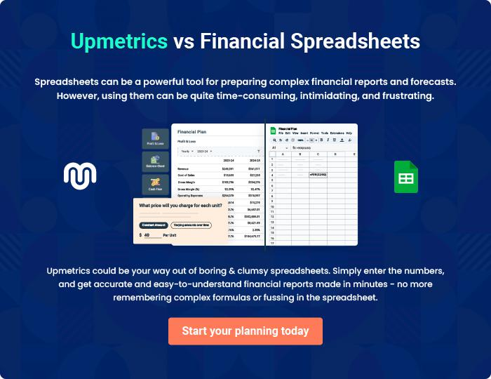

Record Label Company | Business Plan [YEAR] 37/38


Create a winning business plan that gets you funded

Creating a stunning and investment-ready plan requires no writing, graphic designing, or financial planning expertise.

Upmetrics has all the features required to help you create a comprehensive business plan—from start to finish. Make no mistakes, it’s the modern way of planning to structure ideas, make plans, and create stunning pitch decks to awe investors.

Pitch decks that impress investors

Create pitch decks that provide a visual representation of your business, engage investors, and make them want to invest in your business idea.

Interactive plans in no time

Import business plan sections like—SWOT analysis, comparison tables, and others to create an interactive business plan. No designing skills are required.

Stunning cover page designs

With Upmetrics, you have the liberty to choose from multiple stunning cover page designs. Choose a creative design and make your plan stand out.

Online sharing made simple

Upmetrics makes online sharing quick and easier for users. Easily share your business plans with a link while tracking reader activity.

500+ sample business plans

Simply import a template from our library of sample plans into the editor and start customizing it to make it yours. It takes only a few clicks to get started.

Collaborate with team in real-time

Invite team members, initiate conversations, discuss ideas & strategies, share feedback, and work on a business plan in real-time.

